I, shane patrick Carmody, Acting Director of Aviation Safety, on behalf of CASA, make this instrument under paragraph 9 (1) (c) of the Civil Aviation Act 1988, regulation 173.010, subparagraph 173.030 (b) (ii), and regulations 173.250, 173.260 and 173.270 of the Civil Aviation Safety Regulations 1998.
[Signed S. Carmody]
Shane Carmody
Acting Director of Aviation Safety
6 March 2017
Manual of Standards Part 173 Amendment Instrument 2017 (No. 1)
1 Name of instrument
This instrument is the Manual of Standards Part 173 Amendment Instrument 2017 (No. 1).
2 Commencement
This instrument commences on the day after registration.
3 Amendment of the Manual of Standards Part 173
Schedule 1 amends the Manual of Standards (MOS) Part 173 — Standards Applicable to the Provision of Instrument Flight Procedure Design.
Schedule 1 Amendments
[1] Paragraph 3.2.1.2 (b)
substitute
(b) a demonstrated knowledge of, and experience in, the design of procedures in accordance with Section 8.6.
[2] Paragraphs 6.1.1.1 (g) and (h)
substitute
(g) Helicopter (Off-shore) — Airborne Radar.
[3] Paragraph 6.1.2.1
substitute
6.1.2.1 All designs, other than a design mentioned in paragraph 6.1.1.1 (g), must be validated in accordance with the Standards mentioned in Chapter 7.
[4] Paragraph 6.1.2.2
substitute
6.1.2.2 On completion of a design, a certified designer must apply to CASA for flight validation.
Note The address for applications is anaa.corro@casa.gov.au or Air Navigation, Airspace and Aerodromes Manager, Civil Aviation Safety Authority, GPO Box 2005, Canberra, ACT 2601.
[5] Paragraph 6.1.3.2
substitute
6.1.3.2 Other procedures. If a procedure is:
(a) not to be published in the AIP; or
(b) not an amended version of a published foreign State procedure where the amendments have been made by an authorised designer;
then, the certified designer, or authorised designer, must provide the following to CASA:
(c) a copy of the design in the format specified in this MOS;
(d) except for an Off-shore Specialised Helicopter Design — a Certificate of Design signed by the Chief Designer stating that the design has been completed in accordance with Part 173 of CASR 1998.
Note The address for applications is anaa.corro@casa.gov.au or Air Navigation, Airspace and Aerodromes Manager, Civil Aviation Safety Authority, GPO Box 2005, Canberra, ACT 2601.
[6] Paragraph 6.2.1.2 (b)
substitute
(b) the design of a helicopter off-shore TIFP in accordance with Section 8.6 (Helicopter off-shore procedures — airborne radar).
[7] Section 8.6
substitute
Section 8.6 Helicopter off-shore procedures — airborne radar

8.6.1 Definitions and abbreviations
In this section:
AMSL means above mean sea level.
ATP means approach termination point that is for a specialised helicopter operation that is to or from:
(a) an off-shore installation; or
(b) a point in space above the surface of the ocean used for operations connected with the off-shore installation.
Note Specialised helicopter operation and off-shore installation are defined in the CASR Dictionary.
CAR 1988 means the Civil Aviation Regulations 1988.
CASR 1998 means Civil Aviation Safety Regulations 1998.
GNSS means Global Navigation Satellite System.
PANS-OPS means ICAO Doc. 8168 (PANS-OPS) as defined in regulation 173.010 of CASR 1998.
Note ICAO Doc. 8168 (PANS-OPS) means Doc. 8168-OPS/611 Procedures for Air Navigation Services – Aircraft Operations (Vol II – Construction of Visual and Instrument Flight Procedures) approved and published by a decision of the Council of the International Civil Aviation Organization, as in force from time to time.
G/S means ground speed.
ISA means International Standard Atmosphere.
kt means knots.
low terrain means a coastal land feature, including a structure on a feature, provided that the maximum height of the feature and the structure (if any) does not exceed 500 ft AMSL inclusive of any allowance made for vertical errors.
Note Coastal land features include, for example, islets, shoals and cays.
MAPt means missed approach point.
MDA means minimum descent altitude.
MDH means minimum descent height.
MDA/H means minimum descent altitude or height.
MSA means minimum sector altitude.
NM means nautical miles.
OIP means offset initial point.
TAS means true air speed.
TIFP means a terminal instrument flight procedure as defined in the CASR Dictionary.
VF means validation fix.
Note In the CASR Dictionary, terminal instrument flight procedure means an instrument approach procedure or an instrument departure procedure.

8.6.2 Application
8.6.2.1 For subparagraph 173.030 (b) (ii) of CASR 1998, except as provided for in paragraph 8.6.6.6, 30 NM is the closest distance from the nearest land to an off-shore installation that is applicable in carrying on design work on a TIFP that is:
(a) permitted by a procedure design authorisation under Part 173 of CASR 1998; and
(b) for use by Australian aircraft operating under the IFR at or in the vicinity of the installation.
8.6.2.2 The distance mentioned in paragraph 8.6.2.1 may only be used for design work on a TIFP if the requirements of this section are met.
8.6.2.3 The approach criteria for a TIFP provided for in this section represent minimum design standards that must be complied with.
Note Variations to approach designs occasioned by technological change may be presented to CASA and, in the light of aviation safety evaluation, may result in amendment of the MOS or the issue of appropriate instrument.

8.6.3 Airborne radar equipment and ground radar equipment
8.6.3.1 Airborne radar equipment. An airborne radar system must be used for a TIFP under this section, in accordance with the following requirements:
(a) range settings for airborne radar approach procedures must maximise the displayed area around the ATP;
(b) the secondary return from a radar beacon:
(i) must not obscure the primary return; and
(ii) must occur behind the primary return; and
(iii) must not be so remote from the primary return as to cause confusion with a second primary return;
(c) the primary return must be displayed throughout the radar procedure once established inbound.
8.6.3.2 Ground equipment. Subject to paragraph 8.6.3.1, a radar transponder may be used for a TIFP under this section to assist target identification.

8.6.4 Flight crew techniques
8.6.4.1 The flight crew techniques mentioned in this paragraph for a helicopter using a procedure must be:
(a) referred to in the TIFP; and
(b) included in the operations manual of an operator using the TIFP.
8.6.4.2 Flight crew. Only a multi-pilot operation may use an airborne radar approach TIFP.
8.6.4.3 Radar interpretation, operating tolerances and tracking. The following must be complied with for the use of radar:
(a) interpretation of radar pictures must be based on the nearest point of the target return;
(b) distances and flight operating tolerances must be measured from the nearest point of the target return;
(c) no allowance may be made for beam width error or spot size error;
(d) allowance must be made for pulse length error;
Note For a radar with a pulse length of 2.35 µs [long-range mode] the error will be 700 m [0.38 NM], and for a radar with a pulse length of 0.5 µs [short-range mode] the error will be 150 m [0.08 NM]).
(e) radar interpretation must be performed by a pilot who:
(i) has access to all radar controls; and
(ii) is seated in a position to interpret the radar presentation without significant parallax error;
(f) operational tolerances interpreted from radar may be rounded up but must not be rounded down;
(g) radar tracking must be maintained from the VF to the ATP.
8.6.4.4 Radio altimeters. For determining landing minima, fluctuations in measured radio altitude caused by ocean swell may be disregarded if the fluctuations are less than 50 ft about the observed mean.
8.6.4.5 Obstacle clearance check. Before descent from the MSA, the obstacle clearance check must be conducted:
(a) to validate the radar ATP return by:
(i) cross-reference to:
(A) another navigation facility (for example, GNSS); and
(B) the last known position reported by the facility; and
(ii) resolving any discrepancy in position before commencing the approach; and
(b) to detect and locate any radar returns:
(i) between the helicopter and the ATP; or
(ii) in the vicinity of the ATP; and
Note For a method to conduct an obstacle clearance check and ensure that the aircraft does not descend below the radar vertical beam width, see AC 173-5.

8.6.5 Types of procedures
8.6.5.1 When relying on airborne radar, a TIFP must use the following:
(a) when the ATP is radar-reflective:
(i) the radar — for azimuthal and distance guidance; and
(ii) the GNSS — for confirmation of the radar picture;
(b) when the ATP is not radar-reflective:
(i) GNSS position of the ATP — for azimuthal and distance guidance; and
(ii) the radar — for orientation.
8.6.5.2 The TIFP must be in the form of:
(a) the direct approach described in paragraph 8.6.5.3; or
(b) the overhead approach described in paragraph 8.6.5.4.
8.6.5.3 The direct approach. For the direct approach TIFP, the following apply:
(a) the en route track to the ATP must proceed at or above MSA to the ATP as determined by GNSS via hand-entered coordinates or coordinates extracted from an electronic database;
(b) the procedure must:
(i) commence at the VF, located between 6 NM and 10 NM from the ATP; and
(ii) proceed to the OIP, located 1.5 NM from the ATP;
(c) the descent point must be located such that MDA/H is reached by 2 NM before the ATP;
(d) at the OIP, the aircraft must be turned 15° left or right and proceed to the MAPt, located 0.75 NM radar or GNSS range from the ATP;
Note The MAPt is located 0.8 track miles from the OIP.
(e) if the missed approach procedure is flown — at the MAPt, the aircraft must:
(i) be turned an additional 30° in the same direction as it turned under paragraph (d); And
(ii) commence the missed approach climb.
8.6.5.4 The overhead approach. For the overhead approach TIFP, the following apply:
(a) the en route track to the ATP must proceed at or above MSA to overhead the ATP as determined by GNSS via hand-entered coordinates or coordinates extracted from an electronic database;
(b) during the en route leg:
(i) the obstacle clearance check must be conducted; and
(ii) the inbound track must be calculated;
(c) the outbound leg must be:
(i) offset by a design angle of 20° from the inbound track; and
(ii) flown for a design distance of 7 NM on descent to 1 200 ft AMSL;
Note Pilots are given some latitude to make small variations around 20° and 7 NM, commensurate with piloting accuracy.
(d) the inbound turn must be conducted at 1 200 ft AMSL;
(e) the inbound leg must be flown at 1 200 ft AMSL until the ATP is reconfirmed by radar;
(f) the descent point must be located such that MDA/H is reached by 2 NM before the ATP;
(g) from the descent point the procedure must be conducted in accordance with paragraphs 8.6.5.3 (d) and (e).
8.6.5.5 For a TIFP mentioned in paragraph 8.6.5.3 (the direct approach), the content and layout (other than physical size) of Figure 8-25 in Appendix 1, Helicopter approach templates and supporting diagrams, must be used as a template for the production of the approach chart for the TIFP.
8.6.5.6 For a TIFP mentioned in paragraph 8.6.5.4 (the overhead approach), the content and layout (other than physical size) of Figure 8-26 in Appendix 1 must be used as a template for the production of the approach chart for the TIFP.
8.6.5.7 Figures 8-22, 8-23 and 8-24 in Appendix 1 are illustrative only.

8.6.6 Procedure design principles
8.6.6.1 Off-shore helicopter TIFPs must be based on the design criteria provided for by this MOS.
8.6.6.2 The position of radar targets identified in the TIFP must be validated by navigation systems independent of the airborne radar.
Note Validation may be from the last reported position of the ATP under paragraph 8.6.4.5, or from an independent navigation system that complies with AIP Australia Gen 1.5 – 5, Aircraft Instruments, Equipment and Flight Documents, clause 2, Radio Navigation Systems. GNSS is also an example of an independent source of validation.
8.6.6.3 In the final segment of the approach:
(a) radar must be used to detect and locate obstacles; and
(b) once radar contact is established, it must be maintained for the remainder of the approach.
8.6.6.4 Radar target validation must be completed:
(a) before the VF during a direct approach; or
(b) before entering the outbound leg of an overhead approach.
8.6.6.5 Data requirements. Distance, bearing and coordinate data must comply with the quality control requirements specified in Chapter 2 of Annex 11, and in Chapter 2 of Annex 14 — Aerodromes, Volume II, of the Convention on International Civil Aviation, published by ICAO.
8.6.6.6 Reduction of closest distance to nearest land to 15 NM. Despite paragraph 8.6.2.1, the closest distance to nearest land of a TIFP may be reduced to 15 NM but only if:
(a) radar target validation is completed by 10 NM from the ATP; and
(b) there is no terrain (other than low terrain, if any) within 15 NM of the ATP; and
(c) the helicopter flight crew is automatically presented with the VF location as an offset from the ATP; and
Note The VF location is not determined by hand-entered latitude and longitude.
(d) any obstacle greater than 500 ft AMSL:
(i) within a 15 NM radius of the ATP; and
(ii) within 4 NM of the aircraft track;
is identified by the crew; and
(e) the amount by which any obstacle exceeds 500 ft AMSL is added to the holding and initial approach altitudes.
8.6.6.7 Overlap of land. If:
(a) during a direct approach procedure, an ATP located between 30 NM and 15 NM from the coast, results in the holding area overlapping land; and
(b) relocation of the VF and associated holding area does not prevent the overlap;
then, the method for calculating the overlap is as set out in Appendix 2, Calculation of a holding area/land overlap in direct approach procedures.
8.6.6.8 If:
(a) a land overlap cannot be eliminated by:
(i) relocation of the VF; or
(ii) the reorientation of the direct approach direction; and
(b) the nature of the land does not meet the low terrain requirement; and
(c) a holding pattern is to be flown;
then, only an overhead approach procedure may be flown.

8.6.7 Procedure area
8.6.7.1 Secondary areas do not apply to a TIFP area.
8.6.7.2 For navigation specification RNP 0.3, RNP 1, RNP 2 and RNAV 1 and 2, the area semi-width is 2.4 NM.
Note The area semi-width of 2.4 NM is adhered to because RNP 2 and RNAV 2 area primary area semi-width is 2 NM and is fully contained by the procedure area.
The development of the 2.4 NM area semi-width is based on an area length of 8.4 NM. This distance allows a helicopter transit time of 9.4 minutes to the OIP at a G/S of 44 kt for the crew to assess the obstacle situation and determine the MDA/H.
The area semi-width is derived from the distance that would be travelled by a notional surface ship moving at 15 kt towards the MAPt at right angles to the procedure axis, during the time it takes a helicopter to travel 8.4 NM to the OIP.
8.6.7.3 In the missed approach, the procedure is a semi-circle of 4 NM radius centred on the ATP and extending down-track from the ATP, as shown in Figure 8-22.

8.6.8 Flight crew operating tolerance
8.6.8.1 Radar tracking tolerance for a TIFP must not exceed 0.75 NM.
8.6.8.2 The radar tracking tolerance mentioned in paragraph 8.6.8.1 must be included in the operations manual of an operator using the TIFP.

8.6.9 Obstacle clearance
8.6.9.1 Obstacle clearance before the VF. The following applies:
(a) minimum obstacle clearance over obstacles and low terrain must be 1 000 ft; and
(b) if the elevation of an obstacle or low terrain, including small structures on the obstacle or terrain, exceeds 500 ft AMSL, then the elevation must be added to the initial approach altitude.
Note Vertical errors associated with mapping or a database must be included in the 500 ft obstacle clearance.
8.6.9.2 Obstacle clearance after the VF. Minimum obstacle clearance must be applied to the sea surface, and include a minimum wave height of 50 ft, in accordance with PANS-OPS such that the final segment minimum obstacle clearance and the MDA are, respectively, as follows:
(a) 300 ft and 350 ft, using pressure altimetry (BAROALT); and
(b) 200 ft and 250 ft using radar altimetry (RADALT).
8.6.9.3 For observed obstacles (other than ATP) either in the procedure area or radially within 4 NM of the ATP in the missed approach, additional obstacle clearance allowance must be applied in the TIFP, being the greater of:
(a) 200 ft; or
(b) the known obstacle height.
8.6.9.4 If a wave height is forecast, or observed, to exceed 50 ft, the MDA/H must be increased by the amount by which the forecast wave height, or the observed radio altimeter fluctuations, exceed 50 ft.

8.6.10 Values
In determining minima:
(a) minimum altitudes must be rounded up to the nearest 10 ft; and
(b) visibilities must be rounded up to the nearest half kilometre.

8.6.11 Allowance for tidal rise and fall
A TIFP must account for a tidal rise and fall of up to 50 ft by restricting helicopter descent in the visual segment of the approach to not less than 50 ft above the height of the landing deck.

8.6.12 Visibility
The TIFP must require visibility which is the greater of the following:
(a) the nominal distance from the MAPt to the ATP;
(b) the distance required to decelerate from the maximum permitted TAS on final at ISA+15°C to the hover;
(c) the distance as defined by the formula under paragraph 8.6.13.
Note The visibility data shown in Figures 8-25 and 8-26 are based on calculations inparagraph 8.6.13 for the indicated MDA and a G/S of 70 kt. Operators must adjust the calculations for actual conditions in accordance with paragraph (a), (b) or (c), whichever is the greater.

8.6.13 Determination of obstacle avoidance
For paragraph 8.6.12.1 (c), the formula is in Appendix 3, Determination of obstacle avoidance, in this section.
Note To determine obstacle avoidance, calculations in accordance with the formula in Appendix 3 must be undertaken by the TIFP designer, as part of the process of determining the visibility required for the TIFP. Results from the formula are compared with the visibility requirements in paragraphs 8.6.12.1 (a) and (b) to arrive at the correct applicable visibility. (Figure 8-27 is illustrative only.)

8.6.14 Missed approach point (MAPt)
For a TIFP, the minimum distance from a radar defined MAPt to the reference target is the airborne radar’s near echo suppression range.

8.6.15 Administration
CASA Head Office is responsible for issuing design authorisations in accordance with Part 173 of CASR 1998 and this MOS.
Note The relevant CASA Area Office will normally be the first point of contact and will advise, review and otherwise assist applicants’ requests for approvals.
Appendix 1 Helicopter approach templates and supporting diagrams
Note See paragraph 8.6.5.
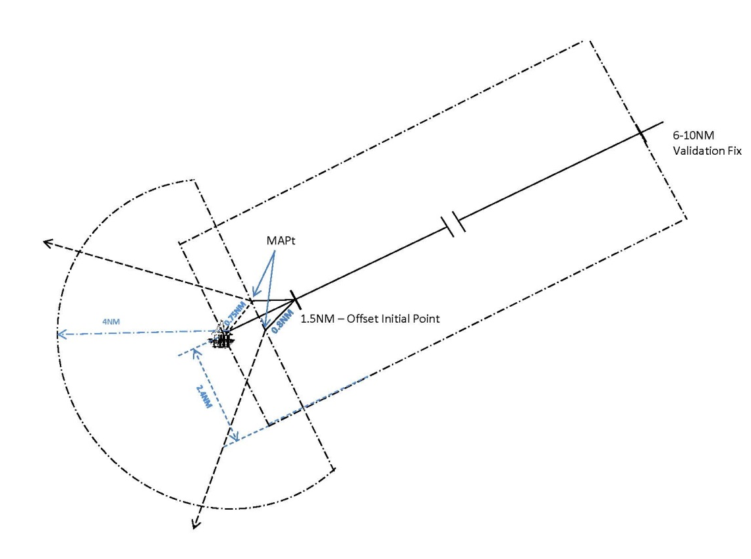
Figure 8-22: Plan – Final and Missed Approach – direct and overhead approaches
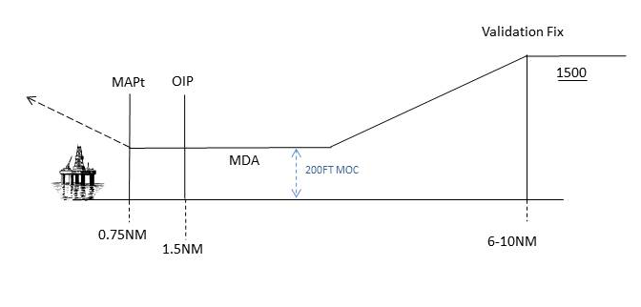
Figure 8-23: Elevation — direct approach

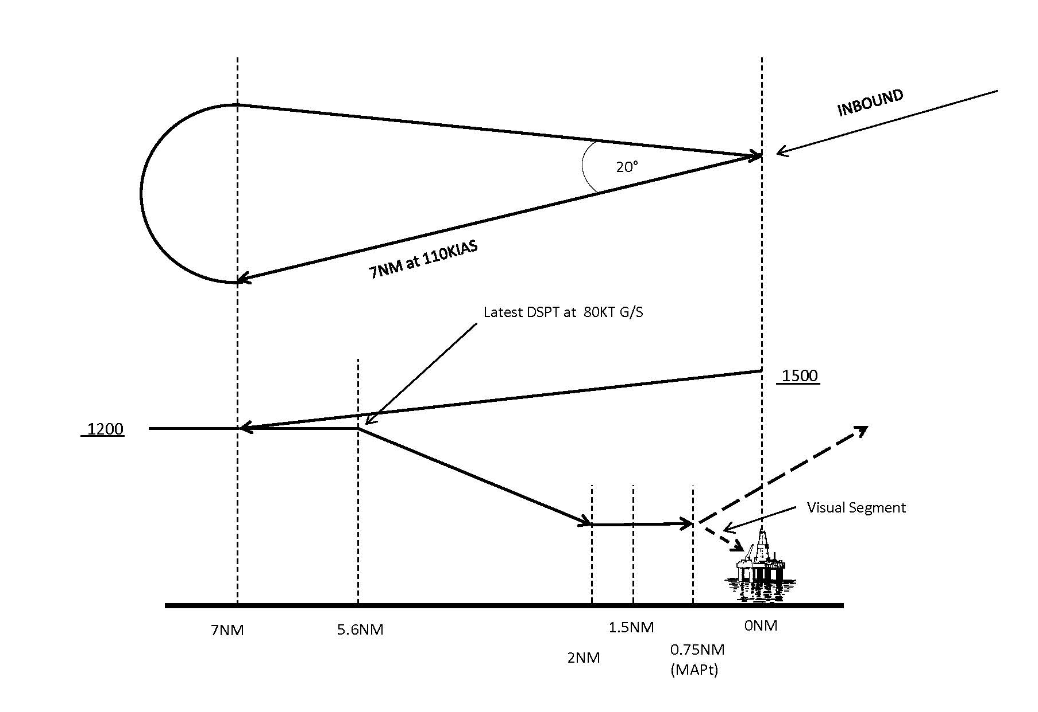
Figure 8-24: Plan and elevation — overhead approach

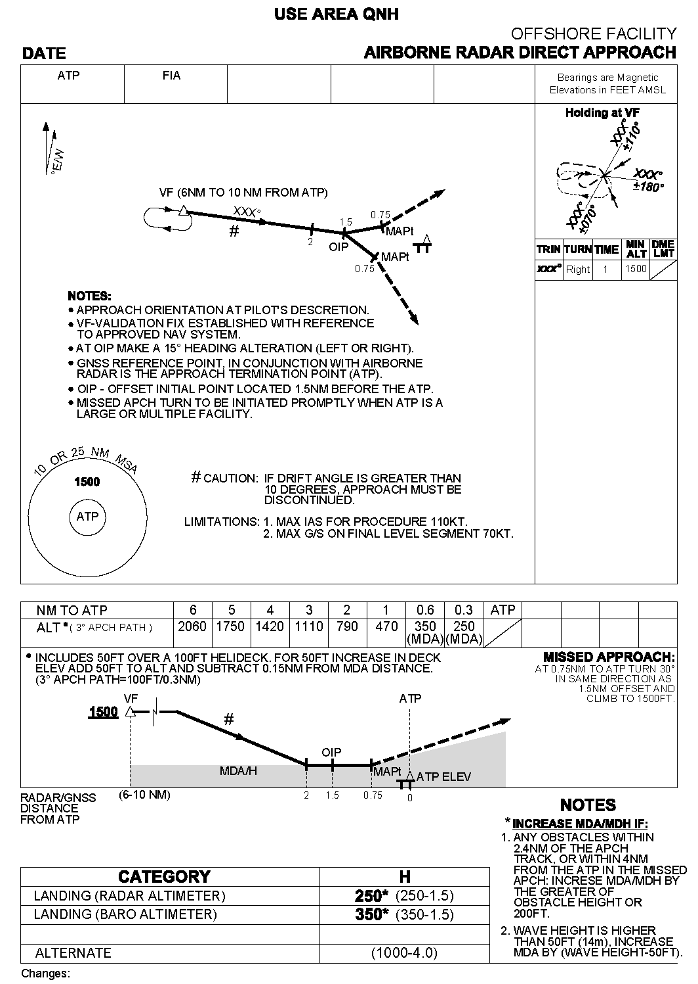
Figure 8-25: Offshore facility — direct airborne radar approach
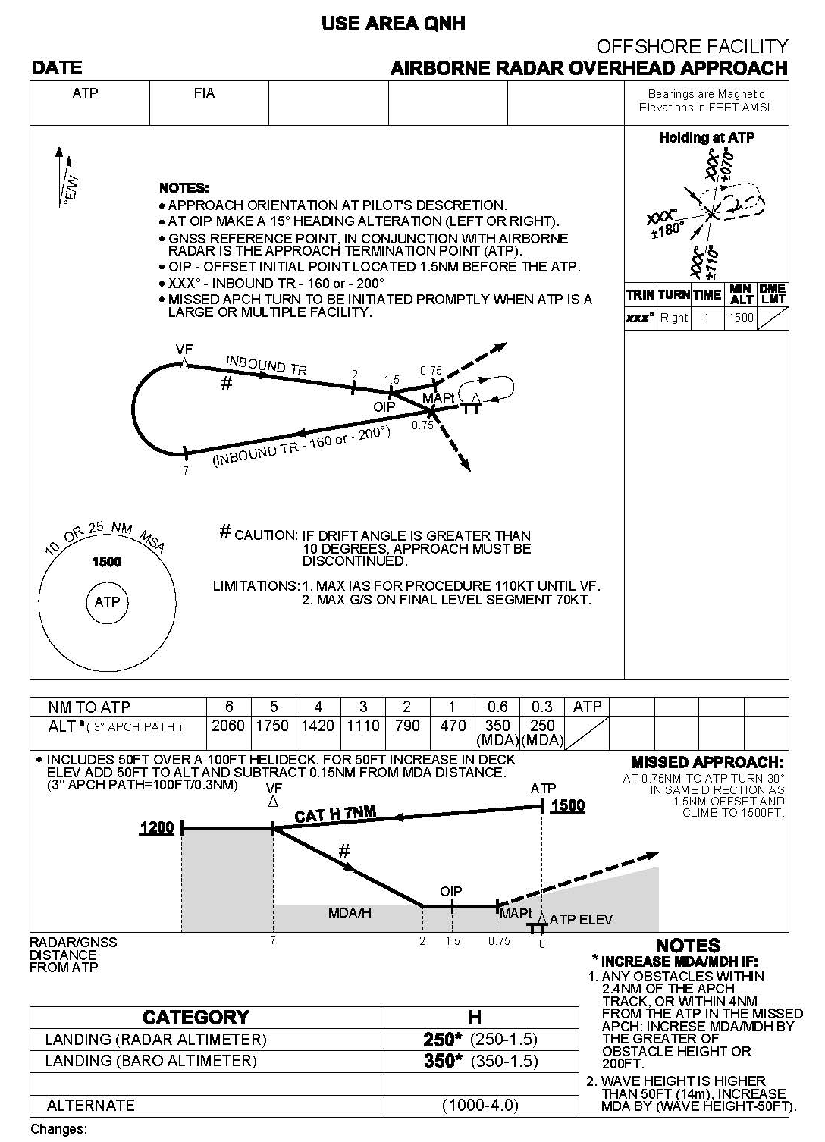
Figure 8-26: Offshore facility — overhead airborne radar approach
Appendix 2 Calculation of a holding area/land overlap in direct approach procedures
The relocation distance for the VF is:
VF_{A} = ATP - VF_{I} - Hold_{SL}
Where:
VF_{A} = relocation distance of the VF location (NM)
ATP = the ATP track distance from land (NM)
VF_{I} = Initial VF distance from ATP (10 NM)
Hold_{SL} = simplified length of the holding pattern (9.1 NM).
The VF is relocated towards the ATP by the amount of VFA, as limited by the 10 NM to 6 NM window.
Example 1: ATP = 15 NM
VF_{I} = 10 NM
Hold_{SL} = 9.1 NM
VF_{A} = 15 - 10 - 9.1 = - 4.1 NM (i.e.; a 4.1 NM overlap).
However, the maximum adjustment for the VF is 4 NM. Therefore, the holding area will overlap land by 0.1 NM.
Example 2: ATP = 21 NM
VF_{I} = 10 NM
Hold_{SL} = 9.1 NM
VF_{A} = 21 – 10 - 9.1 = 1.9 NM.
Therefore, there is a 1.9 NM clearance between land and the holding pattern.
Appendix 3 Determination of obstacle avoidance
Note 1 See paragraph 8.6.12.1 (c) and paragraph 8.6.13.
Note 2 Calculation of the minimum visual segment visibility is based on paragraph 157 (3) (b) of CAR 1988 to avoid obstacles by 300 m horizontally.
Data
Obstacle avoidance (regulation 157 of CAR 1988) | 300 m
Obstacle recognition | 6 sec + 150 m
Bank establishment (sec) | 5
Bank angle | Rate one turn to 170 kt TAS, thence 25°angle of bank
Wind (kt) | 47 + 2H  (where H = altitude/1 000)
TAS (kt) | Maximum TAS permitted at ISA + 15°C.
Calculation
Obstacle avoidance | 300 m | = A
Turn radius (m) (for calculation see PANS-OPS –  Principles for Turn Area Construction) |  | = B
Recognition and bank establishment distance (m)  11sec x (TAS + [47+2H]) x 0.51 + 150 m |  | = C
Turn point to obstacle distance (m)  ((A + B)² - B²)½ |  | = D
∴ Visibility required (m) | = C + D

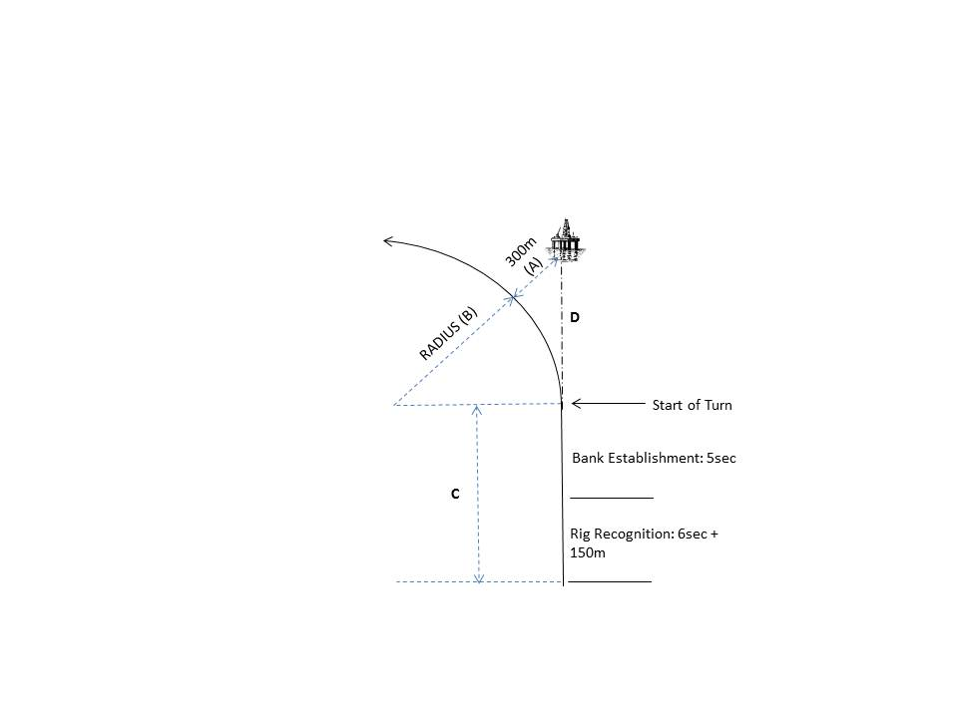
Figure 8-27: Determination of obstacle avoidance distance
[8] Section 8.7
omit
[9] Section 8.8, the heading
substitute
Section 8.8: Helicopter procedures — GNSS/NPAs
[10] Paragraph 8.8.1
substitute
8.8.1 Application
8.8.1.1 A certified designer may design the instrument approach and landing procedures mentioned in this section for helicopter point-in-space (PinS) operations, provided the procedures are only for operators approved by CASA.
8.8.1.2 The instrument approach and landing procedures in Part IV of PANS-OPS for helicopter PinS RNP APCH approach procedures may be used as an alternative to the instrument approach and landing procedures mentioned in this section.
[11] Paragraph 8.8.2.1
substitute
8.8.2.1 Helicopter procedures under this section are:
(a) classified as specialised helicopter operations; and
(b) must be annotated, in the header and footer, with the following words in upper case bold font: FOR USE BY CASA-APPROVED OPERATORS ONLY.
[12] Paragraph 8.8.2.2
substitute
The use of the specialised helicopter procedures is limited to CASA-approved operators only.
Note The CASA Area Office forwards to the Manager, CNS/ATM, copies of the relevant parts of each prospective operator’s operations manual. The Manager provides operators with an approval for each TIFP, in accordance with Part 173 of CASR 1998 and this MOS. CNS/ATM also maintains a register of operators authorised to use the procedures, and holds the relevant part of the operators’ operations manuals.
[13] Paragraphs 8.8.2.3, 8.8.2.4 and 8.8.2.5
omit
[14] Paragraph 8.8.4.8
substitute
8.8.4.8 The missed approach criteria detailed in PANS-OPS are modified to take account of the VAA-H.
[15] Paragraph 8.8.5.1
omit
(see Figure 8-30)
insert
(see Figure 8-28)
[16] Paragraph 8.8.5.1, title of Figure 8-30
substitute
Figure 8-28: Visual approach area — helicopter
[17] Paragraph 8.8.7.1
omit
(see Figure 8-31)
insert
(see Figure 8-29)
[18] Paragraph 8.8.7.1, title of Figure 8-31
substitute
Figure 8-29: Turning missed approach
[19] Paragraph 8.8.7.2
omit
(see Figure 8-32)
insert
(see Figure 8-30)
[20] Paragraph 8.8.7.2, title of Figure 8-32
substitute
Figure 8-30: Straight missed approach
[21] Paragraph 8.8.7.3
omit
(see Figure 8-31)
insert
(see Figure 8-29)

