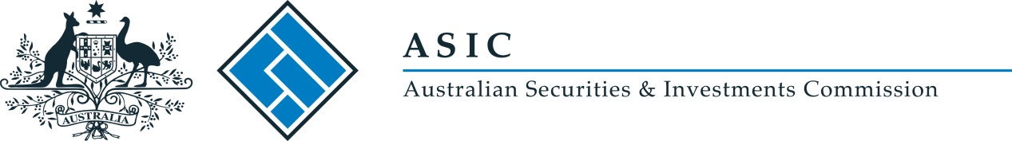
ASIC Credit (Charities) Instrument 2017/64
I, Stephen Yen PSM, delegate of the Australian Securities and Investments Commission, make the following legislative instrument.
Date: 2 February 2017

Stephen Yen

Contents
Part 1—Preliminary 3
1 Name of legislative instrument 3
2 Commencement 3
3 Authority 3
4 Definitions 3
Part 2—Declaration 3
5 Persons exempt from holding a licence when engaging in credit activities for a charitable purpose 3

Part 1—Preliminary

1 Name of legislative instrument
This is the ASIC Credit (Charities) Instrument 2017/64.

2 Commencement
This instrument commences on the day after it is registered on the Federal Register of Legislation.
Note: The register may be accessed at www.legislation.gov.au.

3 Authority
This instrument is made under paragraph 109(3)(d) of the National Consumer Credit Protection Act 2009.

4 Definitions
In this instrument:
Act means the National Consumer Credit Protection Act 2009.
Regulations mean the National Consumer Credit Protection Regulations 2010.

Part 2—Declaration

5 Persons exempt from holding a licence when engaging in credit activities for a charitable purpose
The provisions to which Part 2-6 of the Act applies apply in relation to a person engaging in credit activities as if subparagraphs 20(12)(a)(i) and (ii) of the Regulations were each modified or varied by omitting “a charitable body (within the same meaning as in ASIC Class Order [CO 02/184])” and substituting “a charity (within the meaning of the Charities Act 2013) or a trustee of a charity”.

