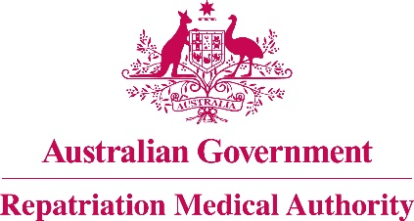

Amendment Statement of Principles

concerning

OTITIC BAROTRAUMA

No. 15 of 2017

for the purposes of the

Veterans’ Entitlements Act 1986
and
Military Rehabilitation and Compensation Act 2004
- This Instrument may be cited as Amendment Statement of Principles concerning otitic barotrauma No. 15 of 2017.
- The Repatriation Medical Authority amends, under subsection 196B(8) of the Veterans’ Entitlements Act 1986, Statement of Principles concerning otitic barotrauma Instrument No. 35 of 2012, by:
- Replacing the definition of "a change in the ambient barometric pressure as specified" in clause 9 with the following:
'"a change in the ambient barometric pressure as specified" means a significant and rapid reduction or increase in the pressure surrounding the person, including in such circumstances as:
- ascending from a submerged craft or device or a submarine escape training facility;
- decompression or compression in a hypobaric or hyperbaric chamber;
- flying;
- sky diving;
- underwater diving;
- working in a submarine; or
- working in a pressurised chamber or tunnel;'.
- The amendment made by this instrument applies to all matters to which Instrument No. 35 of 2012, section 120A of the Veterans’ Entitlements Act 1986 and section 338 of the Military Rehabilitation and Compensation Act 2004 apply.
- The amendment made by this instrument commences on 23 January 2017.
Dated this twentieth day of December 2016
The Common Seal of the )
Repatriation Medical Authority )
was affixed to this instrument )
at the direction of: )
PROFESSOR NICHOLAS SAUNDERS AO
CHAIRPERSON

