

Safety Zone Notice (Sea Installation – CETO 6) 2016

*Sea Installations Act 1987*

I, GREG HUNT, Minister for the Environment, make this notice under subsection 57(1) of the *Sea Installations Act 1987*.

Dated 04 May 2016

Greg Hunt

Minister for the Environment

1 Name of Notice

This is the *Safety Zone Notice (Sea Installation – CETO 6) 2016*.

2 Authority

This notice is made under subsection 57(1) of the *Sea Installations Act 1987*.

3 Commencement

(1) Sections 1 to 4 and Schedule 1 commence at the start of the day after the day the instrument is registered.

(2) Subsection 5(1) commences on a day fixed by the Minister, or an SES employee in the Department of the Environment, by notifiable instrument.

(3) Subsection 5(2) commences on a day fixed by the Minister, or an SES employee in the Department of the Environment, by notifiable instrument and remains in effect for a period of 5 weeks beginning on that day.

**4 Definitions**

***CETO 6 Site*** means the site represented by the area within points L to O on the plan in Schedule 1 together with the area extending to a distance of 25 metres either side of the line joining points P to K (the export cable).

***exempt vessels*** means:

(a) vessels owned or operated by the licensee or its nominees or agents, or

(b) vessels owned or operated by the Commonwealth or its nominees or agents.

*Note:* The licence limits the circumstances in which the Commonwealth or its nominees or agents may access the safety zones prescribed in this notice.

***export cable*** means the export cable to be attached to the CETO 6 wave energy devices and extending to the State coastal water boundary.

***licence*** means the licence granted by the Commonwealth for the construction and operation of a wave energy plant at the CETO 6 (Garden Island) Site.

***licensee*** means the holder of the licence.

***Sea Installation*** means the array of CETO 6 wave energy devices, including the buoyant actuators, tethers, foundations, junction boxes and umbilical cables, and the export cable.

***Safety Zone (Export Cable)*** means the zone extending to a distance of 250 metres either side of the line joining points E to K (the export cable) represented in the plan in Schedule 1 and associated table.

***Safety Zone (Wave Energy Plant)*** means the zone represented by the area within points A to D in the plan in Schedule 1 and associated table.

5 Safety Zones

(1) For the purposes of protecting the Sea Installation, all vessels, other than exempt vessels, are prohibited from entering or remaining in the Safety Zone (Wave Energy Plant).

(2) For the purposes of protecting the Sea Installation, all vessels, other than exempt vessels, are prohibited from entering or remaining in the Safety Zone (Export Cable).

*Note:* Vessels may enter or remain in a specified safety zone with the consent in writing of the Minister: see section 57(1) of the *Sea Installations Act 1987*.

**Schedule 1**

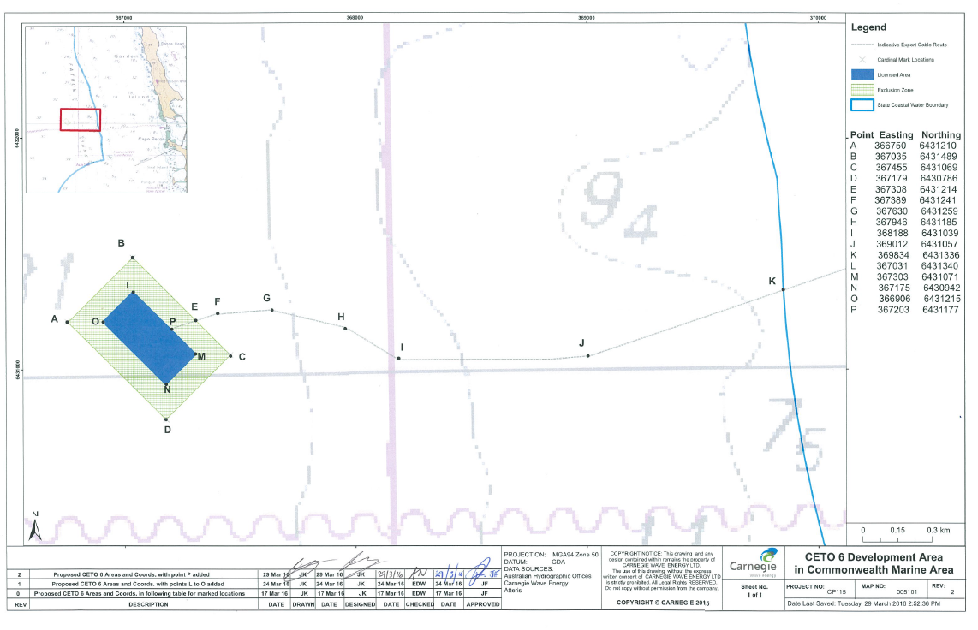

| **Point** | **Description** | **Easting  (GDA‑MGA94, z50)** | **Northing  (GDA‑MGA94, z50)** | **Latitude (WG S84)** | **Longitude (WG S84)** |
| --- | --- | --- | --- | --- | --- |
| **I. Corner points of boundary of Safety Zone (Wave Energy Plant)** | | | | | |
| A | Cardinal Mark, West corner of Licensed Area | 366750 | 6431210 | -32.2479 | 115.5855 |
| B | Cardinal Mark, North corner of Licensed Area | 367035 | 6431489 | -32.2454 | 115.5886 |
| C | Cardinal Mark, East corner of Licensed Area | 367455 | 6431069 | -32.2492 | 115.593 |
| D | Cardinal Mark, South corner of Licensed Area | 367179 | 6430786 | -32.2518 | 115.59 |
| **II. Licensed Area (corner points of boundary of location within which CETO 6 Units, umbilical cables, junction box, part of export cable can be installed and deployed)** | | | | | |
| L | Implementation Zone, North point | 367031 | 6431340 | -32.2492 | 115.5885 |
| M | Implementation Zone, East point | 367303 | 6431071 | -32.2492 | 115.5914 |
| N | Implementation Zone, South point | 367175 | 6430942 | -32.2504 | 115.5900 |
| O | Implementation Zone, West point | 366906 | 6431215 | -32.2479 | 115.5872 |
| **III. Reference points to determine the Safety Zone (Export Cable)** | | | | | |
| E | Intersection of export cable and line between Points B and C | 367308 | 6431214 | -32.2479 | 115.5914 |
| F | Point along export cable | 367389 | 6431241 | -32.2477 | 115.5923 |
| G | Point along export cable | 367630 | 6431259 | -32.2475 | 115.5949 |
| H | Point along export cable | 367946 | 6431185 | -32.2483 | 115.5982 |
| I | Point along export cable | 368188 | 6431039 | -32.2496 | 115.6008 |
| J | Point along export cable | 369012 | 6431057 | -32.2495 | 115.6095 |
| K | Intersection of export cable and WA Border | 369834 | 6431336 | -32.2471 | 115.6183 |