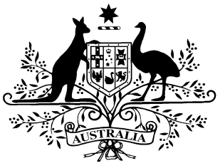
Student Identifiers (Exemptions) Amendment Instrument 2016

Student Identifiers Act 2014

I, Karen Andrews, Assistant Minister for Vocational Education and Skills, make the following instrument under subsection 53(3) of the Student Identifiers Act 2014.

Dated 14 December 2016

The Hon Karen Andrews MP
Assistant Minister for Vocational Education and Skills

1 Name of instrument
This instrument is the Student Identifiers (Exemptions) Amendment
Instrument 2016.
2 Commencement
This instrument commences on the day after it is registered.
3 Authority
The Student Identifiers (Exemptions) Amendment Instrument 2016 is made under subsection 53(3) of the Student Identifiers Act 2014.

4 Amendment to the Student Identifiers (Exemptions) Instrument 2014
The Student Identifiers (Exemptions) Instrument 2014 (F2014L01754) is amended, as set out in Schedule 1.

Schedule 1 - Amendments
- Part 2, subsection 6(4)
Omit “2017” and replace “2018”.

