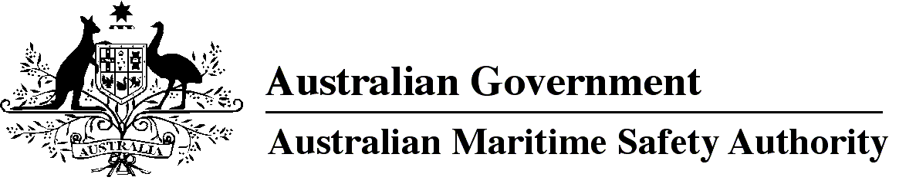

AMSA MO 2016/14

Marine Order 97 (Marine pollution prevention — air pollution) Amendment 2016 (No. 1)

I, Michael Kinley, Chief Executive Officer of the Australian Maritime Safety Authority, make this Order under subsection 342(1) of the *Navigation Act 2012* and subsection 34(1) of the *Protection of the Sea (Prevention of Pollution from Ships) Act 1983*.

1 November 2016

Michael Kinley  
Chief Executive Officer

1 Name of Order

This Order is *Marine Order 97 (Marine pollution prevention — air pollution) Amendment 2016 (No. 1)*.

2 Commencement

This Order commences on 1 December 2016.

3 Amendment of *Marine Order 97 (Marine pollution prevention — air pollution) 2013*

Schedule 1 amends *Marine Order 97 (Marine pollution prevention — air pollution) 2013.*

Schedule 1 Amendment

[1] Section 6, note 1

substitute

*Note 1*Some terms used in this Order are defined in *Marine Order 1 (Administration) 2013* including:

* IMO
* MARPOL
* Navigation Act
* Pollution Prevention Act.

[2] Section 6, after note 3

insert

*Note 4*Information on obtaining copies of any IMO Resolution, IMO document or other document that is mentioned in this Order is available from the AMSA website Marine Orders link at http://www.amsa.gov.au.

[3] Section 9

substitute

9 Equivalents and waivers

(1) A person may apply, in accordance with the application process set out in *Marine Order 1 (Administration) 2013,* for approval to use an equivalent.

(2) AMSA may approve the use of an equivalent if:

(a) it would be at least as effective as compliance with the requirement to which the equivalent is an alternative; and

(b) approving the use of the equivalent would not contravene regulation 4 of Annex VI.

*Note   Marine Order 1 (Administration) 2013* deals with the following matters about equivalents:

* making an application
* seeking further information about an application
* the time allowed for consideration of an application
* imposing conditions on approval of an application
* notifying a decision on an application
* review of decisions.

(3) AMSA may give a waiver in accordance with regulation 19 of Annex VI from a requirement of the Order.

[4] Section 22, note, paragraph (b)

omit

*Standard specification for shipboard incinerators* adopted by IMO Resolution MEPC.76(40)

insert

*2014 Standard specification for shipboard incinerators* adopted by IMO Resolution MEPC.244(66)

[5] Section 26, note

omit

section 13A of *Marine Order 31 (Ship surveys and certification) 2006*

insert

section 48 of *Marine Order 31 (Vessel surveys and certification) 2015*

[6] Section 27, note

omit

*2012 Guidelines on the method of calculation of the Attained Energy Efficiency Design Index (EEDI) for new ships* adopted by IMO Resolution MEPC.212(63)

insert

*2014 Guidelines on the method of calculation of the attained Energy Efficiency Design Index (EEDI) for new ships* adopted by IMO Resolution MEPC.245(66)

[7] Paragraphs 31(2)(a) and (b)

omit

2009

insert

2015

[8] Paragraph 31(3)(b)

omit

2009

insert

2015

[9] Subsection 31(4)

omit

***2009 Guidelines*** means *2009 Guidelines for exhaust gas-SOx cleaning systems* adopted by IMO Resolution MEPC.184(59)

insert

***2015 Guidelines*** means *2015 Guidelines for exhaust gas cleaning systems* adopted by IMO Resolution MEPC.259(68)

[10] Subsection 34(2), note

omit

http://www.amsa.gov.au/forms

insert

http://www.amsa.gov.au

[11] Subsection 34(3), note

omit

http://www.amsa.gov.au/forms

insert

http://www.amsa.gov.au

[12] Further amendments

|  |  |  |
| --- | --- | --- |
| provision | omit each mention of | insert |
| Section 6, note 2 | 2011 | 2013 |
| Section 11 | 2011 | 2013 |
| Subsection 22(6) | 2011 | 2013 |
| Subsection 37(2) | 2011 | 2013 |

**Note**

1. All legislative instruments and compilations of legislative instruments are registered on the Federal Register of Legislation under the *Legislation Act 2003.* See https://www.legislation.gov.au.