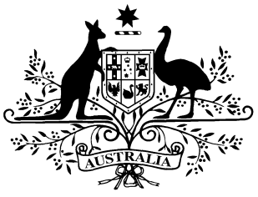

PB 87 of 2016

National Health (Growth Hormone Program) Special Arrangement Amendment Instrument 2016 (No. 1)

*National Health Act 1953*

I, KAREN HALL, Acting Assistant Secretary, Pharmaceutical Access Branch, Pharmaceutical Benefits Division, Department of Health, delegate of the Minister for Health, make this Instrument under subsection 100(2) of the *National Health Act 1953*.

Dated 28 SEPTEMBER 2016

KAREN HALL

Acting Assistant Secretary

Pharmaceutical Access Branch

Pharmaceutical Benefits Division

Department of Health

1 Name of Instrument

(1) This Instrument is the *National Health (Growth Hormone Program) Special Arrangement Amendment Instrument 2016 (No.1).*

(2) This Instrument may also be cited as PB 87 of 2016.

2 Commencement

This Instrument commences on 1 October 2016.

3 Amendment of PB 85 of 2015

Schedule 1 amends the *National Health (Growth Hormone Program) Special Arrangement 2015* (PB 85 of 2015).

Schedule 1 Amendments

1. Schedule 1, entry for Somatropin

*omit:*

Somatropin Injection 0.6 mg (1.8 i.u.) with diluent in single use syringe (without preservative) Injection Genotropin MiniQuick D(100)

*insert:*

Somatropin Injection 0.4 mg (1.2 i.u.) with diluent in single use syringe (without preservative) Injection Genotropin MiniQuick D(100)

Injection 0.6 mg (1.8 i.u.) with diluent in single use syringe (without preservative) Injection Genotropin MiniQuick D(100)