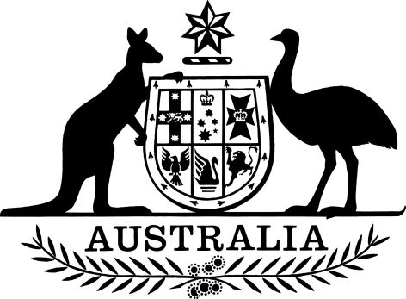

Continence Aids Payment Scheme Amendment 2016
I, Sussan Ley, Minister for Aged Care, make this Instrument under section 12 of the National Health Act 1953.
Dated 18th June 2016
Sussan Ley
Minister for Aged Care

Contents
1 Name 1
2 Commencement 1
3 Authority 1
4 Schedules 1
Schedule 1—Amendments 2
Contienence Aids Payment Scheme Amendment 2016 2

1 Name
This instrument is the Continence Aids Payment Scheme Amendment 2016.

2 Commencement
This instrument commences on 1 July 2016.

3 Authority
This instrument is made under the National Health Act 1953.

4 Schedules
Each instrument that is specified in a Schedule to this instrument is amended or repealed as set out in the applicable items in the Schedule concerned, and any other item in a Schedule to this instrument has effect according to its terms.

Schedule 1—Amendments

Continence Aids Payment Scheme 2010

1 Subsection 9(1)
Repeal the subsection, substitute:
(1) The amount of the CAPS payment for a financial year is $572.30.

