EXPLANATORY STATEMENT

Tertiary Education Quality and Standards Agency Act 2011 - Determination of Fees (Amendment) No. 1 of 2016

Issued by the authority of the Tertiary Education Quality and Standards Agency (TEQSA)

Subject: Tertiary Education Quality and Standards Agency Act 2011 - Determination of Fees (Amendment) No. 1 of 2016

Authority

Subsection 158(1) of the Tertiary Education Quality and Standards Agency Act 2011 (the Act) allows TEQSA to determine, by legislative instrument, fees that TEQSA may charge for things done in the performance of its functions.

Purpose and operation

The purpose of the instrument is to amend Determination of Fees No. 3 of 2013 to provide for the fees payable for applications for registration and renewal of registration under the Education Services for Overseas Students Act 2000 (ESOS Act). The amendment is necessary as a result of amendments to the ESOS Act made by the Education Services for Overseas Students Amendment (Streamlining Regulation) Act 2015 which commence on 1 July 2016.

The amendment made by this instrument provides that the same fee will be payable for applications for registration or renewal of registration as is currently payable under the ESOS Act for the equivalent applications to TEQSA in its capacity as a designated authority.

The Australian Government has previously decided that TEQSA is to function on a cost recovery basis for certain activities. The determination of the fees is based on TEQSA’s estimate of the costs associated with particular activities, such as staff time, travel and associated costs, and considering historic comparative data and modelling of future costs, and considering historic comparative data and modelling of future costs. TEQSA also considered the fees charged by other agencies, including the state and territory accrediting authorities and the former Australian Universities Quality Agency. The 2016-17 Budget includes a measure for the Department of Education and Training to undertake a review of TEQSA’s cost recovery arrangements. Accordingly, the fee amended by this instrument will be considered as part of that review.

TEQSA has responsibility for a broader range of activities than predecessor agencies and has therefore taken a different approach to structuring its fees. TEQSA will only charge for certain activities. Activities including compliance, monitoring and enforcement will not attract a fee. Nor are there any annual charges required to be paid to TEQSA such as those that may have been charged previously by the state and territory authorities (providers registered on CRICOS will also need to pay an annual registration charge under the Education Services for Overseas Students (Registration Charges) Act 1997.

Description of the provisions
Item 1 of the Schedule to the Instrument amends Item 8 of the Table in Schedule A to Determination of Fees No. 3 of 2013. The amendment provides that the fee for applications under ss 9 and 10D of the Education Services for Overseas Students Act is $5,000.

Consultation

TEQSA previously consulted in relation to the development of the Determination of Fees No. 1 of 2012 and details of the consultation arrangements undertaken are set out in the explanatory statement to that instrument.

Given that the only amendment made by the instrument is to retain the existing fee for a provision being amended by the Education Services for Overseas Students Amendment (Streamlining Regulation) Act 2015, TEQSA did not consider it necessary to undertake further consultations. Consistent with the requirement in subsection 158(5) of the TEQSA Act, the Minister for Education and Training gave written approval to the making of the instrument.

The higher education sector and other stakeholders will be fully consulted as part of the review of TEQSA’s cost recovery arrangements, noted above.

Commencement

This Determination is a legislative instrument for the purposes of the Legislation Act 2003 and will commence on 1 July 2016.
Statement of Compatibility with Human Rights
Prepared in accordance with Part 3 of the Human Rights (Parliamentary Scrutiny) Act 2011

Tertiary Education Quality and Standards Agency Act 2011 - Determination of Fees (Amendment) No. 1 of 2016

This Legislative Instrument is compatible with the human rights and freedoms recognised or declared in the international instruments listed in section 3 of the Human Rights (Parliamentary Scrutiny) Act 2011.

Overview of the Legislative Instrument
The purpose of the instrument is to amend Determination of Fees No. 3 of 2013, which determines the fees charged by TEQSA for things done in the performance of its functions.

Human rights implications
This Legislative Instrument does not engage any of the applicable rights or freedoms.

Conclusion
This Legislative Instrument is compatible with human rights as it does not raise any human rights issues.

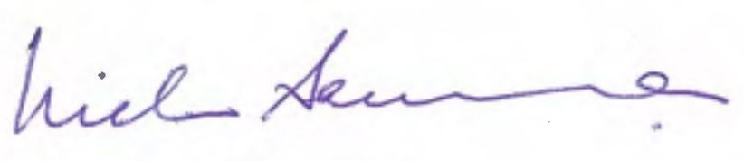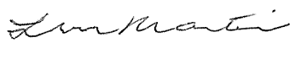
_______________________ _______________________
Professor Nicholas Saunders AO Linley Martin
Chief Commissioner Commissioner

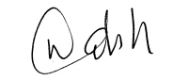
________________________
Emeritus Professor Cliff Walsh
Commissioner

Tertiary Education Quality and Standards Agency

