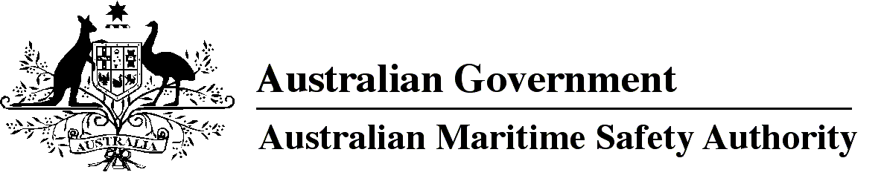

AMSA MO 2016/8

Marine Order 25 (Equipment — lifesaving) Amendment 2016 (No. 1)

I, Michael Kinley, Chief Executive Officer of the Australian Maritime Safety Authority, make this Order under subsection 342(1) of the *Navigation Act 2012*.

14 June 2016

**Michael Kinley**

Chief Executive Officer

1 Name of Order

This Order is *Marine Order 25 (Equipment — lifesaving) Amendment 2016 (No. 1)*.

2 Commencement

This Order commences on 1 July 2016.

3 Amendment of *Marine Order 25 (Equipment — lifesaving) 2014*

Schedule 1 amends *Marine Order 25 (Equipment — lifesaving) 2014*.

Schedule 1 Amendment

[1] Paragraph 2(a)

after

to

insert

parts of

[2] Section 12

omit

III.

insert

III other than Regulations 8, 19, 27, 29, 30 and 37.

[3] Section 12, note

after

Code.

insert

*Marine Order 21 (Safety and emergency arrangements) 2016* gives effect to Regulations8, 19, 27, 29, 30 and 37 of Chapter III for foreign vessels.

[4] Section 24

omit

III.

insert

III other than Regulations 8, 19, 27, 29, 30 and 37.

[5] Section 24, note

after

Code.

insert

*Marine Order 21 (Safety and emergency arrangements) 2016* gives effect to Regulations8, 19, 27, 29, 30 and 37 of Chapter III for regulated Australian vessels.

[6] Section 45

substitute

45 Lifesaving signals

The vessel must have a copy on waterproof card or in a waterproof container of the lifesaving signals mentioned in the *Table of Life-saving Signals* in Appendix 3 to the latest edition of the *International Code of Signals*, published by the IMO.

*Note*   At 1 July 2016, the latest edition of the *International Code of Signals* was the 4th edition published in 2005.

[7] Schedule 1, clause 6

omit

**Note**

1. All legislative instruments and compilations of legislative instruments are registered on the Federal Register of Legislation under the *Legislation Act 2003.* See https://www.legislation.gov.au.