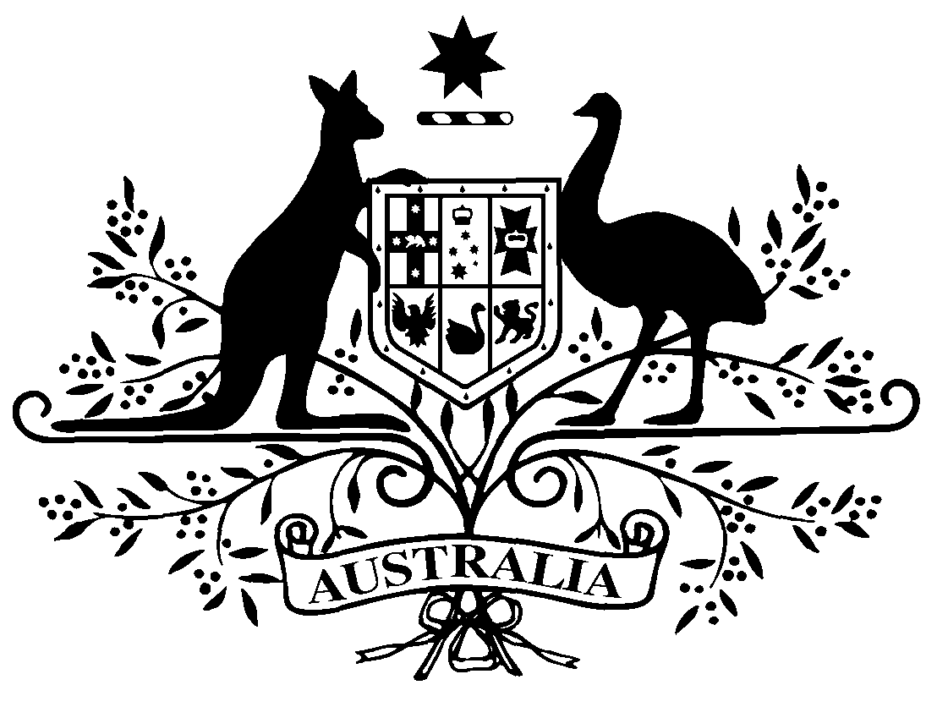

PB 40 of 2016
National Health (Remote Aboriginal Health Services Program) Special Arrangements Amendment Instrument 2016 (No. 2)

National Health Act 1953
___________________________________________________________________________

I, JULIANNE QUAINE, Assistant Secretary, Pharmaceutical Access Branch, Department of Health, delegate of the Minister for Health, make this Amendment Instrument under subsections 100(1) and 100(2) of the National Health Act 1953.
Dated 7 June 2016

JULIANNE QUAINE
Assistant Secretary
Pharmaceutical Access Branch
Pharmaceutical Benefits Division
Department of Health
___________________________________________________________________________

1 Name of Instrument

- This Instrument is the National Health (Remote Aboriginal Health Services Program) Special Arrangements Amendment Instrument 2016 (No. 2).

- This Instrument may also be cited as PB 40 of 2016.

2 Commencement
This Instrument commences on 1 July 2016.
3 Amendment to PB 65 of 2010
Schedule 1 amends the National Health (Remote Aboriginal Health Services Program) Special Arrangements Instrument (PB 65 of 2010).

Schedule 1 Amendment
- Paragraph 9(c)
omit:
$2.92
substitute:
$2.96

Note
All legislative instruments and compilations are registered on the Federal Register of Legislative Instruments kept under the Legislative Instruments Act 2003. See http://www.comlaw.gov.au.

