**EXPLANATORY STATEMENT**

Issued by the authority of the Attorney‑General

*Seas and Submerged Lands Act 1973*

*Seas and Submerged Lands (Territorial Sea Baseline) Proclamation 2016*

Section 7 of the *Seas and Submerged Lands Act 1973* (the Act) provides that the Governor‑General may from time to time by proclamation declare, not inconsistently with section 2 of Part II of the United Nations Convention on the Law of the Sea [Australian Treaty Series 1994 No 31] (the Convention), either or both of the breadth of the territorial sea, and the baselines from which the breadth of the territorial sea or any part of it is to be measured.

The *Seas and Submerged Lands (Territorial Sea Baseline) Proclamation 2016* (the Proclamation) repeals a previous proclamation made in 2006, which declared Australia’s territorial sea baselines and is subject to the sunsetting provisions of the *Legislation Act 2003*. The Proclamation replicates the substance of the previous proclamation and is not intended to effect any substantive changes to the baselines defined in that proclamation.

The Proclamation declares Australia’s territorial sea baselines using the Geocentric Datum of Australia, which is the coordinate reference system currently used in Australia for all spatial information.

A map depicting the straight baselines drawn pursuant to the Proclamation and to the *Seas and Submerged Lands (Historic Bays) Proclamation 2016*, so far as scale permits, is at Attachment A.

The Proclamation defines the territorial sea baseline as the low-water line along the coast except where the Convention enables straight baselines to be drawn sea‑ward of the coast so as to enclose bays or the mouths of rivers, and in cases where there is a fringe of islands along the coast, or the coast line is deeply indented and cut into.

Sections 6 to 13 of the Proclamation set out rules for determining the baselines, consistent with section 2 of Part II of the Convention. Schedule 1 defines the Geocentric Datum of Australia, which is the basis for determining positions on the surface of the earth used in the Proclamation, subject to an exception relating to Macquarie Island. In relation to Macquarie Island, the Proclamation provides for positions to be determined in accordance with the International Terrestrial Reference Frame 2000 as defined by the International Earth Rotation Service at epoch 1 January 2000. Schedule 2 sets out the geographic coordinates along the coast between which straight baselines may be drawn.

The Proclamation does not apply to certain islands forming part of the State of Queensland as the baselines and territorial seas for them are the subject of the Treaty between Australia and the Independent State of Papua New Guinea concerning Sovereignty and Maritime Boundaries in the area between the two Countries, including the area known as Torres Strait, and Related Matters [Australian Treaty Series 1985 No 4].

Details of the Proclamation are set out in Attachment B.

The Proclamation is a legislative instrument for the purposes of the *Legislation Act 2003*.

No public consultation was undertaken in relation to the Proclamation, as it merely makes minor changes to a previous proclamation.

The Proclamation commences the day after it is registered in the Federal Register of Legislative Instruments.

**Attachment A**

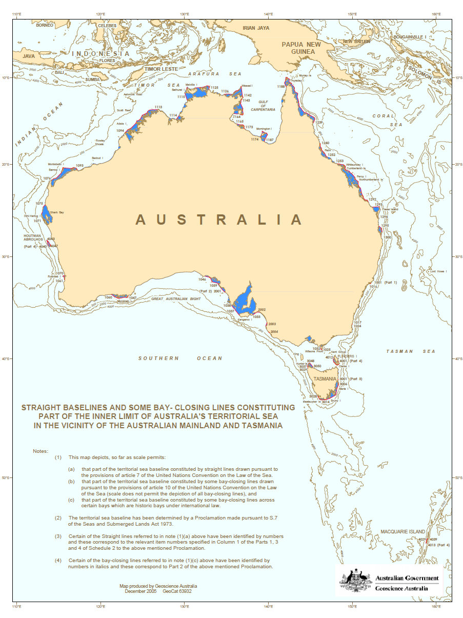

**Attachment B**

**Details of the *Seas and Submerged Lands (Territorial Sea Baseline) Proclamation 2006***

Section 1 – Name

Section 1 gives the name of the Proclamation as the *Seas and Submerged Lands (Territorial Sea Baseline) Proclamation 2016*.

Section 2 - Commencement

Section 2 provides that the Proclamation commences the day after it is registered on the Federal Register of Legislative Instruments.

Section 3 – Authority

Section 3 confirms that the instrument is made under section 7 of the *Seas and Submerged Lands Act 1973* (the Act).

Section 4 – Schedules

Section 4 has the effect of revoking the *Seas and Submerged Lands (Territorial Sea Baseline) Proclamation 2006*, which is referred to in Schedule 3. Section 4 also clarifies that the other items in the Schedules have effect according to their terms.

Section 5 – Definitions

Subsection 5(1) defines particular terms that are used in the Proclamation as follows:

“Act” means the *Seas and Submerged Lands Act 1973*;

“area of the indentation” means the area lying between the low-water mark around the shore of the indentation and a line joining the low-water marks of its natural entrance points, and includes the area of any island within the indentation as if it were part of the water area;

“baseline of the mainland”, in relation to a State or the Northern Territory, means:

(a) for a State (other than Tasmania) or the Northern Territory—the line determined in accordance with sections 7, 10, 11 and 12; or

(b) for Tasmania—the line determined in accordance with sections 8, 10, 11 and 12;

“bay” has the meaning given by section 6;

“Geocentric Datum of Australia” means the datum described in Schedule 1;

“historic bay” means a bay that is declared by an instrument under paragraph 8(a) of the Act to be an historic bay;

“low-tide elevation” has the same meaning as in Article 13 of the Convention;

“low-water” means lowest astronomical tide;

“mile” means an international nautical mile, being 1 852 metres; and

“straight line” means a geodesic line.

Article 11 of the Convention specifies that the outermost permanent harbour works which form an integral part of a harbour system are to be regarded as forming part of the coast. Subsection 5(2) reflects this position.

Paragraph 4 of article 7 of the Convention specifies that, with limited exception, straight baselines cannot be drawn from a low-tide elevation unless there is a lighthouse or other structure erected on it that is permanently above water. Subsection 5(3) of the Proclamation makes this rule applicable to straight baselines determined under the proposed Proclamation.

Paragraph 5(4)(b) has the effect that in general, for the purposes of the Proclamation, the position on the surface of the Earth of a point, line or area is to be determined by reference to the Geocentric Datum of Australia. Paragraph 5(4)(a) relates to the determination of spatial positions on Macquarie Island. In accordance with surveying practice, the datum for determining spatial positions on the Island is the International Terrestrial Reference Frame 2000 as defined by the International Earth Rotation Service at epoch 1 January 2000.

Section 6 – Bays

Section 6 describes indentations that are juridical bays for the purposes of article 10 of the Convention. Subsection 6(1) provides that an indentation is a bay if the distance between the low-water marks of the natural entrance points of the indentation does not exceed 24 nautical miles.

Subsection 6(2) provides than an indentation is not a bay if its area is less than that of a semi-circle the diameter of which is a line drawn across the mouth of the indentation. In the case of an indentation that because of the presence of islands has more than one mouth, it is not to be regarded as a bay if its area does not exceed that of a semicircle drawn on a line as long as the sum total of the lengths of the lines across the different mouths.

Section 7 – Baseline – mainland of Australia

Section 7 describes the baseline around the mainland from which the breadth of the adjacent territorial sea is to be measured. The baseline is the low-water mark on the coast except where, because of the regime of straight baselines, a baseline may enclose waters beyond the low-water mark. Where a river flows into the sea, the baseline would be a line drawn across the mouth of the river. In the case of a bay (other than an historic bay), the baseline is a line drawn between the low-water marks of the mouth. In both cases, if a straight baseline may be drawn beyond the mouth of the river or bay, then the outermost line is the baseline.

Paragraph 7(d) specifies that straight lines drawn between the two geographic coordinates mentioned in each item in Part 1 of Schedule 2 constitute the baselines. There are 300 straight baselines along the coast of the mainland. The regime of straight baselines set out in article 7 of the Convention permits them to be drawn in localities where the coastline is deeply indented and cut into, or where there is a fringe of islands along the coast in its immediate vicinity. Examples include an area around the Whitsunday Islands off the central coast of Queensland and the Archipelago of the Recherche, near Esperance, off the south coast of Western Australia.

Paragraph 7(e) provides for straight baselines to be drawn in respect of the four historic bays of South Australia: Anxious Bay; Encounter Bay; Lacepede Bay; and Rivoli Bay. The relevant coordinates are specified in Part 2 of Schedule 2.

Section 8 – Baseline – mainland of Tasmania

Section 8 makes provision for baselines around Tasmania in the same manner that section 7 does for mainland Australia. Thus the baseline is the low-water line along the coast, bay closing lines and lines across river mouths and, in other cases, straight baselines drawn between the geographic coordinates specified in each item of Part 3 of Schedule 2.

Section 9 – Baseline – islands off the coast of a State or the Northern Territory

Section 9 makes provision for baselines around the coast of islands forming part of a State or of the Northern Territory in the same manner that section 7 does for mainland Australia and section 8 does for Tasmania.

Section 10 – Low-tide elevations

Section 10 provides that where a low-tide elevation is situated at a distance not exceeding the breadth of the territorial sea from the mainland or an island, the baseline is to be the low-water line on the low-tide elevation. This is in accordance with article 13 of the Convention.

Section 11 – Low-water line of naturally formed area

Section 11 makes provision for where a straight baseline would pass through an area of land that is not submerged at any time. In such a case, the baseline between the points where the straight baseline intersects the coast is calculated as if the coast of that land were part of the mainland.

Section 12 – Low-water line of island

Section 12 makes the same provision with respect to islands as does section 11 with respect to naturally formed land areas, in relation to situations where straight baselines would pass over an area of land that is not submerged. In such a case, the low-water line of the sea-ward part of the coast of the island forms the baseline, as if the island were part of the mainland.

Section 13 – Excluded islands and excluded groups of islands

Section 13 provides that sections 9, 10, 11 and 12 do not apply in relation to Pearce Cay, Turnagain Island and Turu Cay, nor to the following groups of islands or islands within those groups:

* Aubusi, Boigu and Moimi;
* Dauan, Kaumag and Saibai;
* Anchor Cay and East Cay;
* Black Rocks and Bramble Cay; and
* Deliverance Island and Kerr Islet.

The territorial sea for these islands and groups of islands, which form part of the State of Queensland, is provided for in the Treaty between Australia and the Independent State of Papua New Guinea concerning Sovereignty and Maritime Boundaries in the area between the two Countries, including the area known as Torres Strait, and Related Matters [Australian Treaty Series 1985 No 4]. The inner limits and outer limits of parts of the territorial sea around certain islands in the Torres Strait are declared in a separate proclamation made under section 7 of the Act on 4 February 1983 and published in *Gazette* No. S 29 of 9 February 1983.

Schedule 1 – Geocentric Datum of Australia

The Geocentric Datum of Australia (GDA) is the coordinate reference system currently used in Australia.

Item 1 – Reference ellipsoid

The item specifies the reference ellipsoid.

Item 2 – Reference Frame

The item explains how the GDA is realised.

Schedule 2 – Straight baseline points under article 7 of the Convention

Schedule 2 consists of four parts describing the straight baseline points for mainland Australia (300 baselines between 600 points), the four historic bays of South Australia (7 straight baselines between 14 points), the coast of Tasmania, including Macquarie Island, (50 straight baselines between 100 points) and the islands off the coast of the States and the Northern Territory (47 straight baselines between 94 points).

**Statement of Compatibility with Human Rights**

*Prepared in accordance with Part 3 of the Human Rights (Parliamentary Scrutiny) Act 2011*

**Seas and Submerged Lands (Territorial Sea Baseline) Proclamation 2016**

This disallowable legislative instrument is compatible with the human rights and freedoms recognised or declared in the international instruments listed in section 3 of the *Human Rights (Parliamentary Scrutiny) Act 2011*.

**Overview of the disallowable legislative instrument**

The *Seas and Submerged Lands (Territorial Sea Baseline) Proclamation 2016* sets out the baselines by reference to which the breadth of Australia’s territorial sea is determined.

The Proclamation is made under section 7 of the *Seas and Submerged Lands Act 1973*. Under that provision, the Governor-General may declare the baselines of Australia’s territorial sea, provided this is done consistently with Section 2 of Part II of the United Nations Convention on the Law of the Sea, which sets out the principles according to which the limits of a State’s territorial sea are determined.

The Proclamation sets out rules for determining the baselines of Australia’s territorial sea consistently with the Convention. Schedule 2 to the Proclamation lists geographical coordinates that constitute straight baseline points for the purposes of article 7 of the Convention, which permits the drawing of straight baselines under particular geographical conditions.

**Human rights implications**

This disallowable legislative instrument does not engage any of the applicable rights or freedoms.

**Conclusion**

This disallowable legislative instrument is compatible with human rights as it does not raise any human rights issues.