**AIRWORTHINESS DIRECTIVE**

On the effective date specified below, and for the reasons set out in the background section, the CASA delegate whose signature appears below repeals Airworthiness Directive (***AD***) AD/EMY/2 Amdt 6 and issues the following AD under subregulation 39.001 (1) of CASR 1998 and subsection 33 (3) of the *Acts Interpretation Act 1901*. The AD requires that the action set out in the requirement section (being action that the delegate considers necessary to correct an unsafe condition) be taken in relation to the aircraft or aeronautical product mentioned in the applicability section: (a) in the circumstances mentioned in the requirement section; and (b) in accordance with the instructions set out in the requirement section; and (c) at the time mentioned in the compliance section.

### Emergency Equipment

|  |  |  |
| --- | --- | --- |
| AD/EMY/2 Amdt 7 | Life Jackets and Inflatable Flotation Devices | 5/2016 |

|  |  |
| --- | --- |
| Applicability: | All life jackets and inflatable flotation devices not subject to a System of Maintenance, which are installed or intended to be installed in an aircraft to which Part 42 of CASR 1998 applies. |
| Requirement: | Inspect and test in accordance with requirements in instructions issued by the manufacturer. This is to be undertaken by an organisation approved for the purpose by CASA. |
| Compliance: | In accordance with:  (1) The approved maintenance data; or  (2) Within 2 years of the date of manufacture and thereafter at intervals not exceeding 1 year. |
|  | The effective date of this AD is 26 February 2016. |
| Background: | Life jackets fall within the definition of aircraft components. Amendment 5 was issued to include inflatable flotation devices.  Amendment 6 was issued to permit inspection intervals to be in accordance with manufacturer’s approved data if that allows a period greater than 2 years from manufacture, then every year. |
|  | Amendment 7 is issued to limit the applicability to Part 42 aircraft only. This AD will be repealed after the requirements are incorporated into a future amendment of the Part 42 Manual of Standards. |

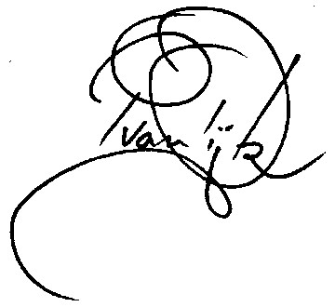

Pieter van Dijk  
Delegate of the Civil Aviation Safety Authority

22 February 2016