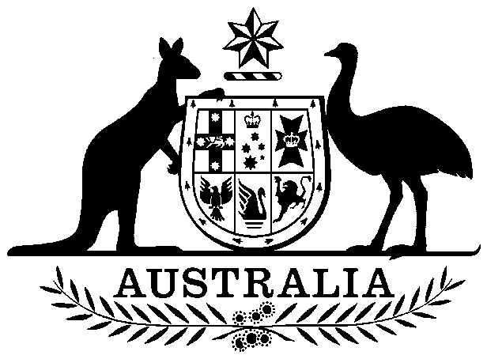
COMMONWEALTH OF AUSTRALIA

Environment Protection and Biodiversity Conservation Act 1999

Amendment of List of Exempt Native Specimens

I, PAUL MURPHY, Assistant Secretary, Wildlife Trade and Biosecurity Branch, as Delegate of the Minister for the Environment, pursuant to subsection 303DC(1) of the Environment Protection and Biodiversity Conservation Act 1999 (EPBC Act), hereby amend the list of exempt native specimens established under section 303DB of the EPBC Act by deleting from the list the following item that was included in the list on 26 May 2009 and any associated notations:

- specimens that are or are derived from fish or invertebrates, other than specimens that belong to species listed under Part 13 of the EPBC Act, taken in the South Australia Lakes and Coorong Fishery, as defined in the Fisheries Management (Lakes and Coorong Fishery) Regulations 2006 and the Fisheries Management (General) Regulations 2007 in force under the Fisheries Management Act 2007 (South Australia),

and including in the list the following:

- specimens that are or are derived from fish or invertebrates, other than specimens that belong to species listed under Part 13 of the EPBC Act, taken in the South Australian Lakes and Coorong Fishery, as defined in the Fisheries Management (Lakes and Coorong Fishery) Regulations 2009 and the Fisheries Management (General) Regulations 2007 in force under the Fisheries Management Act 2007 (South Australia),

with a notation that inclusion of the specimens in the list is subject to the following restrictions or conditions:

- the specimen, or the fish or invertebrate from which it is derived, was taken lawfully, and
- the specimens are included in the list until 26 August 2016.

Dated this 19th day of February 2016

Paul Murphy

Delegate of the Minister for the Environment

