**EXPLANATORY STATEMENT**

Issued by the Authority of the Minister for Indigenous Affairs

*Low Aromatic Fuel Act 2013*

*Low Aromatic Fuel (Designated Areas) (Katherine Region) Instrument 2016*

Section 14 of the *Low Aromatic Fuel Act 2013* (the Act) provides that the Commonwealth Minister for Indigenous Affairs (the Minister) may, by legislative instrument, designate an area as a ‘low aromatic fuel area.’

This instrument designates the following areas in the Northern Territory as low aromatic fuel areas: Katherine, parts of Nitmiluk, Tindal and Mataranka.

If an area is designated as a low aromatic fuel area, then section 8 of the Act makes it an offence for a corporation to engage in the following prohibited conduct:

* Supply regular unleaded petrol to a person in a low aromatic fuel area;
* Transport regular unleaded petrol to supply to a person in a low aromatic fuel area; and
* Possess regular unleaded petrol to supply to a person in a low aromatic fuel area.

Corporations who commit an offence under the Act may face a penalty of up to 300 penalty units. At the time of publication, 300 penalty units equals $54,000.

Before designating a low aromatic fuel area, the Minister must be satisfied that the designation is reasonably likely to help reduce potential harm to the health of people, including Aboriginal persons and Torres Strait Islanders, living in the area from sniffing fuel (paragraph 14(2)(a)). The Minister must also be satisfied that there are adequate facilities for supply of low aromatic fuel in the area (paragraph 14(2)(b)) and that the appropriate States and Territories have not or are unlikely to enact legislation consistent with the Act (paragraph 14(2)(c)).

The Minister must have regard to matters listed in the Act (subsection 14(3)), including the wellbeing of people, including Aboriginal persons and Torres Strait Islanders, living in the area, in designating a low aromatic fuel area under subsection 14(1).

**Background**

The Act consists of measures designed to mitigate the negative impacts of petrol sniffing through controlling the supply of regular unleaded petrol and promoting the supply of low aromatic fuel in designated areas by:

* Prohibiting the supply, transport and possession to supply of regular unleaded petrol;
* Promoting and monitoring the use of low aromatic fuel; and
* Regulating the supply and storage of other fuels – in particular premium unleaded petrol.

This legislative instrument supports a regional approach to controlling the supply of regular unleaded petrol in the areas of Katherine, Tindal, Nitmiluk and Mataranka It will reduce the availability of regular unleaded fuel and subsequently the likelihood of the fuel being transported to areas with a high incidence of petrol sniffing.

This legislative instrument complements the *Low Aromatic Fuel (Designated Areas) (Daly Region) Instrument 2016*.

**Regulatory Impact Statement**

The Office of Best Practice Regulation has advised that a Regulatory Impact Statement is not required for this instrument (OBPR reference: 19939).

**Commencement**

The instrument commences on the day after registration on the Federal Register of Legislative Instruments.

**Consultation**

The Minister is required to consult with certain persons and bodies as the Minister considers appropriate under subsection 16(1) of the Act.

The Minister must ensure certain information has been made available in the area and to the people living in the area (including businesses and organisations operating in the area) and they have been given a reasonable opportunity to make submissions about the proposal under subsection 16(2) of the Act.

The consultation for the Katherine and Daly Regions Legislative Instruments was conducted in one process. A public consultation process on the proposal to designate Adelaide River, Hayes Creek Roadhouse, Pine Creek, Mary River Roadhouse, Katherine, Tindal, Nitmiluk, Mataranka and Mataranka Homestead as low aromatic fuel areas was conducted between 7 September and 2 October 2015.

The Katherine, Nitmiluk, Tindal and Mataranka areas discussed during the consultation process are reflected in this instrument.

On behalf of the Minister, the Department of the Prime Minister and Cabinet (the Department) wrote to stakeholders outlining the proposal and inviting them to make a submission or provide their views, including fuel retailers and distributors, health professionals, the local council and other relevant persons.

Officials from the Department visited the Katherine region from 14 to 17 September 2015 for meetings with retailers, health providers, Aboriginal organisations, residents and other relevant persons, as part of this consultation process. A website also invited submissions from anyone interested in the area.

The consultation process demonstrated overall strong support for the designation in order to address the serious social impact of petrol sniffing. Some concerns about the impact of low aromatic fuel upon engines were raised, therefore the Department has undertaken to work closely with the communities during the transition to address any relevant issues.

**Explanation of provisions**

**Item** **1** sets out the name of the instrument, being the *Low Aromatic Fuel (Designated Areas) (Katherine Region) Instrument 2016.*

**Item 2** provides that the instrument commences on the day after registration on the Federal Register of Legislative Instruments.

**Item 3** specifies that the instrument is made under the authority of subsection 14(1) of the *Low Aromatic Fuel Act 2013*.

**Item 4** defines key terms contained in the instrument.

**Item 5** designates Katherine, Nitmiluk, Tindal and Mataranka as low aromatic fuel areas under section 14(1) of the Act.

Maps of the areas designated by this instrument are at **Attachment A**.

**Statement of Compatibility**

***Prepared in accordance with Part 3 of the Human Rights (Parliamentary Scrutiny) Act 2011***

This legislative instrument is compatible with the human rights and freedoms recognised or declared in the international instruments listed in section 3 of the *Human Rights (Parliamentary Scrutiny) Act 2011*.

***Overview of the Legislative Instrument***

The *Low Aromatic Fuel Act 2013* is designed to reduce petrol sniffing through promoting the supply of low aromatic fuel and controlling the supply of other fuels in certain areas.

This legislative instrument designates Katherine, Nitmiluk, Tindal and Mataranka as low aromatic fuel areas.

The effect of this designation is that it will be an offence for a corporation to which paragraph 51(xx) of the Constitution applies to engage in the following prohibited conduct:

* Supply of regular unleaded petrol to a person in a low aromatic fuel area;
* Transport of regular unleaded petrol to supply to a person in a low aromatic fuel area; and
* Possession of regular unleaded petrol to supply to a person in a low aromatic fuel area.

Regular unleaded petrol can be sniffed to cause the feeling of being ‘high’, while low aromatic fuel will not give the feeling of being ‘high’.

***Human rights implications***

The instrument advances the rights of people in Katherine, Nitmiluk, Tindal, Mataranka and Mataranka Homestead who sniff petrol and affected communities. In particular, it promotes the right to health under Article 12 of the International Covenant on Economic Social and Cultural Rights (ICESCR). To the extent, if any, the instrument discriminates on the basis of race, it is intended as a ‘special measure’ within the meaning of Article 1(4) of the International Convention on the Elimination of All Forms of Racial Discrimination (ICERD).

*Article 12 of the ICESCR (Right to health)*

Article 12 recognises "the right of everyone to the enjoyment of the highest attainable standard of physical and mental health." According to General Comment 14, the authoritative interpretation of that right, the right to health embraces a wide range of socio-economic factors that promote conditions in which people can lead a healthy life, and extends to the underlying determinants of health.

Under the General Comment the obligation to fulfil the right to health requires the Australian Government to take positive measures that enable and assist individuals and communities to enjoy the right to health, including giving sufficient recognition to the right to health in the national political and legal systems, preferably by way of legislative implementation.

The consequences of sniffing fuel include enduring physical harm to sniffers. Chronic sniffers can suffer cerebellar ataxia, grand mal epilepsy, encephalopathy, persistent psychosis and chronic disability including mental impairment. Neurological damage from petrol sniffing can be present at the very early stages of abuse. This can include effects on memory, attention, learning, executive function and behavioural inhibition.

The physical impacts of sniffing fuel have been connected to a range of social problems including low school attendance and illegal activity.

This instrument will help reduce petrol sniffing and resultant harm, supporting rights under Article 12 of the ICESCR.

*Article 1(4) of the ICERD (‘Special measures’)*

To the extent that practical operation of the instrument means that Aboriginal and Torres Strait Islander persons do not enjoy certain human rights to the same extent as other persons, the instrument is intended to be a ‘special measure’ within the meaning of Article 1(4) of the ICERD and section 8(1) of the *Racial Discrimination Act 1975.*

Aboriginal and Torres Strait Islander persons make up 31 per cent of the region that includes Katherine, Tindal, Nitmiluk and Mataranka. The instrument is therefore unlikely to have a greater impact on Aboriginal and Torres Strait Islander persons than other persons.

However, to the extent, if any, that the instrument means Aboriginal and Torres Strait Islander persons in Katherine, Nitmiluk, Tindal and Mataranka cannot enjoy certain human rights (such as the right to own property in Article 5(d)(v) of the ICERD) to the same extent as other persons, the instrument is intended to meet the criteria for a ‘special measure.’

‘Special measures’ are an exception to the general prohibition on racial discrimination, and are designed to ‘secure to disadvantaged groups the full and equal enjoyment of human rights and fundamental freedoms’[1]. For a measure to be characterised as a ‘special measure’ it must:

* Be for a particular group or individuals;
* Be taken for the sole purpose of securing the adequate advancement of those groups or individuals;
* Be ‘necessary’; and
* Not continue after its objectives have been achieved.

To the extent, if any, that it discriminates, the purpose of the instrument is to protect Aboriginal and Torres Strait Islander persons living in the areas from the negative impacts of petrol sniffing so as to ensure their equal enjoyment of their human rights (such as the right to health in Article 12 of the ICESCR).

The instrument is necessary to reduce Aboriginal and Torres Strait Islander petrol sniffing and resultant harm in the relevant areas. Petrol sniffing continues to cause harm to individuals and communities in the region. It can cause brain damage or death and can lead to poor health, increased violence and crime and the breakdown of communities and families. This instrument complements the *Low Aromatic Fuel Area (Designated Areas) (Daly Region) Instrument 2016*.

Low aromatic fuel has been specially designed by fuel industry chemists to contain lower levels of toxic aromatic compounds such as benzene, toluene and xylene which give people who sniff petrol a ‘high’. Research conducted by the Menzies School of Health Research has found that in most places where low aromatic fuel has been introduced the prevalence of petrol sniffing has dropped sharply.

The consultation process found strong community support to designate Katherine, Tindal, Nitmiluk, Mataranka and Mataranka Homestead as low aromatic fuel areas. Fuel suppliers and distributors are generally supportive of these areas being designated.

The Act will be reviewed on the fifth anniversary of its commencement (in 2018) and every five years after that (section 18).

**Conclusion**

The instrument is compatible with human rights. The instrument advances human rights (particularly the right to health under Article 12 of the ICESCR), and to the extent, if any, that the instrument discriminates on the basis of race, it is intended as a ‘special measure.’

**Attachment A**

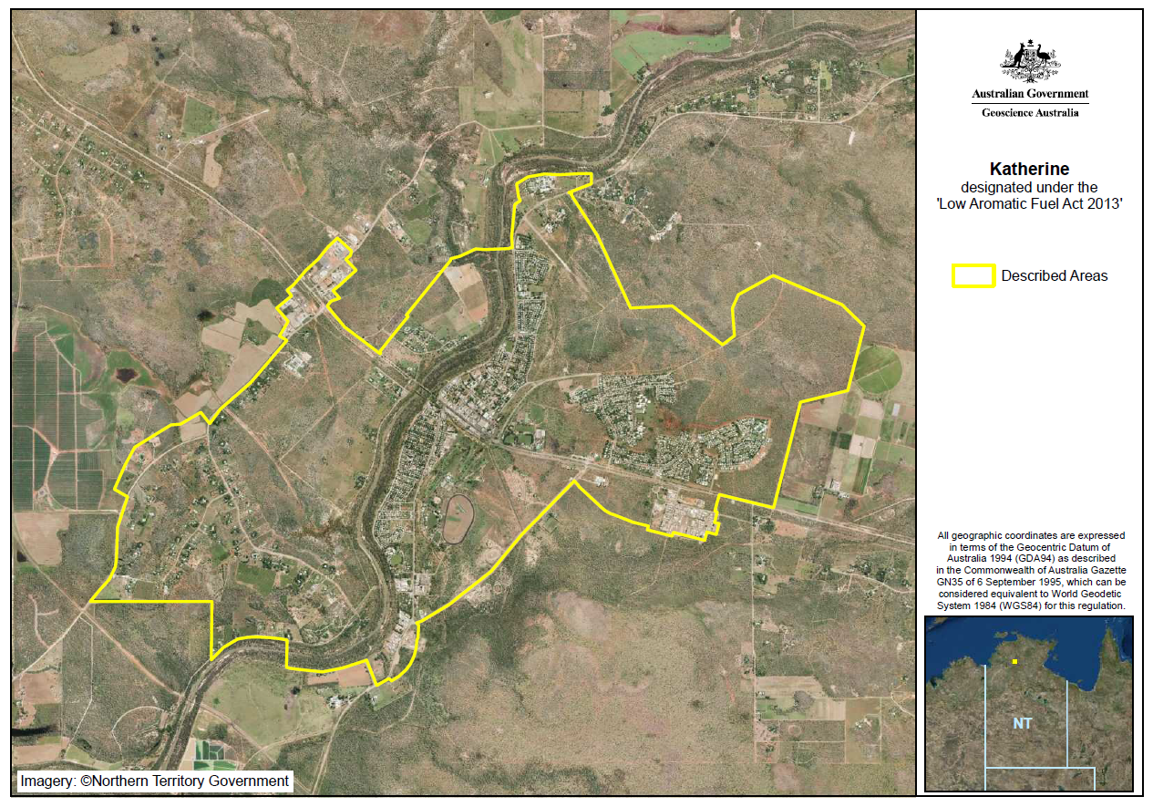

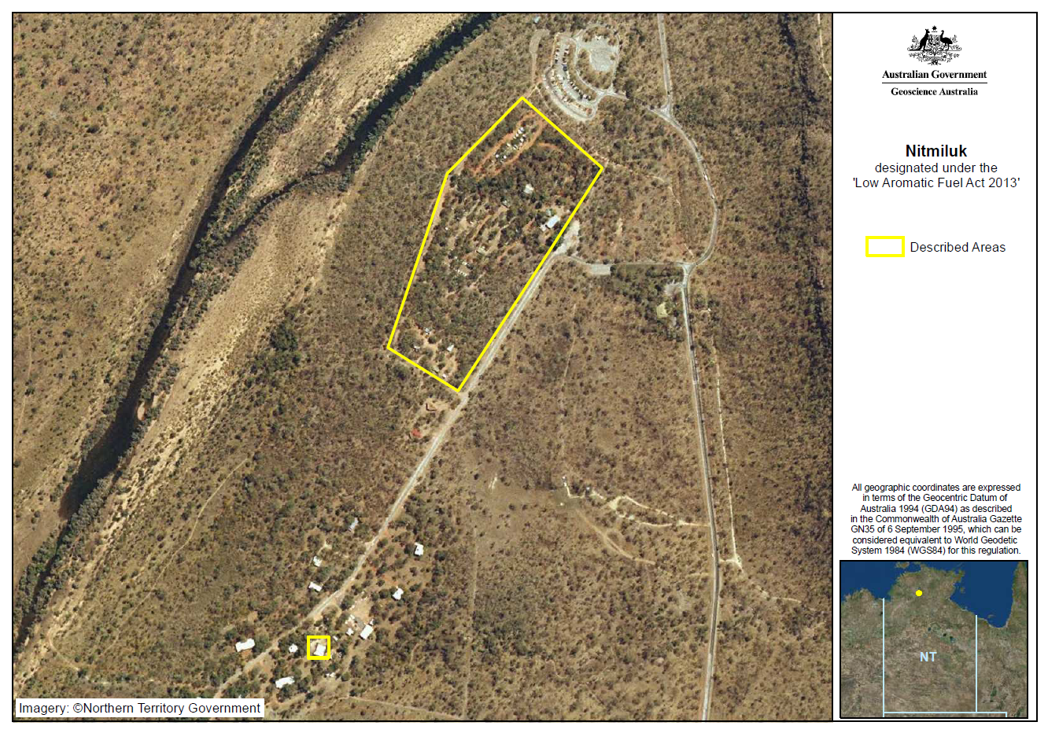

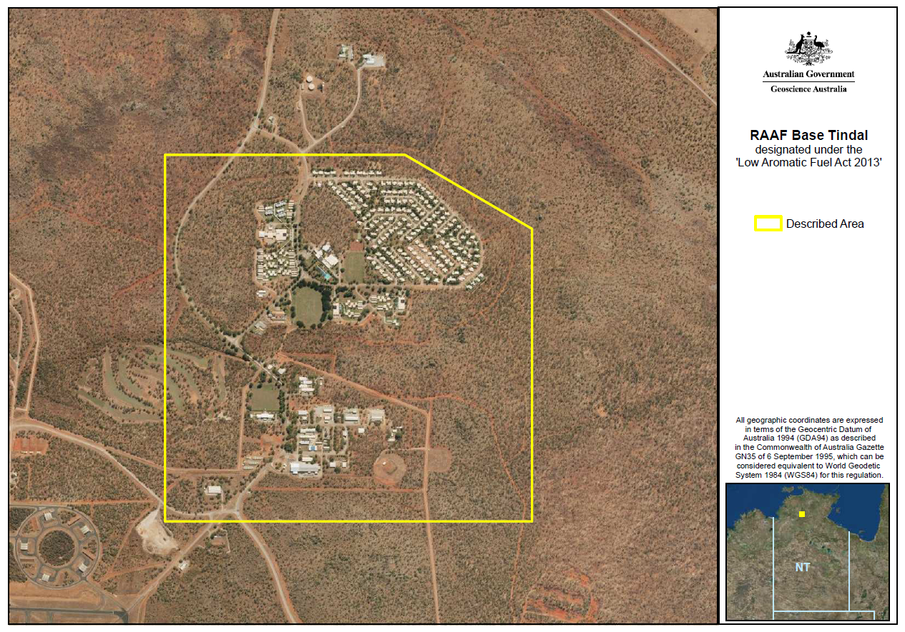

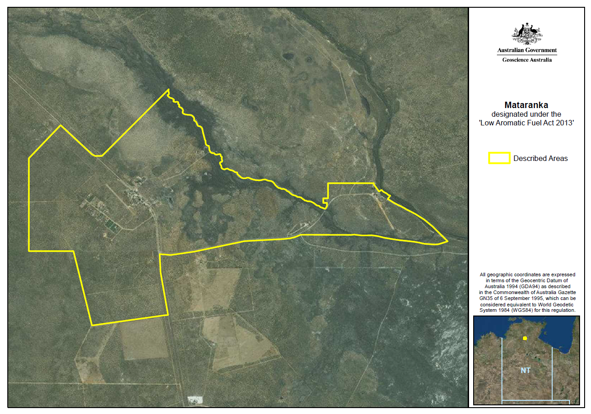

1. Committee on the Elimination of Racial Discrimination, *General Recommendation: No. 32: The Meaning and Scope of Special Measures in the International Convention on the Elimination of Racial Discrimination* (August 2009),at paragraph [11].