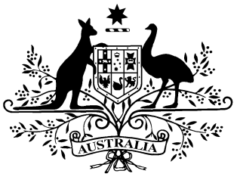

**PB 4 of 2016**

**National Health (Pharmaceutical benefits – early supply) Amendment Instrument 2016 (No.****1)**

*National Health Act 1953*

I, JULIANNE QUAINE, First Assistant Secretary (Acting), Pharmaceutical Benefits Division, Department of Health, delegate of the Minister for Health, make this Instrument under subsection 84AAA(2) of the *National Health Act 1953*.

Dated 25 January 2016

**JULIANNE QUAINE**

First Assistant Secretary (Acting)

Pharmaceutical Benefits Division

Department of Health

___________________________________________________________________________

Amendment determination – Pharmaceutical Benefits – Early Supply

**1 Name of Instrument**

* 1. This Instrument is the National Health (*Pharmaceutical benefits – early supply*) Amendment Instrument 2016 (No. 1)
  2. This Instrument may also be cited as PB 4 of 2016.

**2 Commencement**

This Instrument commences on 1 February 2016.

**3 Amendment of PB 120 of 2016**

Schedule 1 amends the *National Health (Pharmaceutical benefits—early supply) Instrument 2015* (PB 120 of 2015).

Schedule 1 Amendments

1. **Schedule 1, after entry for Rotigotine in the form Transdermal patch 9 mg**

insert:

|  |  |  |  |  |  |
| --- | --- | --- | --- | --- | --- |
| Ruxolitinib | Tablet 5 mg | 20 | 112 | 5 |  |
| Ruxolitinib | Tablet 15 mg | 20 | 56 | 5 |  |
| Ruxolitinib | Tablet 20 mg | 20 | 56 | 5 |  |