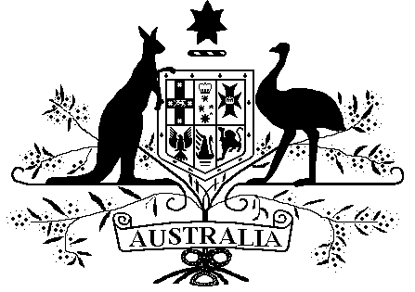

Veterans’ Entitlements Act 1986

Veterans’ Entitlements (Income Exempt Lump Sum – Queensland Stolen Wages Reparation Payment Scheme) Determination 2016

Instrument 2016 No. R9

I, MARK HARRIGAN, delegate of the Repatriation Commission, hereby determine under paragraph 5H(12)(c) of the Veterans’ Entitlements Act 1986 (VEA) that the amount specified in Part 2 is an exempt lump sum for the purposes of the definition of “ordinary income” in subsection 5H(1) of the VEA.

Dated this 7th day of January 2016

Mark Harrigan
…………………………………………………………
MARK HARRIGAN
Part 1: Preliminary and Interpretation
1.1 Name of determination
This determination is the Veterans’ Entitlements (Income Exempt Lump Sum – Queensland Stolen Wages Reparation Payment Scheme) Determination 2016.
1.2 Commencement
This determination is taken to have commenced on 1 December 2015.
1.3 Definition
In this determination:

“income support supplement” means the payment called the income support supplement payable under Part IIIA of the VEA;
“Queensland Stolen Wages Reparation Payment Scheme” means a scheme operated by the Queensland Government to provide ex gratia lump sum payments to Aboriginal and Torres Strait Islander persons whose wages and savings were controlled by the Queensland Government under a legislative regime known as the “Protection Acts.”;
“reparation payment” means a payment made by the Queensland Government in accordance with the Queensland Stolen Wages Reparation Payment Scheme;
“service pension” has the meaning given to service pension in subsection 5Q(1) of the VEA.

Part 2: Exempt Lump Sum
2.1 Reparation Payments – exempt lump sums
If a person or a person’s partner receives a reparation payment and the person is eligible for, or in receipt of a service pension or income support supplement, then the amount of the reparation payment received by the person or the person’s partner is an exempt lump sum.

