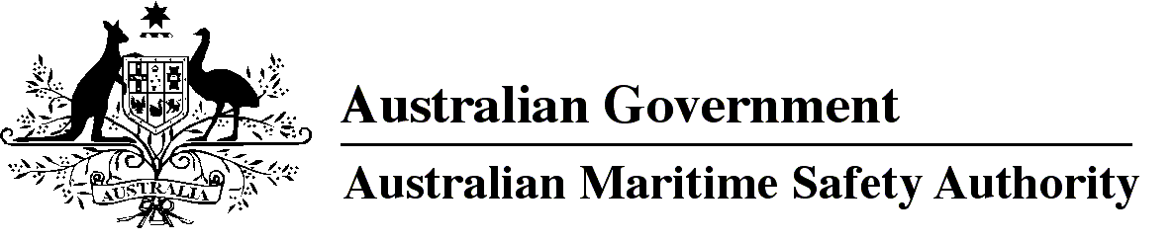

AMSA MO 2015/9

Marine Order 11 (Living and working conditions on vessels) Amendment 2015 (No. 1)

I, Gary Prosser, Acting Chief Executive Officer of the Australian Maritime Safety Authority, make this Order under subsection 342(1) of the *Navigation Act 2012*.

4 December 2015

Gary Prosser  
Acting Chief Executive Officer

1 Name of Order

This Order is *Marine Order 11 (Living and working conditions on vessels) Amendment 2015 (No. 1)*.

2 Commencement

This Order commences immediately after the commencement of *Marine Order 28 (Operations standards and procedures) 2015*.

3 Amendment of *Marine Order 11 (Living and working conditions on vessels) 2015*

Schedule 1 amends *Marine Order 11 (Living and working conditions on vessels) 2015*.

Schedule 1 Amendment

[1] Sections 28 and 29

omit each mention of

*2012*

insert

*2015*

[2] Schedule 4, subclause 5(a)

omit

*2009*

insert

*2014*

**Note**

1. All legislative instruments and compilations are registered on the Federal Register of Legislative Instruments kept under the *Legislative Instruments Act 2003.* See http://www.frli.gov.au.