

Greenhouse and Energy Minimum Standards (Clothes Washing Machines) Determination 20151

*Greenhouse and Energy Minimum Standards Act 2012*

I, Josh Frydenberg, Minister for Resources, Energy and Northern Australia, make this replacement Determination under sections 23 and 35 of the *Greenhouse and Energy Minimum Standards Act 2012*.

Dated 30 October 2015

JOSH FRYDENBERG

JOSH FRYDENBERG

Minister for Resources, Energy and Northern Australia

**COPYRIGHT**

© 2015 Commonwealth of Australia

This Determination includes material from Australian Standards and/or Australian/New Zealand Standards, which are copyright Standards Australia Ltd. Apart from reproduction for personal and non-commercial use, and uses permitted under the *Copyright Act 1968,* Standards Australia Ltd material may not be reproduced without permission or licence.

With the exception of the Commonwealth Coat of Arms, Commonwealth copyright material is licensed under a [Creative Commons Attribution-NonCommercial-ShareAlike 4.0 International License](http://creativecommons.org/licenses/by-nc-sa/4.0/). To view a copy of this license, visit <https://creativecommons.org/licenses/by-nc-sa/4.0/>.

You are free to copy, communicate and adapt the Commonwealth copyright material, so long as you attribute the Commonwealth of Australia.

Complete Australian/New Zealand Standards are available for purchase from Standards Australia Ltd. Requests and inquiries concerning other reproduction and rights pertaining to standards should be directed to SAI Global Limited.

# Name of Determination

This Determination is the *Greenhouse and Energy Minimum Standards (Clothes Washing Machines) Determination 2015*.

# Commencement, revocation and replacement

## This Determination comes into force on the day after it is registered.

## This Determination revokes and replaces the *Greenhouse and Energy Minimum Standards (Clothes Washing Machines) Determination 2012* (F2012L02117).

*Note:* The revoked determination ceases to be in force immediately before the replacement determination comes into force (see subsection 35(2) of the Act).

# Definitions

In this Determination:

***Act*** means the *Greenhouse and Energy Minimum Standards Act 2012*.

***AS/NZS 2040.1:2005*** means *Australian/New Zealand Standard 2040.1:2005 Performance of household electrical appliances* – *Clothes washing machines* – *Part 1: Methods for measuring performance, energy and water consumption*, as it existed on the date this Determination came into force.

*Note 1:* AS/NZS 2040.1:2005 is available from Standards Australia Limited.

*Note 2:* AS/NZS 2040.1:2005 includes all amendments up to and including AS/NZS 2040.1:2005/Amdt 3:2010 made on 1 April 2012.

***AS/NZS 2040.2:2005*** means *Australian/New Zealand Standard* *2040.2:2005 Performance of household electrical appliances* – *Clothes washing machines* – *Part 2: Energy efficiency labelling requirements*, as it existed on the date this Determination came into force.

*Note 1:* AS/NZS 2040.2:2005 is available from Standards Australia Limited.

*Note 2:* AS/NZS 2040.2:2005 includes all amendments up to and including AS/NZS 2040.2:2005/Amdt 1:2012 made on 20 June 2012.

***Australian Standard*** means a standard that is published by Standards Australia Limited denoted by the letters "AS" and identifying numbers and/or letters.

***Australian/New Zealand Standard*** means a standard that is jointly published by Standards Australia Limited and Standards New Zealand, is applicable in both countries and denoted by the letters “AS/NZS” and identifying numbers and/or letters.

***clothes washing machine*** meansan appliance designed to wash textile materials in water by mechanical action, and extract water from the textile materials, usually by centrifugal action.

***Energy Efficiency Label*** means the label described in section 5 of AS/NZS 2040.2:2005.

*Note 1:* This is the same meaning as in subclause 1.4.1 of AS/NZS 2040.1:2005.

*Note 2:*An example of an Energy Efficiency Label is shown in Figure 5.1 of AS/NZS 2040.2:2005.

***standard*** means an Australian Standard, an Australian/New Zealand Standard, or any other equivalent document.

***Super-Efficiency Label*** means the label described in Part 2 of Schedule 1 of this Determination.

*Note:* An example of a Super-Efficiency Label is shown in Figure 1 of Part 2 of this Determination.

*Note:* Several other words and expressions used in this Determination have the meaning given by section 5 of the Act. For example:

* category A product
* covered by
* family of models
* GEMS
* GEMS labelling requirements
* GEMS level requirements
* model
* product classes
* supply

# Interpretation

Applicable definitions of terms or phrases

## If there is inconsistency in the definitions of words or expressions, words or expression will be interpreted in the following order of priority to the extent of any inconsistency:

1. the Act;
2. this Determination;
3. the Standards.

## A word or expression defined in a standard mentioned specifically in section 3 of this Determination has the meaning given to it in the relevant standard.

*Note:* Notwithstanding this, for convenience to users, the key terms for ascertaining if a product is covered by this Determination are defined in this Determination.

Applicable version of documents incorporated into Determination and Standards

## For the purposes of this Determination the applicable version of any:

1. standard or
2. other document that:

#### is referred to in a standard under the heading ‘Referenced Documents’, or under an equivalent heading in a standard; and

#### must be applied to give effect to this Determination or a standard referred to in this Determination,

is the version of the standard or other document that existed at the date this Determination came into force.

*Note:* For example clause 3.2 ofAS/NZS 2040.2:2005 requires clothes washing machines to meet the water consumption requirements set out in section 4 of AS/NZS 2040.1:2005. The applicable version of AS/NZS 2040.1:2005 is the version that exists at the date this Determination comes into force.

# Specified product class covered by this Determination

## This Determination covers clothes washing machines that are ordinarily supplied and used for personal, domestic and household purposes.

*Note 1:* This subsection reflects the scope specified in clause 1.1 of AS/NZS 2040.1:2005 and clause 1.1 of AS/NZS 2040.2:2005.

*Note 2:* This Determination covers household clothes washing machines irrespective of the context in which they are used. For example, this Determination applies to household clothes washing machines that are used in a commercial context.

*Note 3:* Examples of appliances covered by this Determination are both horizontal and vertical axis single bowl machines (front or top loading), twin tub units and the washing function of combination washer/dryer units.

*Note 4:* This subsection specifies products that are covered by the Determination. See subsection (3) for products that are not covered.

## These products form a single product class for the purposes of the Act.

## For subsection 23 (2) of the Act, this Determination does not cover:

1. clothes washing machines that have:
   * + 1. a rated load capacity of less than or equal to 2 kilograms for all textile materials;
       2. no connections to a mains water supply; and
       3. no pump or other means for extracting water; and
2. clothes washing machines that are only capable of being used for cold wash operations and have:

#### no provision for internal water heating;

#### a single water connection marked only for cold water;

#### automatic fill control;

#### no program that indicates (directly or indirectly) that a program other than a cold wash program is possible;

#### a user manual that explicitly states it is only suitable for cold washing operations; and

#### no associated product literature that states it is suitable for anything other than cold washing operations.

## In this section:

***automatic fill control*** means a mechanism that automatically controls the amount of water delivered into a clothes washing machine for each fill operation undertaken during the program.

***rated load capacity*** means the maximum mass of a textile material (measured in multiples of 0.5 kilograms for each kind of textile material) that the supplier or manufacturer claims can be treated in all operations by the clothes washing machine.

*Note 1:* This is the same meaning as in subclauses 1.4.11 and 5.2 of AS/NZS 2040.1:2005.

*Note 2:* The rated load capacity is ordinarily claimed in the clothes washing machines product literature. For example, the operating manual.

# GEMS level requirements

There are no GEMS level requirements for products covered by this Determination.

# GEMS labelling requirements

Labelling and communication requirements

## Subject to subsection 7 (2) of this Determination, for subsections 24 (1) (b), 26 (1) (a) and 26 (1) (b) of the Act, the labelling requirements are the labelling and communication requirements in sections 2 and 5 and Appendix B of AS/NZS 2040.2:2005 with the following modifications:

1. Part 1 of Schedule 1 of this Determination applies instead of clause 1.5.7 and 2.8 of AS/NZS 2040.2:2005.
2. Part 3 of Schedule 1 of this Determination applies instead of the requirements in clause 5.1 of AS/NZS 2040.2:2005.

## For subsection 7 (1) of this Determination, if a star rating of seven or more stars is derived from the star rating index in accordance with Part 1 of Schedule 1 of this Determination, the labelling requirements are either:

1. the requirements specified in sections 2, 5 and Appendix B of AS/NZS 2040.2:2005 as if the star rating were deemed to be 6 stars; or
2. the requirements specified in Part 2 of Schedule 1 of this Determination (the Super-Efficiency Label).

*Note:* Where the derived star rating is one to six stars, the standard Energy Efficiency Label (that is, the labelling requirements specified in sections 2 and 5 and Appendix B of AS/NZS 2040.2:2005) must still be used.

Conducting tests

## For paragraphs 24 (1) (b) and 26 (1) (c) of the Act, the specified requirements for conducting tests are the requirements prescribed section 2 of AS/NZS 2040.2:2005, with the following modifications:

1. For any test, the standard mixed cotton test load must be:

#### for test loads of 10 kilograms or less – as shown in Table C2 of AS/NZS 2040.1:2005, made up from the components detailed in Table C1 of AS/NZS 2040.1‑2005; or

#### for test loads greater than 10 kg but not greater than 20 kg – as shown in the Table in Part 1 of Schedule 2 made up from the components detailed in the Table C1 of AS/NZS 2040.1:2005.

1. Where a manufacturer claims a rated capacity greater than 20 kg, the product must be rated and tested at 20 kg under this Determination.
2. For paragraph C 3.1 of AS/NZS 2040.1:2005, the total number of swatches required is determined according to Part 2 of Schedule 2 of this Determination.

Quartz cell specification

## For subsection 7 (2) of this Determination, the absorbance requirement for the quartz cell in subclause N 3.2 (g) of Appendix N of AS/NZS 2040.1:2005 is replaced with a transmittance requirement of between 80 per cent and 100 per cent.

PBIS limit in the conditioned load specification

## For subsection 7 (2) of this Determination, the PBIS limit of 0.05 milligrams per litre in subclause M 5.1 of Appendix M of AS/NZS 2040.1:2005 is replaced with a PBIS limit of 0.2 milligrams per litre.

# Other GEMS requirements

There are no other GEMS requirements for products covered by this Determination.

# Families of models

For section 28 of the Act, the specified circumstances, in which 2 or more models from a single product class covered by this Determination are in the same family, are the circumstances mentioned in subclause 1.5.4 of AS/NZS 2040.2:2005.

# Product categories

For subsection 29 (1) of the Act, the products covered by this Determination are category A products.

# Registrations affected by this Determination

For paragraph 36 (1) (c) of the Act, this Determination does not affect the registration of any model registered against the *Greenhouse and Energy Minimum Standards (Clothes Washing Machines) Determination 2012* (F2012L02117).

*Note:* If a model’s registration is not affected the model is taken to be registered against this Determination. See subsection 36 (2) of the Act.

**Note**

1. All legislative instruments and compilations are registered on the Federal Register of Legislative Instruments kept under the *Legislative Instruments Act 2003.* See http://www.frli.gov.au.

Schedule 1 Variation to AS/NZS 2040.2:2005 – GEMS star rating and labelling requirements

(paragraphs 7 (1) (a), 7 (1) (b) and subparagraph 7 (1) (c) (ii) of this Determination)

Part 1 Modifications to the Australian Standards to provide for Energy Efficiency and Super-Efficient Star Ratings

For paragraph (a) of this Determination, the following requirements in subparagraphs (a) and (b) apply:

### the number of stars displayed on the Super-Efficient Label and Energy Efficiency Label. Available stars are between a minimum of one and a maximum of ten, shown in half star intervals for an Energy Efficiency Label, and one star intervals for a Super-Efficient Label. The star rating is calculated from the star rating index.

### the table below applies instead of Table 2.1 in clause 2.8 of AS/NZS 2040.2:2005.

|  |  |
| --- | --- |
| **Star Rating Index (SRI)** | **Star rating** |
| SRI < 1.5 | 1.0 |
| 1.5 ≤ SRI ˂ 2.0 | 1.5 |
| 2.0 ≤ SRI ˂ 2.5 | 2.0 |
| 2.5 ≤ SRI ˂ 3 | 2.5 |
| 3.0 ≤ SRI ˂ 3.5 | 3.0 |
| 3.5 ≤ SRI ˂ 4 | 3.5 |
| 4.0 ≤ SRI ˂ 4.5 | 4.0 |
| 4.5 ≤ SRI ˂ 5.0 | 4.5 |
| 5.0 ≤ SRI ˂ 5.5 | 5.0 |
| 5.5 ≤ SRI ˂ 6.0 | 5.5 |
| 6.0 ≤ SRI < 7.0 | 6.0 |
| 7.0 ≤ SRI < 8.0 | 7.0 |
| 8.0 ≤ SRI < 9.0 | 8.0 |
| 9.0 ≤ SRI < 10.0 | 9.0 |
| 10.0 ≤ SRI | 10.0 |

Part 2 Labelling requirements

For paragraph 7 (2) (b) of this Determination, the following requirements apply:

### Figure 1, Figure 2 (Super-Efficiency Label Dimensions) and Figure 3 (Star Dimensions and geometry) must be used; and

1. the Super-Efficiency Label must be self-adhesive;.
2. a trim or die cut margin of up to 2mm around the Super-Efficiency Label is acceptable; and
3. the Super-Efficiency Label must be printed in the following colours on a white background:

Red: Pantone Warm Red

Blue: Pantone 299

Yellow: Pantone 116

Black: Pantone Black

Green: Pantone 340

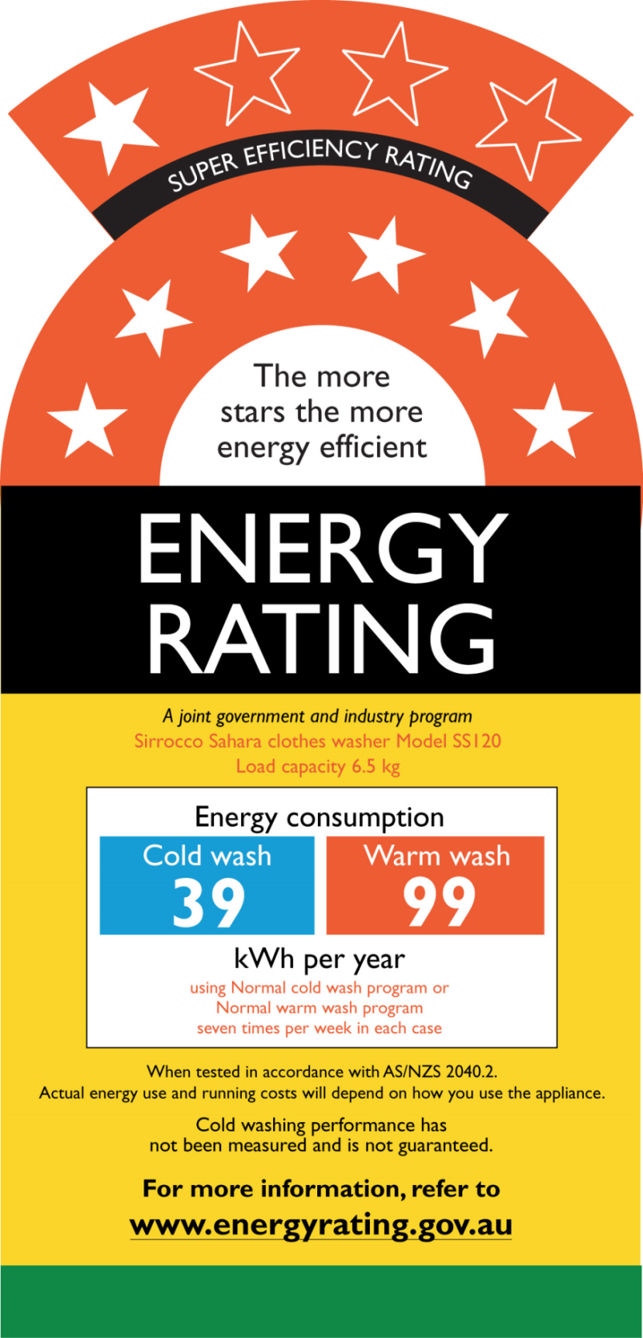

Figure 1: Super-Efficiency Label

*Note:* This example depicts 7 stars (out of a possible 10 stars).

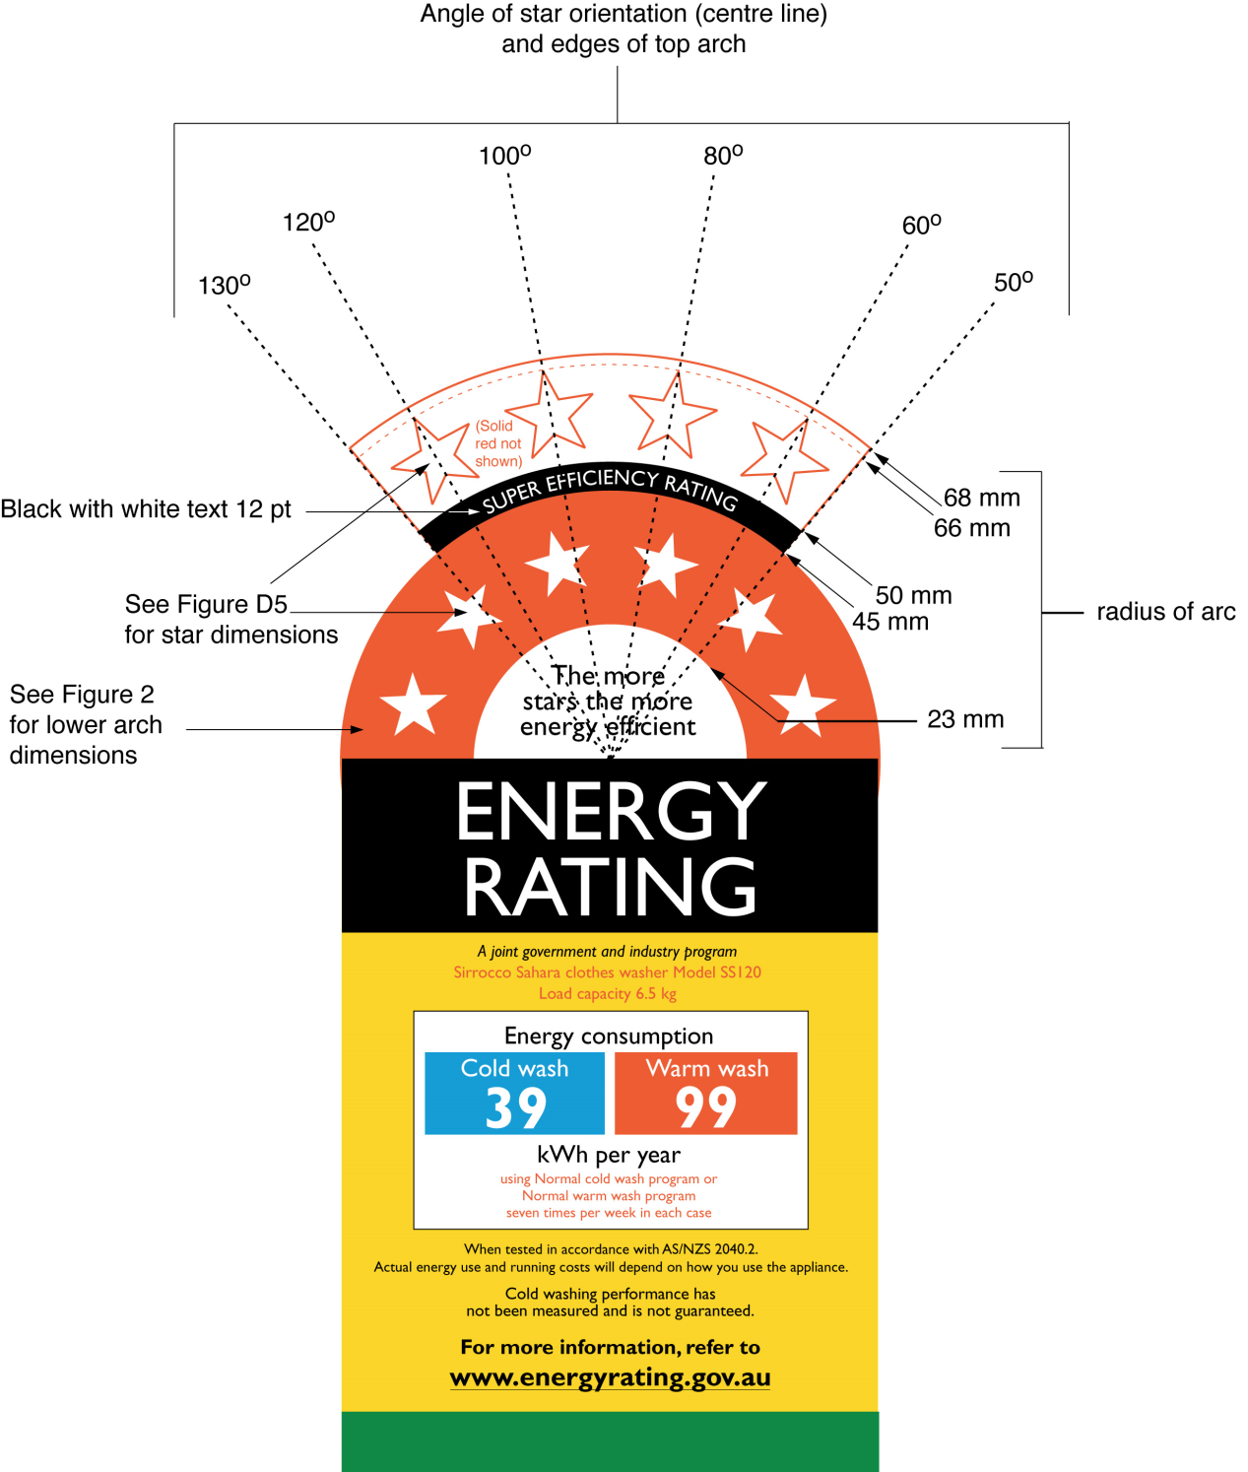

Figure 2 Super-Efficiency Label Dimensions

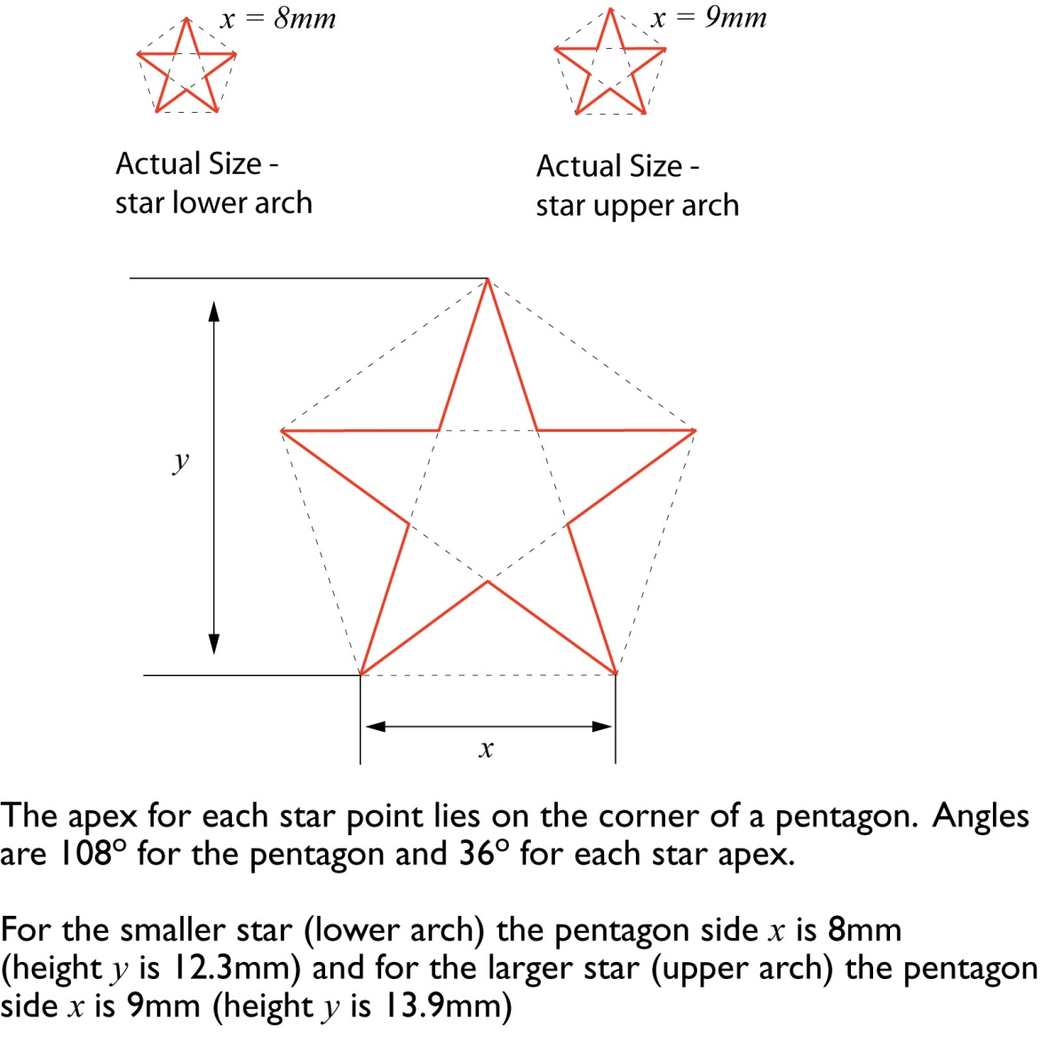

Figure 3: Star Dimensions and Geometry

Part 3 Label placement

For paragraph (b) of this Determination, the following requirements apply:

### The Energy Efficiency Label or Super-Efficiency Label must be adhered to the upper-front part of the clothes washing machine or any display front; or

### if the either Energy Efficiency Label or Super-Efficiency Label cannot be adhered to the upper front part of the clothes washing machine because it is not feasible or practicable, then the Energy Efficiency Label or Super-Efficiency Label must be—

1. adhered to the top of the clothes washing machine, or on any display front of the clothes washing machine so that the Energy Efficiency Label or Super-Efficiency Label is not obscured when the clothes washing machine is on display; or
2. displayed via a swing tag with the Energy Efficiency Label or Super‑Efficiency Label located at the upper-front part of the clothes washing machine (any single-sided swing tag shall be non-rotating and rotating swing tags shall be double-sided).

*Note:* This means that the Energy Efficiency Label or Super-Efficiency Label cannot be affixed to the side, back or base of the clothes washing machine.

Schedule 2 Make-up of test loads and numbers of swatches

(subparagraph 7(3)(ii) and paragraph (c) of this Determination)

Part 1 Make-up of test loads

|  |  |  |  |  |  |  |  |  |  |  |  |  |  |  |  |  |  |  |  |  |
| --- | --- | --- | --- | --- | --- | --- | --- | --- | --- | --- | --- | --- | --- | --- | --- | --- | --- | --- | --- | --- |
| **Load item** | **Test load mass, kg** | | | | | | | | | | | | | | | | | | | |
| **10.5** | **11** | **11.5** | **12** | **12.5** | **13** | **13.5** | **14** | **14.5** | **15** | **15.5** | **16** | **16.5** | **17** | **17.5** | **18** | **18.5** | **19** | **19.5** | **20** |
| **Bone dry mass required, kg** | | | | | | | | | | | | | | | | | | | |
| **9.72** | **10.19** | **10.65** | **11.11** | **11.57** | **12.04** | **12.50** | **12.96** | **13.43** | **13.89** | **14.35** | **14.81** | **15.28** | **15.74** | **16.20** | **16.67** | **17.13** | **17.59** | **18.06** | **18.52** |
| **Sheets** | 4 | 4 | 4 | 4 | 5 | 5 | 5 | 5 | 5 | 5 | 6 | 6 | 6 | 6 | 6 | 7 | 7 | 7 | 7 | 7 |
| **Bath towels** | 7 | 8 | 8 | 8 | 8 | 9 | 9 | 10 | 10 | 11 | 11 | 11 | 11 | 12 | 12 | 12 | 13 | 13 | 13 | 14 |
| **Tablecloths** | 3 | 4 | 4 | 5 | 4 | 4 | 4 | 4 | 5 | 5 | 5 | 5 | 5 | 5 | 6 | 6 | 6 | 6 | 6 | 6 |
| **Shirts** | 5 | 5 | 5 | 6 | 5 | 5 | 7 | 6 | 7 | 7 | 6 | 7 | 8 | 8 | 8 | 8 | 9 | 9 | 10 | 10 |
| **T-shirts** | 6 | 5 | 7 | 7 | 7 | 8 | 8 | 8 | 8 | 9 | 8 | 9 | 10 | 11 | 10 | 10 | 10 | 11 | 12 | 12 |
| **Pillow cases** | 6 | 7 | 7 | 7 | 8 | 8 | 8 | 9 | 10 | 9 | 10 | 10 | 10 | 10 | 11 | 11 | 10 | 12 | 12 | 12 |
| **Undershorts** | 7 | 7 | 8 | 8 | 9 | 9 | 9 | 11 | 10 | 10 | 10 | 11 | 12 | 12 | 13 | 12 | 12 | 12 | 13 | 14 |
| **Wash cloths** | 9 | 8 | 9 | 9 | 9 | 9 | 10 | 10 | 10 | 12 | 11 | 12 | 12 | 12 | 14 | 12 | 13 | 14 | 14 | 15 |
| **Handkerchiefs** | 8 | 7 | 8 | 11 | 8 | 8 | 8 | 10 | 10 | 10 | 11 | 10 | 12 | 11 | 14 | 11 | 12 | 12 | 14 | 14 |

*Note:* For any particular test load mass, a load consisting of items of mass as set out in AS/NZS 2040.1:2005 Table C1 and assembled in accordance with this Schedule 2 Part 1 of this Determination might not have a total bone-dry mass equal to the nominal bone-dry mass. Adjustment of the load in accordance with AS/NZS 2040.1:2005 Paragraph C2.2, will frequently be required.

Part 2 Number of swatches per test load component

For each type of swatch, the number of swatches to be attached to each relevant test load component is:

### For test loads of 10 kilograms or less – the number of swatches set out in Table C3 in Appendix C of AS/NZS 2040 1-2005; and

### For test loads of more than 10 kilograms - the number of swatches set out in the table below:

|  |  |  |  |  |  |  |  |  |  |  |  |  |  |  |  |  |  |  |  |  |
| --- | --- | --- | --- | --- | --- | --- | --- | --- | --- | --- | --- | --- | --- | --- | --- | --- | --- | --- | --- | --- |
| **Load item** | **Test load mass, kg** | | | | | | | | | | | | | | | | | | | |
| **10.5** | **11** | **11.5** | **12** | **12.5** | **13** | **13.5** | **14** | **14.5** | **15** | **15.5** | **16** | **16.5** | **17** | **17.5** | **18** | **18.5** | **19** | **19.5** | **20** |
| **Number of swatches required** | | | | | | | | | | | | | | | | | | | |
| **30** | **35** | **35** | **35** | **35** | **40** | **40** | **40** | **45** | **45** | **45** | **50** | **50** | **50** | **50** | **55** | **55** | **55** | **60** | **60** |
| **Sheets** | 3 | 4 | 4 | 4 | 4 | 4 | 4 | 4 | 5 | 5 | 5 | 5 | 5 | 5 | 5 | 6 | 6 | 6 | 6 | 6 |
| **Bath towels** | 4 | 6 | 6 | 6 | 6 | 6 | 6 | 6 | 7 | 7 | 7 | 8 | 8 | 8 | 8 | 9 | 9 | 9 | 10 | 10 |
| **Tablecloths** | 3 | 4 | 4 | 4 | 4 | 4 | 4 | 4 | 5 | 5 | 5 | 5 | 5 | 5 | 5 | 5 | 5 | 5 | 6 | 6 |
| **Shirts** | 5 | * 6 | * 6 | 6 | * 6 | * 7 | 7 | * 7 | 7 | 7 | * 7 | * 8 | 8 | 8 | 8 | * 9 | 9 | 9 | 10 | 10 |
| **T-shirts** | 5 | 5 | 5 | 5 | 5 | 6 | 6 | 6 | 7 | 7 | 7 | 8 | 8 | 8 | 8 | 8 | 8 | 8 | 9 | 9 |
| **Pillow cases** | 5 | 5 | 5 | 5 | 5 | 7 | 7 | 7 | 7 | 7 | 7 | 8 | 8 | 8 | 8 | 9 | 9 | 9 | 10 | 10 |
| **Undershorts** | 5 | 5 | 5 | 5 | 5 | 6 | 6 | 6 | 7 | 7 | 7 | 8 | 8 | 8 | 8 | 9 | 9 | 9 | 9 | 9 |
| **Wash cloths** | 0 | 0 | 0 | 0 | 0 | 0 | 0 | 0 | 0 | 0 | 0 | 0 | 0 | 0 | 0 | 0 | 0 | 0 | 0 | 0 |
| **Handkerchiefs** | 0 | 0 | 0 | 0 | 0 | 0 | 0 | 0 | 0 | 0 | 0 | 0 | 0 | 0 | 0 | 0 | 0 | 0 | 0 | 0 |

*Note:* * In these cases the extra soil swatches are attached to the same article, as indicated in AS/NZS 2040.1:2005 Figure C1.