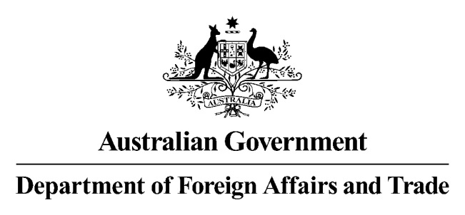

File Number: 15/1509#5

24 November 2015

Clerk of the Senate

Senate Table

SG 25

Parliament House

CANBERRA ACT 2600

**Charter of the United Nations (Sanctions – Syria) Amendment Regulation 2015 [F2015L01463] – Amended Explanatory Statement**

On 11 November 2015 the Senate Standing Committee on Regulations and Ordinances requested advice on the Charter of the United Nations (Sanctions-Syria) Regulation 2015 (the Instrument). In particular, the Committee noted that the Explanatory Statement for the Instrument did not include a definition of ‘illegally removed’, details on the retrospective effect of the Instrument and the justification for the imposition of strict liability offences

The Department of Foreign Affairs and Trade replied to the Committee and we have now amended the Explanatory Statement to include information on the consultation.

Enclosed is the amended Explanatory Statement for the Instrument.

If you require further information please do not hesitate to contact me.

Yours sincerely

Julie Heckscher

Assistant Secretary

Sanctions, Treaties and Transnational Crime Branch

Legal Division