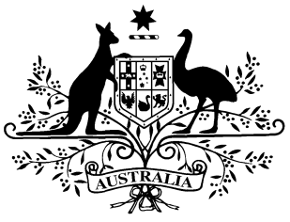

**PB 63 of 2015**

**National Health (Subsection 84C(7)) Amendment Determination 2015 (No.1)**

*National Health Act 1953*

I, JULIANNE QUAINE, Assistant Secretary, Pharmaceutical Access Branch, Pharmaceutical Benefits Division, Department of Health, delegate of the Minister for Health, make this determination under subsection 84C(7) of the *National Health Act 1953* having in accordance with subsection 84C(9) of the *National Health Act 1953,* obtained the written agreement of the Pharmacy Guild of Australia.

Dated 29 June 2015

**JULIANNE QUAINE**

Assistant Secretary

Pharmaceutical Access Branch

Pharmaceutical Benefits Division

Department of Health

**Name of Determination**

(1) This Determination is the *National Health (Subsection 84C(7)) Amendment Determination 2015 (No.1).*

(2) This Determination may also be cited as PB 63 of 2015.

**2.****Commencement**

This Determination commences on 1 July 2015.

# 3 Amendment

Schedule 1 amends the *National Health (Subsection 84C(7)) Determination 2010* made on 20 July 2010.

Schedule 1 - Amendments

[1] Paragraph 6(1)(a)

omit

$1.15

substitute

$1.17

[2] Paragraph 6(1)(b)

omit

$1.50

substitute

$1.53