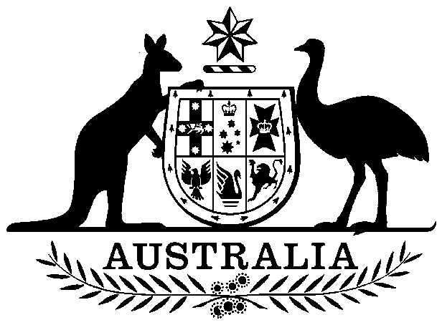
COMMONWEALTH OF AUSTRALIA

Environment Protection and Biodiversity Conservation Act 1999

Amendment of List of Exempt Native Specimens

I, PAUL MURPHY, Assistant Secretary, Wildlife Trade and Biosecurity Branch, as Delegate of the Minister for the Environment, pursuant to subsection 303DC(1) of the Environment Protection and Biodiversity Conservation Act 1999 (EPBC Act), hereby amend the list of exempt native specimens established under section 303DB of the EPBC Act by including in the list the following:

- specimens that are or are derived from fish or invertebrates, other than specimens that belong to species listed under Part 13 of the EPBC Act, taken by the Miscellaneous Fishery licence Y078 in the South Australian Beach-Cast Marine Algae Fishery as defined in the Fisheries Management (Miscellaneous Fishery) Regulations 2000 in force under the Fisheries Management Act 2007 (South Australia),

with a notation that inclusion of the specimens in the list is subject to the following restrictions or conditions:

- the specimen, or the fish or invertebrate from which it is derived, was taken lawfully, and
- the specimens are covered by the declaration of an approved wildlife trade operation under section 303FN of the EPBC Act in relation to the fishery.

Dated this 3rd day of June 2015

….……………………Paul Murphy…………………………

Delegate of the Minister for the Environment

