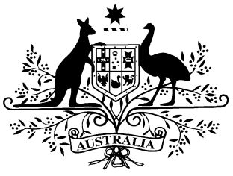

**PB 42 of 2015**

**National Health (Prescriber bag supplies) Amendment Determination 2015 (No. 4)**

_____________________________________________________________________

I, FELICITY McNEILL, First Assistant Secretary, Pharmaceutical Benefits Division, Department of Health, delegate of the Minister for Health, make this Instrument under sections 93 and 93AB of the *National Health Act 1953*.

Dated 22 April 2015

**FELICITY McNEILL**

First Assistant Secretary

Pharmaceutical Benefits Division

Department of Health

**1 Name of Determination**

1. This Determination is the *National Health (Prescriber bag supplies) Amendment Determination 2015 (No. 4).*
2. This Determination may also be cited as PB 42 of 2015.

2 Commencement

This Determination commences on 1 May 2015.

3 Amendment of *National Health (Prescriber bag supplies) Determination 2012*

Schedule 1 amends the National Health (Prescriber bag supplies) Determination*2012* (PB 73 of 2012).

Schedule 1 Amendments

[1] The Schedule

omit:

|  |  |  |  |  |
| --- | --- | --- | --- | --- |
| **3** | Benztropine | Injection containing benztropine mesylate 2 mg in 2 mL vial | MP, NP | 10 |