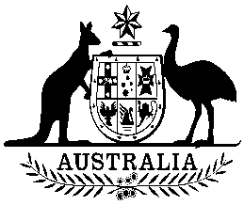
COMMONWEALTH OF AUSTRALIA

Environment Protection and Biodiversity Conservation Act 1999

Amendment of List of Exempt Native Specimens

I, PAUL MURPHY, Assistant Secretary, Wildlife Trade and Biosecurity Branch, as Delegate of the Minister for the Environment, pursuant to subsection 303DC(1) of the Environment Protection and Biodiversity Conservation Act 1999 (EPBC Act), hereby amend the list of exempt native specimens established under section 303DB of the EPBC Act by deleting from the list the following item that was included in the list on 13 September 2013 and any associated notations:

- specimens taken by Australian Kelp Products Pty Ltd between April and July 2013 inclusive, under licences issued by the Department of Primary Industries and Regions South Australia for the South Australian Beach-cast Seagrass and Marine Algae Fishery as defined in the Fisheries Management (Miscellaneous Fishery) Regulations 2000 in force under the Fisheries Management Act 2007 (South Australia).

Dated this 11th day of March 2015

Paul Murphy
….…………………………………………………
Delegate of the Minister for the Environment

