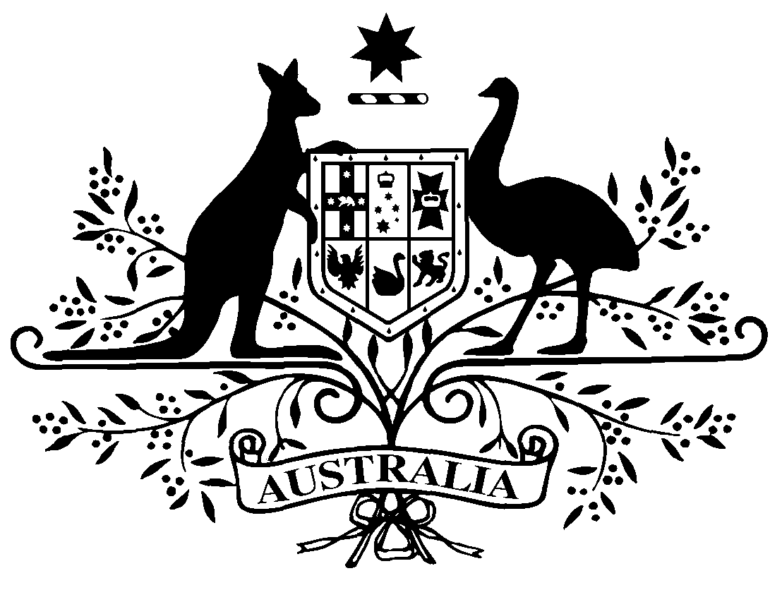

PB 9 of 2015
National Health (Weighted average disclosed price –April 2015 reduction day) Amendment Determination 2015 (No.1)
National Health Act 1953
I, FELICITY MCNEILL, First Assistant Secretary, Pharmaceutical Benefits Division, Department of Health, delegate of the Minister for Health, make this determination under subsection 99ADB(4) of the National Health Act 1953.
Dated: 25 February 2015

FELICITY MCNEILL

First Assistant Secretary
Pharmaceutical Benefits Division
Department of Health

1 Name of Determination
(1) This Determination is the National Health (Weighted average disclosed price – April 2015 reduction day) Amendment Determination 2015 (No.1).
(2) This Determination may also be cited as PB 9 of 2015.
2 Commencement
This Determination commences on the day after it is registered.

- Amendments to PB 97 of 2014
Schedule 1 amends the National Health (Weighted average disclosed price – April 2015 reduction day) Determination 2014 (PB 97 of 2014).
Schedule 1 Amendments

[1] Schedule 1
omit:
152 | Aspirin | Tablet 100 mg | Oral | Astrix | 0.96
153 | Aspirin | Tablet 100 mg | Oral | Mayne Pharma Aspirin | 0.96
154 | Aspirin | Tablet 100 mg | Oral | Spren 100 | 0.96
155 | Aspirin | Tablet, dispersible, 300 mg | Oral | Solprin | 1.23

[2] Schedule 1
omit:
582 | Exemestane | Tablet 25 mg | Oral | APO-Exemestane | 71.33
583 | Exemestane | Tablet 25 mg | Oral | Aromasin | 71.33
584 | Exemestane | Tablet 25 mg | Oral | Exaccord | 71.33
585 | Exemestane | Tablet 25 mg | Oral | Exemestane AN | 71.33
586 | Exemestane | Tablet 25 mg | Oral | Exemestane GH | 71.33
587 | Exemestane | Tablet 25 mg | Oral | Exemestane Pfizer | 71.33
588 | Exemestane | Tablet 25 mg | Oral | Exemestane Sandoz | 71.33
589 | Exemestane | Tablet 25 mg | Oral | Exemestane-GA | 71.33
substitute:
582 | Exemestane | Tablet 25 mg | Oral | APO-Exemestane | 84.64
583 | Exemestane | Tablet 25 mg | Oral | Aromasin | 84.64
584 | Exemestane | Tablet 25 mg | Oral | Exaccord | 84.64
585 | Exemestane | Tablet 25 mg | Oral | Exemestane AN | 84.64
586 | Exemestane | Tablet 25 mg | Oral | Exemestane GH | 84.64
587 | Exemestane | Tablet 25 mg | Oral | Exemestane Pfizer | 84.64
588 | Exemestane | Tablet 25 mg | Oral | Exemestane Sandoz | 84.64
589 | Exemestane | Tablet 25 mg | Oral | Exemestane-GA | 84.64

[3] Schedule 1
omit:
1080 | Macrogol 3350 | Oral liquid 13.125 g with electrolytes, 500 mL | Oral | Movicol Liquid | 6.37
substitute:
1080 | Macrogol 3350 | Oral liquid 13.125 g in 25 mL with electrolytes, 500 mL | Oral | Movicol Liquid | 6.37

[4] Schedule 1
omit:
1259 | Nevirapine | Tablet 200 mg | Oral | Nevipin | 166.60
1260 | Nevirapine | Tablet 200 mg | Oral | Nevirapine Alphapharm | 166.60
1261 | Nevirapine | Tablet 200 mg | Oral | Nevirapine RBX | 166.60
1262 | Nevirapine | Tablet 200 mg | Oral | Viramune | 166.60
1263 | Nevirapine | Tablet 400 mg (extended release) | Oral | Viramune XR | 166.60
substitute:
1259 | Nevirapine | Tablet 200 mg | Oral | Nevipin | 198.09
1260 | Nevirapine | Tablet 200 mg | Oral | Nevirapine Alphapharm | 198.09
1261 | Nevirapine | Tablet 200 mg | Oral | Nevirapine RBX | 198.09
1262 | Nevirapine | Tablet 200 mg | Oral | Viramune | 198.09
1263 | Nevirapine | Tablet 400 mg (extended release) | Oral | Viramune XR | 198.09

[5] Schedule 1
after:
2075 | Tramadol | Tablet (sustained release) containing tramadol hydrochloride 200 mg | Oral | Zydol SR 200 | 4.14
omit:
2076 | Tramadol | Tablet (sustained release) containing tramadol hydrochloride 50 mg | Oral | Tramal SR 50 | 1.76

[6] Schedule 2
after:
99 | Ampicillin | Powder for injection 500 mg (as sodium) | Injection | Ibimicyn | 3.09
insert:
99A | Aspirin | Tablet 100 mg | Oral | Astrix | 1.07
99B | Aspirin | Tablet 100 mg | Oral | Mayne Pharma Aspirin | 1.07
99C | Aspirin | Tablet 100 mg | Oral | Spren 100 | 1.07
99D | Aspirin | Tablet, dispersible, 300 mg | Oral | Solprin | 1.37

[7] Schedule 2
omit:
1416 | Sodium chloride | I.V. infusion 154 mmol per L. 1 L | Injection | Baxter Healthcare Pty Ltd | 1.27
substitute:
1416 | Sodium chloride | I.V. infusion 154 mmol per L, 1 L | Injection | Baxter Healthcare Pty Ltd | 1.27

