Australian Government

Civil Aviation Safety Authority

Tabling Officer Department of the Senate Parliament House CANBERRA ACT 2600

Dear Tabling Officer

Substitution of Explanatory Statement tabled with instrument CASA 293/14 (F2015L00024)

I am writing to request the substitution of the Explanatory Statement tabled with instrument CASA 293/14.

In spite of section 26 of the Legislative Instruments Act 2003, the original Explanatory Statement did not provide a description of consultation undertaken or a reason as to why consultation was not undertaken. This was noted by the Senate Standing Committee on Regulations and Ordinances which requested further information from the Minister and that the Explanatory Statement be updated in accordance with the requirements of the Legislative Instruments Act 2003.

Two copies of the revised Explanatory Statement are attached for your attention. I would be grateful if this Explanatory Statement could be substituted for the one tabled with the instrument on 9 February 2015.
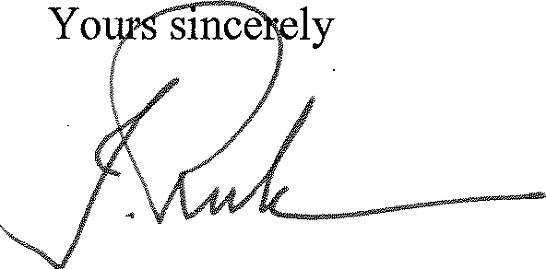

Joe Rule Manager Legal Branch
Legal Services Division
18 February 2015

GPO Box 2005 Canberra ACT 2601 Telephone 131 757
Canberra, Brisbane, Darwin, Cairns, Townsville, Tamworth, Bankstown, Mascot, Melbourne, Adelaide, Perth

