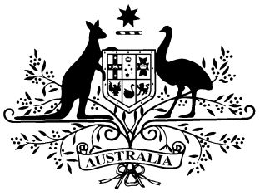
PB 91 of 2014

National Health (Prescriber bag supplies) Amendment Determination 2014 (No. 1)
_____________________________________________________________________

I, FELICITY McNEILL, First Assistant Secretary, Pharmaceutical Benefits Division, Department of Health, delegate of the Minister for Health, make this Instrument under sections 93 and 93AB of the National Health Act 1953.

Dated 25 November 2014

FELICITY McNEILL
First Assistant Secretary
Pharmaceutical Benefits Division
Department of Health

1 Name of Determination
- This Determination is the National Health (Prescriber bag supplies) Amendment Determination 2014 (No. 1).
- This Determination may also be cited as PB 91 of 2014.
2 Commencement
This Determination commences on 1 December 2014.
3 Amendment of National Health (Prescriber bag supplies) Determination 2012
Schedule 1 amends the National Health (Prescriber bag supplies) Determination 2012 (PB 73 of 2012).
Schedule 1 Amendments
[1] The Schedule, after entry for Group Number 25
insert:
26 | Midazolam | Injection 5 mg (as hydrochloride) in 1 mL | MP, NP | 10

