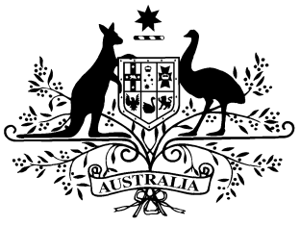

**PB 99 of 2014**

**National Health (Remote Aboriginal Health Services Program) Special Arrangements Amendment Instrument 2014** **(No. 2)**

*National Health Act 1953*

___________________________________________________________________________

I, Kim Bessell, Assistant Secretary, Pharmaceutical Access Branch, Pharmaceutical Benefits Division, Department of Health, delegate of the Minister for Health, make this instrument under subsections 100(1) and (2) of the *National Health Act 1953*.

Dated 17 November 2014

**KIM BESSELL**

Assistant Secretary

Pharmaceutical Access Branch

Principal Pharmacy Advisor

Pharmaceutical Benefits Division

Department of Health

___________________________________________________________________

1 Name of Instrument

1. This Instrument is the *National Health (Remote Aboriginal Health Services Program) Special Arrangements Amendment Instrument 2014* *(No.2).*

1. This Instrument may also be cited as PB 99 of 2014.

2 Commencement

This Instrument commences on 1 December 2014.

3 Amendments to PB 65 of 2010

Schedule 1 amends the *National Health (Remote Aboriginal Health Services Program) Special Arrangements Instrument 2010* (PB 65 of 2010).

Schedule 1 Amendments

1. After section 9

Insert:

**10. Modified application of paragraph 92A(1)(f) conditions of approval**

Subsection 8(3) of the conditions of approval for approved pharmacists made under paragraph 92A(1)(f) of the Act does not apply to the supply of a pharmaceutical benefit under this arrangement.