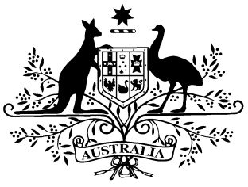
PB 74 of 2014

National Health Determination under paragraph 98C(1)(b) Amendment 2014
(No. 9)
_____________________________________________________________________

I, FELICITY McNEILL, First Assistant Secretary, Pharmaceutical Benefits Division, Department of Health, delegate of the Minister for Health, make this Instrument under paragraph 98C(1)(b) of the National Health Act 1953.

Dated 23 September 2014

FELICITY McNEILL
First Assistant Secretary
Pharmaceutical Benefits Division
Department of Health

1 Name of Instrument
- This Instrument is the National Health Determination under paragraph 98C(1)(b) Amendment 2014 (No. 9).
- This Instrument may also be cited as PB 74 of 2014.
2 Commencement
This instrument commences on 1 October 2014.
3 Amendments to Determination under paragraph 98C(1)(b) of the National Health Act 1953 (PB 119 of 2008)
Schedule 1 amends the Determination under paragraph 98C(1)(b) of the National Health Act 1953 (PB 119 of 2008).

Schedule 1 Amendments

[1] Schedule 4, entry for Aclidinium
omit from the column headed “Form (strength, type, size, etc.)”:
containing aclidinium bromide 400 micrograms per dose, 60 doses
substitute:
322 micrograms (as bromide) per dose, 60 doses
[2] Schedule 4, after entry for Glucose Indicator—Blood in the form Test strips, 100 (Contour)
insert in the column headed “Form (strength, type, size, etc.)”:
Test strips, 100 (EasyMate II)
[3] Schedule 4, entry for Oestradiol and Oestradiol with Dydrogesterone
insert as first item in the column headed “Form (strength, type, size, etc.)”:
Pack containing 14 tablets oestradiol 1 mg and 14 tablets oestradiol 1 mg with dydrogesterone 10 mg
[4] Schedule 4, omit entry for Polyethylene glycol 400

