Australian Film, Television and Radio School Act 1973

DETERMINATION OF DEGREES, DIPLOMAS AND CERTIFICATES No. 2014/2

I, Julianne Schultz, Chair of the Council of the Australian Film, Television and Radio School, on behalf of the Australian Film, Television and Radio School, make a determination under section 6A of the Australian Film, Television and Radio School Act 1973 (the Act) specifying the following degrees, diplomas and certificates for the purposes of paragraph 5(1)(g) of the Act.

DIPLOMAS

- Diploma in Editing Fundamentals
- Diploma in Camera Fundamentals
- Diploma in Design for the Screen
- Diploma in Factual Television Fundamentals
- Diploma in Sound Fundamentals
- Diploma in Digital Content (Radio)
- Diploma in Visual Effects Fundamentals ADVANCED DIPLOMAS
- Advanced Diploma in Radio
- Advanced Diploma in Cine Essentials
- Advanced Diploma in Screenwriting: Series Television
- Advanced Diploma in Screenwriting: Feature Film
- Advanced Diploma in Factual Storytelling
- Advanced Diploma in Music Scoring for the Screen
- Advanced Diploma in Producing: Story, Audience, Finance.

This Determination comes into effect on the day after it is registered on the Federal Register of Legislative Instruments.
)

Dated: 16 May 2014

Signed: 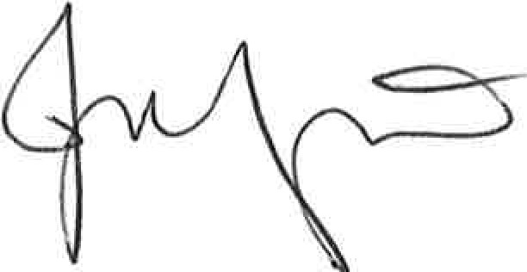
Professor Julianne Schultz AM FAHA
Chair of Council, Australian Film, Television and Radio School

