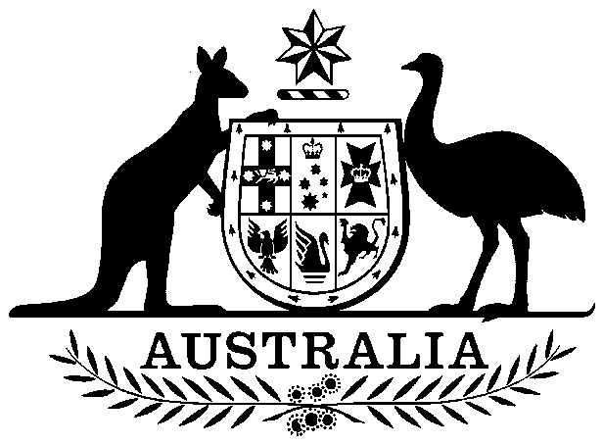
COMMONWEALTH OF AUSTRALIA

Environment Protection and Biodiversity Conservation Act 1999

Amendment of List of Exempt Native Specimens

I, SHANEEN COULSON, A/g Assistant Secretary, Wildlife Trade and Biosecurity Branch, as Delegate of the Minister for the Environment, pursuant to subsection 303DC(1) of the Environment Protection and Biodiversity Conservation Act 1999 (EPBC Act), hereby amend the list of exempt native specimens established under section 303DB of the EPBC Act by revoking the conditions to which the inclusion of the following item in the list on 27 February 2013 is subject:

- specimens that are or are derived from fish or invertebrates, other than specimens that belong to species listed under Part 13 of the EPBC Act, taken in the Tasmanian Giant Crab Fishery, as defined in the Tasmanian Fisheries (giant crab) rules 2013 in force under the Tasmanian Living Marine Resources Management Act 1995

and imposing the following conditions to which inclusion of the specimens in the list is subject:

- the specimen, or the fish or invertebrate from which it is derived, was taken lawfully, and

- the specimens are included in the list until 18 July 2019.

Dated this 18th day of July 2014

….……………………S. Coulson…………………….

Delegate of the Minister for the Environment

