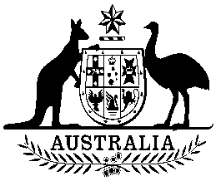
COMMONWEALTH OF AUSTRALIA

Environment Protection and Biodiversity Conservation Act 1999

Amendment of List of Exempt Native Specimens

I, SHANEEN COULSON, A/g Assistant Secretary, Wildlife Trade and Biosecurity Branch, as Delegate of the Minister for the Environment pursuant to subsection 303DC(1) of the Environment Protection and Biodiversity Conservation Act 1999 (EPBC Act), hereby amend the list of exempt native specimens established under section 303DB of the EPBC Act by deleting from the list the following item that was included in the list on 22 December 2004 and any associated notations:

- specimens that are or are derived from fish or invertebrates, other than specimens that belong to species listed under Part 13 of the Act, taken in the Queensland East Coast Beché- de- mer Fishery.

Dated this 16th day of JULY 2014

….…………………Shaneen Coulson………………………………
Delegate of the Minister for the Environment

