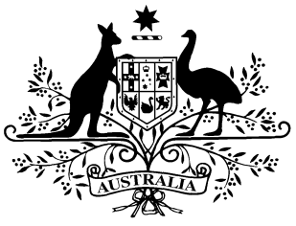

**PB 59 of 2014**

**National Health (Subsection 84C(7)) Amendment Determination 2014 (No.1)**[1]

*National Health Act 1953*

I, KIM BESSELL, Assistant Secretary, Pharmaceutical Access Branch, Department of Health, delegate of the Minister for Health, make this determination under subsection 84C(7) of the *National Health Act 1953* having in accordance with subsection 84C(9) of the *National Health Act 1953,* obtained the written agreement of the Pharmacy Guild of Australia.

Dated 30 June 2014

**KIM BESSELL**

Assistant Secretary

Pharmaceutical Access Branch

**Name of Determination**

(1) This Determination is the *National Health (Subsection 84C(7)) Amendment Determination 2014 (No.1).*

(2) This Determination may also be cited by PB 59 of 2014.

**2.****Commencement**

This Determination commences on 1 August 2014.

# 3 Amendment

Schedule 1 amends the *National Health (Subsection 84C(7)) Determination 2010* made on 20 July 2010.

Schedule 1 - Amendments

[1] Paragraph 6(1)(a)

omit:

$1.13

substitute:

$1.15

[2] Paragraph 6(1)(b)

omit:

$1.48

substitute:

$1.50

1. **Note**

   All legislative instruments and compilations are registered on the Federal Register of Legislative Instruments kept under the *Legislative Instruments Act 2003.*

   See <http://www.comlaw.gov.au>