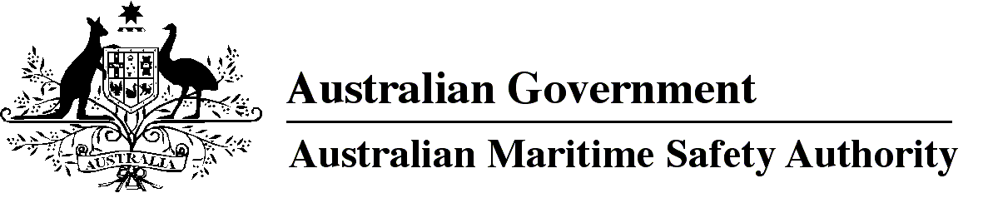

AMSA MO 2014/12

Marine Order 505 (Certificates of competency — national law) Amendment 2014 (No. 1)

I, Mick Kinley, Acting Chief Executive Officer of the Australian Maritime Safety Authority (the National Marine Safety Regulator under section 9 of the *Marine Safety (Domestic Commercial Vessel) National Law*), make this Order under subsection 163(1) of the *Marine Safety (Domestic Commercial Vessel) National Law.*

26 June 2014

**Mick Kinley**  
Acting Chief Executive Officer

1 Name of Order

This Order is *Marine Order 505 (Certificates of competency — national law) Amendment 2014 (No. 1).*

2 Commencement

This Order commences on the day after it is registered.

3 Amendment of *Marine Order 505 (Certificates of competency* — *national law) 2013*

Schedule 1 amends *Marine Order 505 (Certificates of competency* — *national law) 2013.*

Schedule 1 Amendment

[1] After section 18

insert

18A Prescribed period of suspension

(1) For subparagraph 63(3)(b)(i) of the national law, the prescribed period is the following:

(a) if the suspension is for a purpose mentioned in paragraph 63(2)(a) of the national law and a revocation show cause notice has not been given to the holder of the certificate within the 14 days after the holder has been notified in writing of the suspension — 14 days;

(b) if the suspension is for a purpose mentioned in paragraph 63(2)(a) of the national law and a revocation show cause notice has been given to the holder of the certificate within the 14 days after the holder has been notified in writing of the suspension — 14 days after the earlier of the following:

(i) the end of the period specified in the show cause notice;

(ii) the day the National Regulator receives the response to the show cause notice;

(c) if the suspension is for a purpose prescribed under paragraph 63(2)(b) of the national law — 6 months after the end of the period specified in the suspension show cause notice.

*Note 1*Subsection 18(2) prescribes the purposes for suspension of a certificate of competency under paragraph 63(2)(b) of the national law. Under paragraph 72(2)(a) of the national law the National Regulator must, before suspending a certificate under paragraph 63(2)(b), give the holder of the certificate a notice inviting the holder to show cause, within a reasonable period specified in the notice, why the certificate should not be suspended.

*Note 2*The prescribed period is the maximum period a suspension may remain in force — the National Regulator may specify in writing an earlier period — see paragraph 63(3)(b) of the national law.

(2) In subsection (1):

***revocation show cause notice*** means a notice given under paragraph 72(1)(a) of the national law.

***suspension show cause notice*** means a notice given under paragraph 72(2)(a) of the national law.

**Note**

1. All legislative instruments and compilations are registered on the Federal Register of Legislative Instruments kept under the *Legislative Instruments Act 2003.* See http://www.frli.gov.au.