

**Australian Government**

**Department of Health**

Clerk of the House of Representatives

Parliament House

Canberra ACT 2600

**Tabling - Revised Explanatory Statement for the *National Health (Pharmaceutical Benefits Amendment (Price Disclosure) Regulation 2014***

**Attention: Document Supervisor**

Dear Sir/Madam

The Explanatory Statement for the above legislative instrument was registered on the Federal Register of Legislative Instruments (FRLI) on 2 June 2014 and tabled in the House of Representatives on 3 June 2014. An incorrect version of the Explanatory Statement was inadvertently uploaded onto FRLI. After this mistake was identified, the correct version of the Explanatory Statement in relation to the above instrument was uploaded onto FRLI on 6 June 2014.

I would be grateful if you could arrange for the correct version of the Explanatory Statement to be tabled in the House of Representatives. The FRLI number is: F2014L00636.

The contact officer for this is Eleanor Lewis, ExCo liaison officer, on ph: 6289 9190, should you require further information.

Thank you for your assistance.

Yours sincerely

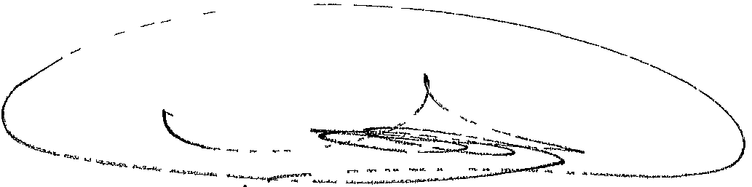

April Purry

Assistant Secretary

Legal Services Branch

10 June 2014

Legal & General Counsel MDP 350 GPO Box 9848 Canberra ACT 2601

Telephone: (02) 6289 9190 Fax: (02) 6289 5604 ABN 83 605 426 759



**Australian Government**

**Department of Health**

Clerk of the Senate

Parliament House

Canberra ACT 2600

**Tabling - Revised Explanatory Statement for the *National Health (Pharmaceutical Benefits Amendment (Price Disclosure) Regulation 2014***

**Attention: Assistant Legislation Officer**

Dear Sir/Madam

The Explanatory Statement for the above legislative instrument was registered on the Federal Register of Legislative Instruments (FRLI) on 2 June 2014 and tabled in the House of Representatives on 3 June 2014. An incorrect version of the Explanatory Statement was inadvertently uploaded onto FRLI. After this mistake was identified, the correct version of the Explanatory Statement in relation to the above instrument was uploaded onto FRLI on 6 June 2014.

I would be grateful if you could arrange for the correct version of the Explanatory Statement to be tabled in the Senate. The FRLI number is: F2014L00636.

The contact officer for this is Eleanor Lewis, ExCo liaison officer, on ph: 6289 9190, should you require further information.

Thank you for your assistance.

Yours sincerely

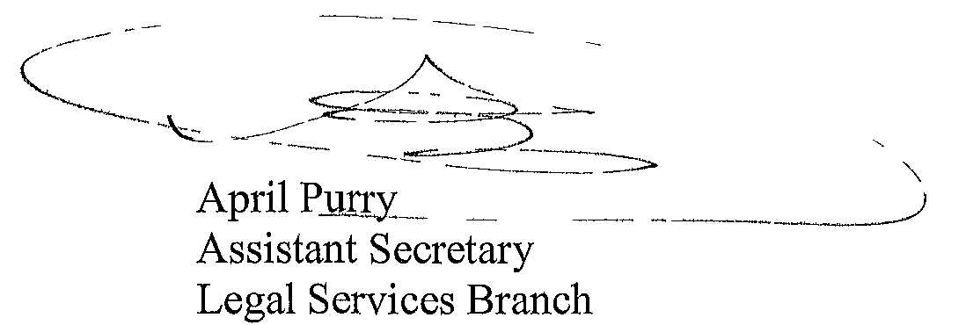

10 June 2014

Legal & General Counsel MDP 350 GPO Box 9848 Canberra ACT 2601

Telephone: (02) 6289 9190 Fax: (02) 6289 5604 ABN 83 605 426 759