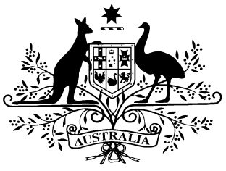
PB 38 of 2014

National Health Determination under paragraph 98C(1)(b) Amendment 2014
(No. 5)
_____________________________________________________________________

I, FELICITY McNEILL, First Assistant Secretary, Pharmaceutical Benefits Division, Department of Health, delegate of the Minister for Health, make this Instrument under paragraph 98C(1)(b) of the National Health Act 1953.

Dated 12 May 2014

FELICITY McNEILL
First Assistant Secretary
Pharmaceutical Benefits Division
Department of Health

1 Name of Instrument
- This Instrument is the National Health Determination under paragraph 98C(1)(b) Amendment 2014 (No. 5).
- This Instrument may also be cited as PB 38 of 2014.
2 Commencement
This instrument commences on 1 June 2014.
3 Amendments to Determination under paragraph 98C(1)(b) of the National Health Act 1953 (PB 119 of 2008)
Schedule 1 amends the Determination under paragraph 98C(1)(b) of the National Health Act 1953 (PB 119 of 2008).

Schedule 1 Amendments

[1] Schedule 3, after entry for Oxycodone with naloxone in the form Tablet (controlled release) containing oxycodone hydrochloride 40 mg with naloxone hydrochloride 20 mg
insert:
Tapentadol | Tablet (modified release) 50 mg (as hydrochloride)
 | Tablet (modified release) 100 mg (as hydrochloride)
 | Tablet (modified release) 150 mg (as hydrochloride)
 | Tablet (modified release) 200 mg (as hydrochloride)
 | Tablet (modified release) 250 mg (as hydrochloride)
[2] Schedule 4, after entry for Glucose Indicator―Blood in the form Test strips, 100 (FreeStyle Optium)
insert in the column headed “Form (strength, type, size, etc.)”:
Test strips, 100 (GoodLife)
[3] Schedule 4, omit entry for Phenoxybenzamine

