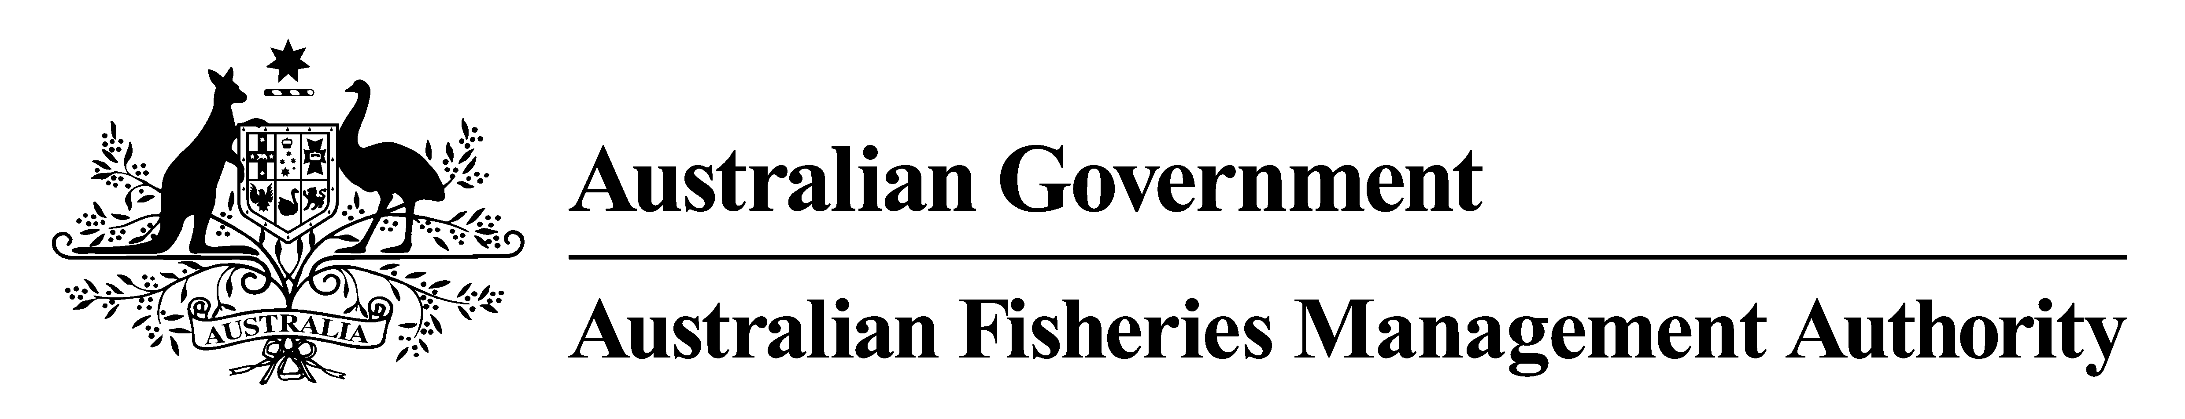

DETERMINATION OF FISHING CAPACITY
Fisheries Management Act 1991
Subsection 17(6)(aa)

Macquarie Island Toothfish Fishery Management Plan 2006

Section 11

MACQUARIE ISLAND TOOTHFISH FISHERY

TOTAL ALLOWABLE CATCH DETERMINATION 2014

The AUSTRALIAN FISHERIES MANAGEMENT AUTHORITY makes the following Determination pursuant to subsection 17(6)(aa) of the Fisheries Management Act 1991 under section 11 of the Macquarie Island Toothfish Fishery Management Plan 2006.

Dated: 17 April 2014

The Common Seal of the Australian
Fisheries Management Authority
was affixed in accordance with a
resolution of the Commission

Ryan Murphy

Executive Secretary
Australian Fisheries Management Authority

Citation
- This Determination may be cited as the Macquarie Island Toothfish Fishery Total Allowable Catch Determination 2014.
Commencement
- This Determination commences the day after it is registered on the Federal Register of Legislative Instruments.
Cessation
- This Determination ceases as if it was revoked on 1 May 2015 unless earlier revoked.
Interpretation
- A term used in this Determination that is defined for the purposes of the Macquarie Island Toothfish Fishery Management Plan 2006 has the same meaning in this Determination as it has in that Plan.
Note: Terms defined in the Fisheries Management Act 1991 have the same meanings in this Determination.
Determination of total allowable catch
- The total allowable catch for Patagonian Toothfish and catch limits for other species in the Macquarie Island Toothfish Fishery for the 2014/2015 fishing year commencing on 1 May 2014 and ending on 30 April 2015 are:
Patagonian Toothfish (Dissostichus eleginoides) 410 tonnes
Other Species:
Singular catch limit for any one other species 50 tonnes

