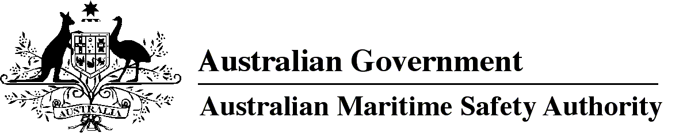

AMSA MO 2014/6

Marine Order 503 (Certificates of survey — national law) Amendment 2014 (No. 1)

I, Graham Peachey, Chief Executive Officer of the Australian Maritime Safety Authority (the National Marine Safety Regulator under section 9 of the Marine Safety (Domestic Commercial Vessel) National Law), make this Order under subsection 163(1) of the Marine Safety (Domestic Commercial Vessel) National Law.

21 February 2014

Graham Peachey  
Chief Executive Officer

1 Name of Order

This Order is *Marine Order 503 (Certificates of survey — national law) Amendment 2014 (No. 1)*.

2 Commencement

This Order commences on 1 April 2014.

3 Amendment of *Marine Order 503 (Certificates of survey — national law) 2013*

Schedule 1 amends *Marine Order 503 (Certificates of survey — national law) 2013*.

Schedule 1 Amendment

(section 3)

[1] Subparagraph 8(a)(i)

omit

Sections 1 and 2

insert

Section 2

[2] Subparagraph 8(a)(iv)

omit

[3] Subparagraph 8(a)(v)

omit

Sections 6 and 7

insert

Section 7

[4] Subparagraph 8(a)(vi)

omit

**Note**

1. All legislative instruments and compilations are registered on the Federal Register of Legislative Instruments kept under the *Legislative Instruments Act 2003.* See http://www.frli.gov.au.