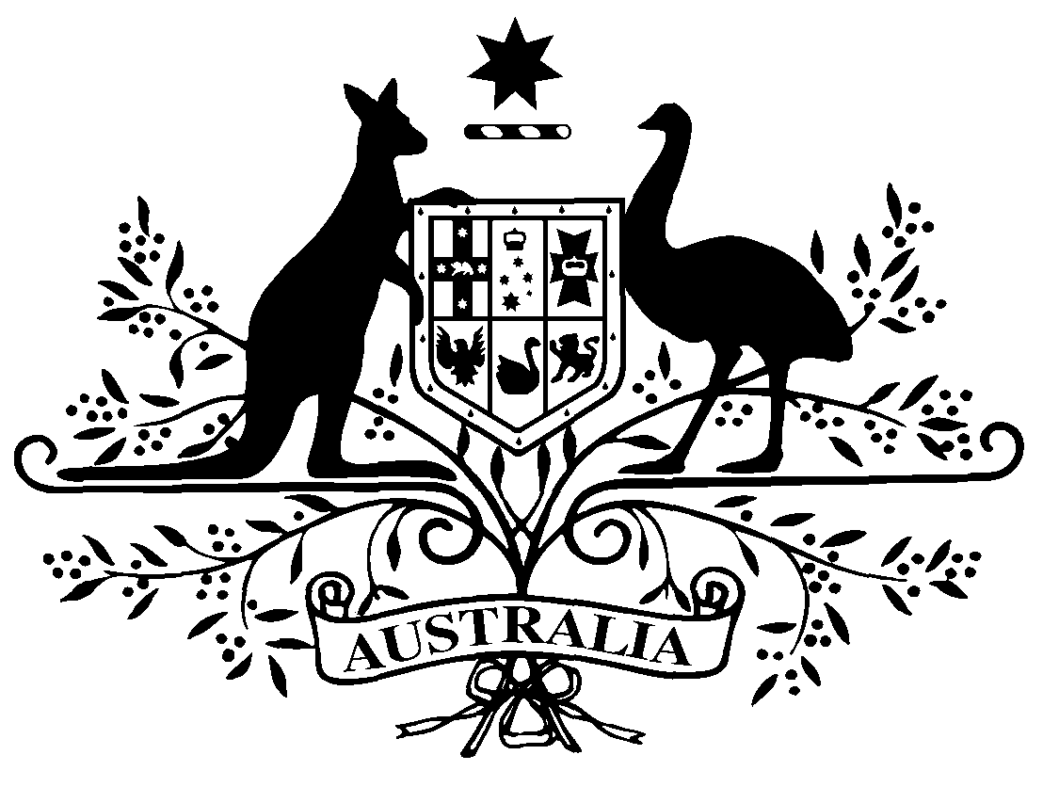
PB 8 of 2014
National Health (Weighted average disclosed price – main disclosure cycle) Amendment Determination 2014 (No. 1)
National Health Act 1953
I, FELICITY McNEILL, First Assistant Secretary, Pharmaceutical Benefits Division, Department of Health, delegate of the Minister for Health, make this amendment determination under subsection 99ADB(4) and paragraph 99ADH(1)(aa) of the National Health Act 1953.
Dated 6 February 2014

FELICITY McNEILL

First Assistant Secretary
Pharmaceutical Benefits Division
Department of Health

1 Name of Determination
(1) This Determination is the National Health (Weighted average disclosed price – main disclosure cycle) Amendment Determination 2014 (No. 1).
(2) This Determination may also be cited as PB 8 of 2014.
2 Commencement
This Determination commences on the day after it is registered.
3 Amendments to PB 82 of 2013
Schedule 1 amends the National Health (Weighted average disclosed price - main disclosure cycle) Determination 2013 (No.2) (PB 82 of 2013).
Schedule 1 Amendments

1] Schedule 1, After

1235 | Mometasone | Ointment containing mometasone furoate  1 mg per g, 15 g | Application | Zatamil | 4.52

omit:
1236 | Morphine | Injection containing morphine sulfate 10 mg in 1 mL | Injection | Hospira Pty Limited | 4.27
1237 | Morphine | Injection containing morphine sulfate 15 mg in 1 mL | Injection | Hospira Pty Limited | 4.58
1238 | Morphine | Injection containing morphine sulfate 30 mg in 1 mL | Injection | Hospira Pty Limited | 5.82
1239 | Morphine | Injection containing morphine sulphate 10 mg in 1 mL (with preservative) | Injection | Morphine Sulphate Wockhardt | 8.53
1240 | Morphine | Injection containing morphine tartrate 120 mg in 1.5 mL | Injection | Hospira Pty Limited | 17.64

Note
1. All legislative instruments and compilations are registered on the Federal Register of Legislative Instruments kept under the Legislative Instruments Act 2003. See http://www.comlaw.gov.au/Home.

