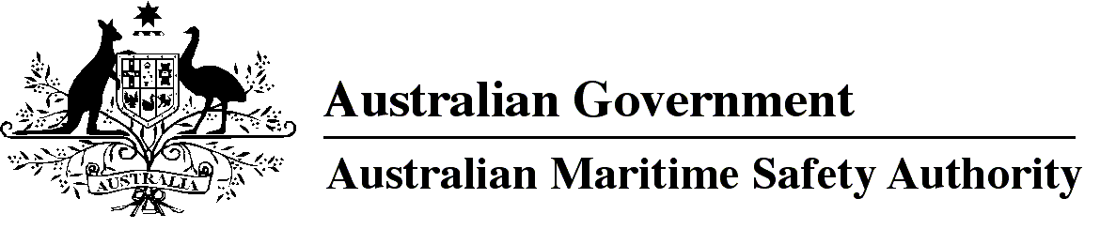
AMSA MO 2013/20
Marine Order 21 (Safety of navigation and emergency procedures) Modification 2013 (No. 1)
I, Mick Kinley, Acting Chief Executive Officer of the Australian Maritime Safety Authority, make this Order under subsection 342(1) of the Navigation Act 2012.
9 December 2013
Mick Kinley
Acting Chief Executive Officer

1 Name of Order
This Order is Marine Order 21 (Safety of navigation and emergency procedures) Modification 2013 (No. 1).
2 Commencement
This Order commences on the day after it is registered.
3 Modification of Marine Order 21 (Safety of navigation and emergency procedures) 2012
For subsection 343(2) of the Navigation Act 2012, Marine Order 21 (Safety of navigation and emergency procedures) 2012 is modified in accordance with Schedule 1.

Schedule 1 Modification
[1] Subsection 29.1
omit
the voyage
insert
the intended voyage
[2] Subsection 29.2
omit
publication
insert
nautical publication
[3] Paragraph 29.2(b)
omit
supplies; and
insert
supplies.
[4] Paragraph 29.2(c)
omit
[5] After subsection 29.2
insert
29.2A For an electronic nautical publication, the owner of a vessel must ensure that a back up version is available:
(a) as an up to date printout; or
(b) on at least 1 other computer or in digital format (eg portable mass storage device or compact disc) that can be made available to the officer of the watch within 5 minutes.
[6] Subsection 29.3
substitute
29.3 For an electronic nautical chart, the owner of the vessel must ensure that:
(a) the chart is displayed on an ECDIS that complies with Regulation 19 of Chapter V of SOLAS; and
(b) a back up version is available:
(i) on a second ECDIS that complies with Regulation 19 of Chapter V of SOLAS; or
(ii) as a folio of adequate and up to date paper charts relevant to the voyage.

Note
1. All legislative instruments and compilations are registered on the Federal Register of Legislative Instruments kept under the Legislative Instruments Act 2003. See http://www.frli.gov.au.

