Instrument number CASA EX113/13

I, JOHN FRANCIS McCORMICK, Director of Aviation Safety, on behalf of CASA, make this instrument under regulation 11.160 of the *Civil Aviation Safety Regulations 1998.*

**[Signed John F. McCormick]**

John F. McCormick  
Director of Aviation Safety

24 October 2013

Exemption — temporary relief from requirement to carry serviceable ADS‑B transmitting equipment when operating in defined exempted airspace

1 Duration

This instrument:

(a) commences on the day after registration; and

(b) stops having effect at the end of 11 December 2015, as if it had been repealed by another instrument.

2 Definitions

In this instrument:

***ADS-B*** means automatic dependent surveillance – broadcast.

***AOC*** means air operator’s certificate.

***ATS Route***, followed by a letter and numbers, means a flight path labelled with the letter and numbers whose way points are set out for the Route in the DAH that is in effect from time to time.

*Note*   For example “ATS Route B598”, which is comprised of several waypoints.

***Australian‑administered airspace*** means:

(a) the airspace over Australian territory; and

(b) airspace that has been allocated to Australia by ICAO under the Chicago Convention and for which Australia has accepted responsibility.

***DAH*** means the Designated Airspace Handbook published twice-yearly by Airservices Australia.

***exempted airspace*** means the Australian-administered airspace, at or above FL 290, described in paragraphs (a), (b) and (c), but **EXCLUDING** the airspace, at or above FL 290, described in paragraph (d):

(a) airspace within the area of Australian east coast SSR coverage, whose lateral limits are set out in Schedule 1; and

*Note*   For general guidance only, the east coast SSR area is depicted in the J-curve shape coloured blue in Attachment 1 to Schedule 1, and known as the ADS-B Mandate Radar Coverage Map.

(b) airspace beyond the limits of the territorial sea; and

(c) airspace over an external territory or Lord Howe Island, or over the territorial sea of an external territory or Lord Howe Island; and

(d) airspace that is the following:

*Note*   For general guidance only, EXCLUDED areas and exempted areas are depicted on the map in Attachment 2 to Schedule 1. Thus, the pink continental and pink sea areas are excluded from the scope of the exemption. The turquoise J-curve area, and the green oceanic area are within the scope of the exemption. (The light blue archipelago areas are outside Australian Administered Airspace.)

(i) airspace inside the territory of Australia and within its territorial sea, other than the airspace mentioned in paragraph (a);

(ii) the airspace:

(A) of ATS Route B598; and

(B) over the sea and any islands lying south of ATS Route B598;

*Note* For general guidance only, this excluded area is part of the area known geographically as the Gulf of Carpentaria.

(iii) the airspace:

(A) of ATS Route H20; and

(B) over the sea and any islands lying between ATS Route H20 and the eastern boundary of the Australian east coast SSR coverage area;

*Note* For general guidance only, this excluded area is part of the area known geographically as Bass Strait.

(iv) the airspace:

(A) of ATS Route L513 west of waypoint HB (***part ATS Route L513***); and

(B) over the sea and any islands lying north of part ATS Route L513;

*Note* For general guidance only, this excluded area is part of the area known geographically as the Great Australian Bight.

(v) the airspace:

(A) of ATS Route Q27; and

(B) over the sea and any islands lying north of ATS Route Q27.

*Note* For general guidance only, this excluded area is part of the area known geographically as the Great Australian Bight.

***exempted operation*** means one or more aircraft operations of which CASA has been notified in writing by the operator, not less than 14 days before the operation commences, of the following:

(a) the operator’s intention to operate aircraft in exempted airspace during the ***exemption period***;

(b) the type, model, and nationality and registration marks of each aircraft which will operate in exempted airspace during the exemption period.

***exemption period*** means the period that:

(a) commences at the start of 12 December 2013; and

(b) expires at the end of 11 December 2015.

***FL*** means flight level.

***requirement to carry serviceable ADS-B transmitting equipment*** means the requirement under whichever of the following applies to the aircraft of an aircraft operator:

(a) paragraph 9B.8 of Civil Aviation Order 20.18 — Aircraft equipment – basic operational requirements, for all Australian registered aircraft;

(b) clause 7 in Appendix 3 of Civil Aviation Order 82.1 — Conditions on Air Operators’ Certificates authorising charter operations and aerial work operations, for the aircraft of an operator who holds a foreign registered aircraft AOC issued by CASA for charter operations or aerial work operations;

(c) clause 7 in Appendix 6 of Civil Aviation Order 82.3 — Conditions on Air Operators’ Certificates authorising regular public transport operations in other that high capacity aircraft, for the aircraft of an operator who holds a foreign registered aircraft AOC issued by CASA for regular public transport operations in other that high capacity aircraft;

(d) clause 7 in Appendix 4 of Civil Aviation Order 82.5 — Conditions on Air Operators’ Certificates authorising regular public transport operations in high capacity aircraft, for the aircraft of an operator who holds a foreign registered aircraft AOC issued by CASA for regular public transport operations in high capacity aircraft;

(e) a direction under regulation 209 of the *Civil Aviation Regulations 1988* — only to the extent of the direction in clause 7 in Schedule 1 of CASA instrument 521/09: Direction — use of ADS-B in foreign registered aircraft engaged in private operations in Australian territory, for private operations of a foreign registered aircraft.

***SSR*** means secondary surveillance radar.

***territorial sea*** has the same meaning as in the *Acts Interpretation Act 1901.*

*Note*   The *Acts Interpretation Act 1901* adopts the definition in the *Seas and Submerged Lands Act 1973* which is based on the definition in Articles 3 and 4 of the *United Nations Convention on the Law of the Sea*. For general guidance only, the territorial sea extends for 12 nautical from the officially recognised coastal low-water line.

***waypoint*** means a specified geographical location used in an ATS Route to define the flight path of an aircraft using area navigation.

3 Application

This instrument applies to the operator of an aircraft operated in exempted airspace which, but for this exemption, would be required to carry ADS-B transmitting equipment.

4 Exemption

With effect on and from 12 December 2013, I exempt the operator of an aircraft from the requirement to carry serviceable ADS-B transmitting equipment for an exempted operation in exempted airspace.

*Note*   The maps of ***exempted airspace*** in Attachments 1 and 2 in Schedule 1 are merely to provide a general pictorial indication of exempted airspace (and non-exempted airspace).

5 Conditions

The exemption in subsection 4.1 is subject to the following conditions:

(a) the exempted operations must be confined to exempted airspace;

(b) the flight plan for each exempted operation must include the following details at item 18 of the plan: RMK/ADSB EXEMPT.

*Note*   This exemption does not mean that appropriate air traffic control (***ATC***) clearance is automatic or guaranteed. ATC makes clearance decisions subject to prevailing air traffic and operational conditions at the time of the flight.

Schedule 1 East coast secondary surveillance radar coverage area

LATERAL LIMITS: 37 49 33S 136 26 05E,

then along the major arc of a circle of 200.0NM radius centred on

34 56 49S 138 31 28E (AD/DME) to 32 01 59S 140 28 20E

33 48 37S 144 31 36E, 31 56 12S 147 44 07E

27 58 27S 149 04 03E, 18 35 49S 142 45 54E,

then along the minor arc of a circle of 200.0NM radius centred on

16 51 01S 145 44 38E (CS/DME) to 15 03 37S 148 40 04E

25 25 47S 156 09 57E,

then along the minor arc of a circle of 200.0NM radius centred on

27 21 57S 153 08 21E (BN/DME) to 28 07 25S 156 47 55E

34 44 32S 155 05 22E,

then along the minor arc of a circle of 200.0NM radius centred on

33 56 34S 151 10 51E (SY/DME) to 36 33 48S 153 42 11E

40 20 43S 147 22 52E, 40 39 27S 147 11 54E

42 45 31S 147 57 48E,

then along the minor arc of a circle of 20.0NM radius centred on

42 50 50S 147 31 36E (HB/DME) to 43 00 15S 147 07 35E

40 55 56S 145 40 52E,

then along the minor arc of a circle of 200.0NM radius centred on

37 39 36S 144 50 31E (ML/DME) to 40 38 32S 142 55 11E

37 49 33S 136 26 05E.

Attachment 1 to Schedule 1 ADS-B Mandate Radar Coverage Map

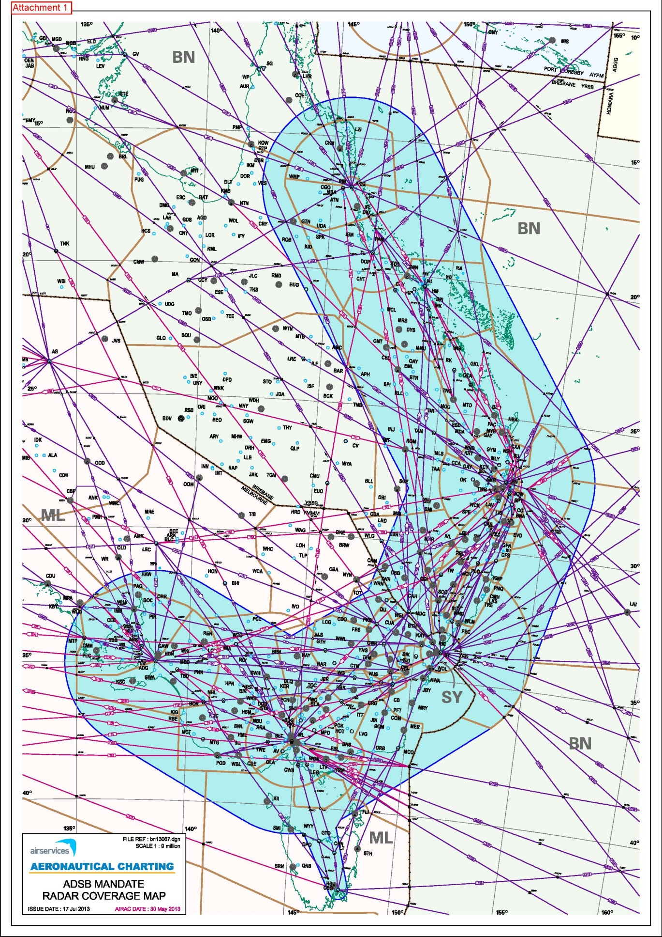

Attachment 2 to Schedule 1 Exempted areas (turquoise J curve and green); and non-exempted areas (both lighter and darker pink)

