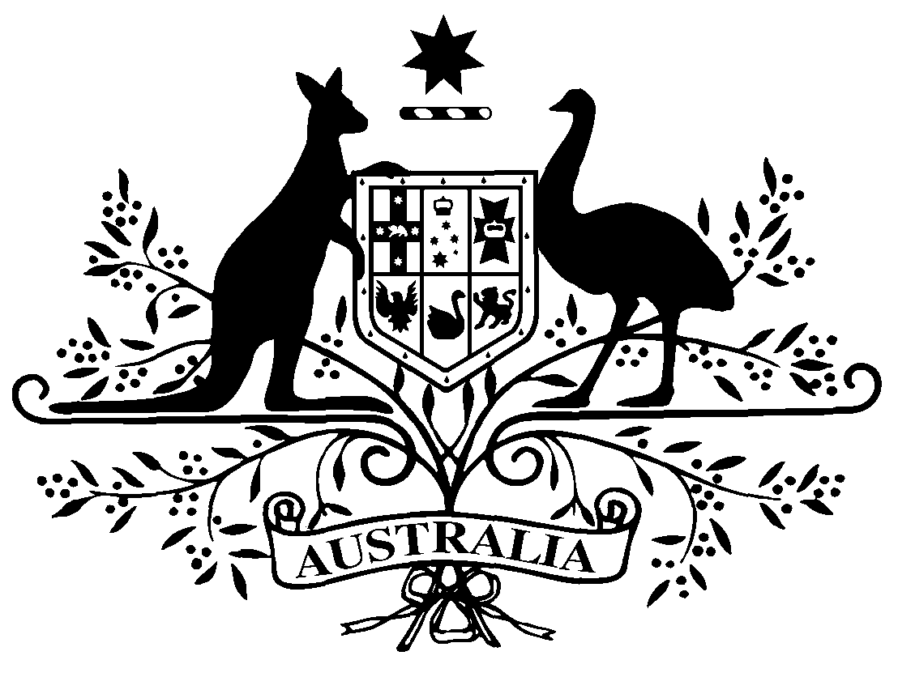

COMMONWEALTH OF AUSTRALIA
Instrument number QAA 2/2013
Amendment Declaration of Quality Assurance Activity QAA 4/2011 under section 124X of the Health Insurance Act 1973.

I, PROFESSOR CHRISTOPHER BAGGOLEY, Chief Medical Officer of the Department of Health and Ageing, under Section 124X of the Health Insurance Act 1973 (the Act):

- DECLARE that the Declaration of Quality Assurance Activity under section 124X
(QAA No. 4/2011) is amended as set out in this Declaration.

- Amendment:
  - Schedule 1, item 2, Description:
Insert:
The ANZASM also involves data from audits conducted by the Australian and New Zealand College of Anaesthetists (ANZCA).

- This Amendment Declaration commences the day after registration on the Federal Register of Legislative Instruments and unless sooner revoked will cease on the day of cessation of QAA 4/2011.

Dated 12 September 2013

PROFESSOR CHRISTOPHER BAGGOLEY
Chief Medical Officer
Department of Health and Ageing

