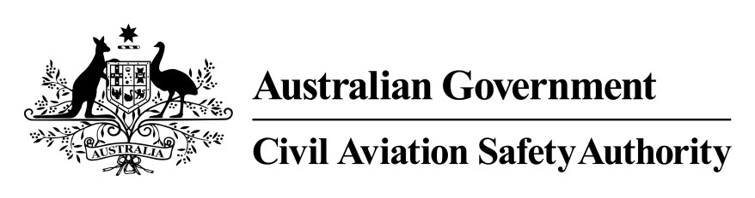

Instrument number A&ESB 12/3050

I, MICHAEL JAMES HIGGINS, Manager Continuing Airworthiness Section, Airworthiness and Engineering Standards Branch, Standards Division, a delegate of CASA, make this instrument under paragraph 39.004 (3) (a) of the Civil Aviation Safety Regulations 1998.
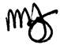

Mike Higgins
Manager Continuing Airworthiness Section Airworthiness and Engineering Standards Branch Standards Division

16 September 2013

Approval — means of compliance with Airworthiness Directive for
Grob G 109 and G 109 B aircraft

1 Duration
This instrument:
(a) commences on the day of registration; and
(b) ceases to have effect if European Aviation Safety Agency Airworthiness
Directive 2012-0027 (the AD) is amended or cancelled.

2 Application
This instrument applies to any Grob G109 or Grob G 109 B aircraft registered in
Australia and engaged in operations within Australian territory (the aircraft).

3 Approved means of compliance
I approve for the aircraft, as a means of compliance with paragraphs (2) and (3) of the AD other than that set out in paragraphs (2) and (3) of the AD, the completion of both of the following actions:
(a) during the next scheduled 50 hours inspection or within 3 months, whichever occurs first after the effective date of the AD, and thereafter at intervals not to exceed 100 flight hours, inspection of the nose plate part number 109-2160.01 in the vertical stabiliser in accordance with the section of GFA Engineering Order 2012-3 Issue 1 titled “Inspection”; and
(b) prior to, or concurrent with the initial inspection as required by
paragraph (a), installation of 2 borescope access holes on the left side of the vertical stabiliser in accordance with the section of GFA Engineering Order
2012-3 Issue 1 titled “Inspection hole positions”.

