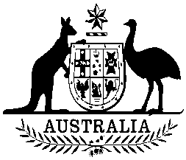
Commonwealth of Australia
Environment Protection and Biodiversity Conservation Act 1999
Section 269A
Instrument making a recovery plan

I, TONY BURKE, Minister for Sustainability, Environment, Water, Population and Communities, pursuant to:
- section 269A(2) of the Environment Protection and Biodiversity Conservation Act 1999 (Cth), make a recovery plan for Neophoca cinerea – Australian sea lion entitled “Recovery Plan for the Australian Sea Lion (Neophoca cinerea) 2013”
The recovery plan will come into force on the day after the plan is registered on the Federal Register of Legislative Instruments.

Dated this 11 day of June 2013

Tony Burke
Tony Burke
Minister for Sustainability, Environment, Water, Population and Communities

