Description: Commonwealth Coat of Arms

Recognition as Representative Aboriginal/Torres Strait Islander Body 2013 (No. 5)

*Native Title Act 1993*

I, Jenny Macklin, Minister for Families, Community Services and Indigenous Affairs, under subsection 203AD(1) of the *Native Title Act 1993*, recognise the South West Aboriginal Land and Sea Council Aboriginal Corporation as the representative Aboriginal/Torres Strait Islander body for the area described in Schedule 1.

This Recognition commences on 1 July 2013 and ceases to have effect at the end of 30 June 2015.

The ***Recognition of Representative Aboriginal/Torres Strait Islander Body 2010 (No. 1)*** is revoked with effect from the commencement of this Recognition.

Dated 10 May 2013

JENNY MACKLIN

Minister for Families, Community Services and Indigenous Affairs

Schedule 1—Description of area (Western Australia South West)

**1** The Western Australia South West area is the area of land and water bounded by a line commencing at the point of intersection of the northern boundary of the 1991 Local Government Area (LGA) of Coorow and the coastline of mainland Australia, and then proceeding generally easterly along the northern boundary of that LGA to its intersection with Dalwallinu LGA, then generally easterly along the northern boundary of that LGA to its intersection with Mount Marshall LGA, then generally easterly along the northern boundary of that LGA to its intersection with Yilgam LGA, then generally south-easterly and southerly along the northern and eastern boundaries of that LGA to its intersection with Kondinin LGA, then generally southerly along the eastern boundary of that LGA to its intersection with Ravensthorpe LGA, then generally easterly and southerly along the northern and eastern boundaries of that LGA to the intersection with the coastline of mainland Australia, then due south in a straight line to the intersection with the Exclusive Economic Zone of Australia (EEZ), then generally north-westerly along the southern and western boundaries of that EEZ to a point due west of the point of commencement, and then due east by a straight line to the point of commencement.

**2** In this Schedule:

***exclusive economic zone*** means the exclusive economic zone within the meaning of the *Seas and Submerged Lands Act 1973*.

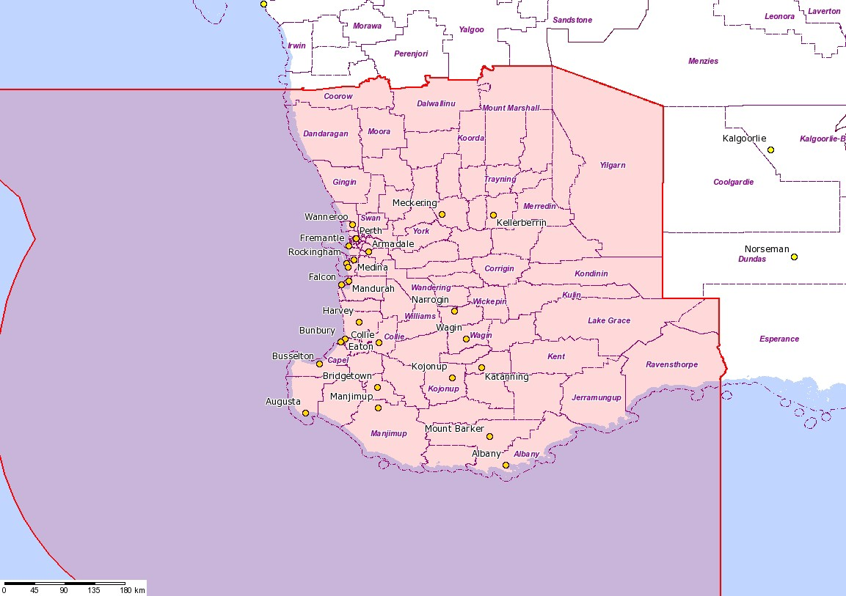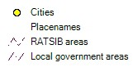

|  |  |  |  |
| --- | --- | --- | --- |
|  | | |  |
| **Native TitleVision**  **South West** |
| Selection information  **RATSIB areas**  **Name** South West  **Organisation** South West Aboriginal Land and Sea Council  **Gazetted** 01/07/2010  **Effective** 30/06/2013 |
| **Disclaimer**  This information product has been created to assist in understanding the spatial characteristics and relationships of this native title matter and is intended as a guide only. It is not suitable for media reproduction purposes. Spatial data used has been sourced from the relevant custodians in each jurisdiction - Commonwealth: ABS, AEC, DCC, DEWHA, Geoscience Australia, ILC, NNTT; ACT: ACTPLA; NSW: DECC, DOL, DPI; NT: DPI, RDPIFR; QLD: DEEDI, DERM; SA: DEH, DTEI, PIRSA; TAS: DIER, DPIW; VIC: DPI, DSE; WA: DEC, DIA, DMP, Landgate; National: PSMA Australia. | The Registrar, the National Native Title Tribunal and its staff, members and agents and the Commonwealth (collectively the Commonwealth) accept no liability and give no undertakings guarantees or warranties concerning the accuracy, completeness or fitness for purpose of the information provided. In return for being allowed to access this information you agree to release and indemnify the Commonwealth and third party data suppliers in respect of all claims, expenses, losses, damages and costs arising directly or indirectly from your use of the information and the use of the information you obtained by any third party. | **Map created:** Wednesday, 24 April 2013  **Map Extent:**  **Top left**: -29.3339612997855, 111.078927334865  **Bottom right:** -36.183174189917, 125.15455614386  **Copyright © Commonwealth of Australia** |