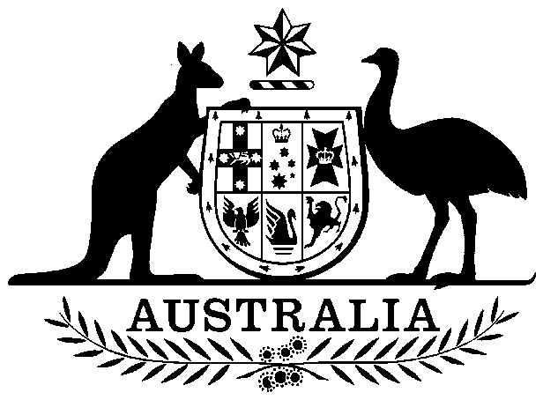
COMMONWEALTH OF AUSTRALIA

Environment Protection and Biodiversity Conservation Act 1999

Amendment of List of Exempt Native Specimens

I, GEOFF RICHARDSON, Assistant Secretary, Marine Biodiversity and Biosecurity Branch, as Delegate of the Minister for Sustainability, Environment, Water, Population and Communities, pursuant to subsection 303DC(1) of the Environment Protection and Biodiversity Conservation Act 1999 (EPBC Act), hereby amend the list of exempt native specimens established under section 303DB of the EPBC Act by including in the list the following:

- specimens that are or are derived from fish or invertebrates, other than specimens that belong to species listed under Part 13 of the EPBC Act, taken in the Western Australian Mackerel Fishery, as defined in the Mackerel Managed Fishery Management Plan 2011, made under the Western Australian Fish Resources Management Act 1994,

with a notation that inclusion of the specimens in the list is subject to the following restrictions or conditions:

- the specimen, or the fish or invertebrate from which it is derived, was taken lawfully, and

- the specimens are included in the list until 17 November 2014.

Dated this 4th day of May 2013

……………………Geoff Richardson……………………

Delegate of the Minister for Sustainability, Environment, Water, Population and Communities

