

**Food Standards (Application A1073 – Food derived from Herbicide-tolerant Soybean DAS‑44406-6) Variation**

The Board of Food Standards Australia New Zealand gives notice of the making of this variation under section 92 of the *Food Standards Australia New Zealand Act 1991*. The Standard commences on the date specified in clause 3 of this variation.

Dated 12 April 2013

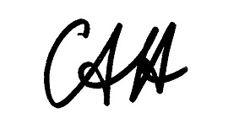

Standards Management Officer

Delegate of the Board of Food Standards Australia New Zealand

Note:

This variation will be published in the Commonwealth of Australia Gazette No. FSC 82 on18 April 2013. This means that this date is the gazettal date for the purposes of clause 3 of the variation.

**1 Name**

This instrument is the *Food Standards (Application A1073 - Food derived from Herbicide-tolerant Soybean DAS-44406-6) Variation*

**2 Variation to Standards in the *Australia New Zealand Food Standards Code***

The Schedule varies the Standards in the *Australia New Zealand Food Standards Code*.

**3 Commencement**

This variation commences on **the date of gazettal**.

**SCHEDULE**

[1]Standard 1.5.2is varied by inserting in numerical order in the Schedule

“

|  |  |  |  |
| --- | --- | --- | --- |
|  | 7.13 | Food derived from herbicide-tolerant soybean line DAS-44406-6 |  |

”