

Food Standards (Application A1071 – Food derived from Glyphosate-tolerant Canola MON88302) Variation

The Board of Food Standards Australia New Zealand gives notice of the making of this variation under section 92 of the Food Standards Australia New Zealand Act 1991. The Standard commences on the date specified in clause 3 of this variation.

Dated 15 February 2013
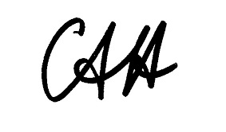
Standards Management Officer
Delegate of the Board of Food Standards Australia New Zealand

1 Name

This instrument is the Food Standards (Application A1071 – Food derived from Glyphosate-tolerant Canola MON88302) Variation.

2 Variation to Standards in the Australia New Zealand Food Standards Code

The Schedule varies the Standards in the Australia New Zealand Food Standards Code.

3 Commencement

These variations commence on 21 February 2013.

SCHEDULE

[1] Standard 1.5.2 is varied by inserting in numerical order in the Schedule –

“
 | 1.4 | Food derived from herbicide-tolerant canola line MON88302
”

