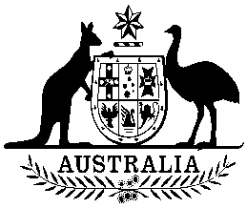
COMMONWEALTH OF AUSTRALIA

Environment Protection and Biodiversity Conservation Act 1999

Amendment of List of Exempt Native Specimens

I, GEOFF RICHARDSON, Assistant Secretary, Marine Biodiversity and Biosecurity Branch, as Delegate of the Minister for Sustainability, Environment, Water, Population and Communities, pursuant to subsection 303DC(1) of the Environment Protection and Biodiversity Conservation Act 1999 (EPBC Act), hereby amend the list of exempt native specimens established under section 303DB of the EPBC Act by revoking the conditions to which the inclusion of the following item in the list on 8 February 2008 is subject:

- Specimens that are or are derived from fish or invertebrates, other than specimens
that belong to species listed under Part 13 of the EPBC Act, taken in the Western
Australian Exmouth Gulf Prawn Managed Fishery, as defined in the Exmouth Gulf Prawn Management Plan 1989 in force under the Western Australian Fish Resources Management Act 1994.

and imposing the following conditions to which inclusion of the specimens in the list is subject:

- the specimen, or the fish or invertebrate from which it is derived, was taken lawfully, and

- the specimens are included in the list until 8 February 2018.

Dated this 4th day of February 2013

…G Richardson……………………

Delegate of the Minister for Sustainability, Environment, Water, Population and Communities

