

**Food Standards (Proposal P1011 – Country of Origin Labelling – Unpackaged Meat Products – Consequential) Variation**

The Board of Food Standards Australia New Zealand gives notice of the making of this variation under section 92 of the *Food Standards Australia New Zealand Act 1991*. The Standard commences on the date specified in clause 3 of this variation.

Dated 7 January 2013

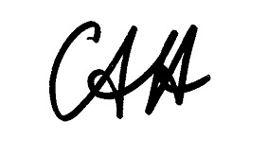

Standards Management Officer

Delegate of the Board of Food Standards Australia New Zealand

**1 Name**

This instrument is the *Food Standards (Proposal P1011 – Country of Origin Labelling – Unpackaged Meat Products – Consequential) Variation*.

**2 Variation to Standards in the *Australia New Zealand Food Standards Code***

The Schedule varies the Standards in the *Australia New Zealand Food Standards Code*.

**3 Commencement**

These variations commence on 18 July 2013.

SCHEDULE

**[1]** ***Standard 1.2.1*** *is varied by omitting clause 2(2)(g), substituting* –

(g) subclauses 2(3) and 2(4), and clause 3 of Standard 1.2.11 – Country of Origin Labelling; and

**[2]** ***Standard 1.2.11*** *is repealed.*